

10

Threads

**CERTIFICATION OBJECTIVES**

•       Create Worker Threads Using Runnable, Callable, and Use an ExecutorService to Concurrently Execute Tasks

•       Identify Potential Threading Problems among Deadlock, Starvation, Livelock, and Race Conditions

•       Use Synchronized keyword and java.util.concurrent.atomic Package to Control the Order of Thread Execution

     Two-Minute Drill

**Q&A**   Self Test

**CERTIFICATION OBJECTIVE**

**DEFINING, INSTANTIATING, AND STARTING THREADS (OCP OBJECTIVE 10.1)**

*10.1   Create worker threads using Runnable, Callable, and use an ExecutorService to concurrently execute tasks.*

Imagine a stockbroker application with a lot of complex capabilities. One of its functions is “download last stock option prices,” another is “check prices for warnings,” and a third time-consuming operation is “analyze historical data for company XYZ.”

In a single-threaded runtime environment, these actions execute one after another. The next action can happen *only* when the previous one is finished. If a historical analysis takes half an hour, and the user selects to perform a download and check afterward, the warning may come too late to, say, buy or sell stock as a result.

We just imagined the sort of application that cries out for multithreading. Ideally, the download should happen in the background (that is, in another thread). That way, other processes could happen at the same time so that, for example, a warning could be communicated instantly. All the while, the user is interacting with other parts of the application. The analysis, too, could happen in a separate thread so the user can work in the rest of the application while the results are being calculated.

So what exactly is a thread? In Java, “thread” means two different things:

   An instance of class java.lang.Thread

   A thread of execution

An instance of Thread is just…an object. Like any other object in Java, it has variables and methods, and it lives and dies on the heap. But a *thread of execution*is an individual process (a “lightweight” process) that has its own call stack. In Java, there is *one thread per call stack*—or, to think of it in reverse, *one call stack per thread.* Even if you don’t create any new threads in your program, threads are back there running.

The main() method, which starts the whole ball rolling, runs in one thread, called (surprisingly) the *main* thread. If you looked at the main call stack (and you can any time you get a stack trace from something that happens after main begins, but not within another thread), you’d see that main() is the first method on the stack—the method at the bottom. But as soon as you create a *new* thread, a new stack materializes and methods called from *that* thread run in a call stack that’s separate from the main() call stack. That second new call stack is said to run concurrently with the main thread, but we’ll refine that notion as we go through this chapter.

You might find it confusing that we’re talking about code running *concurrently*—what gives? The JVM, which gets its turn at the CPU by whatever scheduling mechanism the underlying OS uses, operates like a mini-OS and schedules *its* own threads, regardless of the underlying operating system. In some JVMs, the Java threads are actually mapped to native OS threads, but we won’t discuss that here; native threads are not on the exam. Nor is it required to understand how threads behave in different JVM environments. In fact, the most important concept to understand from this entire chapter is this:

When it comes to threads, very little is guaranteed.

So be very cautious about interpreting the behavior you see on *one* machine as “the way threads work.” The exam expects you to know what is and is not guaranteed behavior so that you can design your program in such a way that it will work, regardless of the underlying JVM. *That’s part of the whole point of Java.*



***Don’t make the mistake of designing your program to be dependent on a particular implementation of the JVM. As you’ll learn a little later, different JVMs can run threads in profoundly different ways. For example, one JVM might be sure that all threads get their turn, with a fairly even amount of time allocated for each thread in a nice, happy, round-robin fashion. But in other JVMs, a thread might start running and then just hog the whole show, never stepping out so others can have a turn. If you test your application on the “nice turn-taking” JVM and you don’t know what is and is not guaranteed in Java, then you might be in for a big shock when you run it under a JVM with a different thread-scheduling mechanism.***

The thread questions are among the most difficult questions on the exam. In fact, for most people, they *are* the toughest questions on the exam, and with three objectives for threads, you’ll be answering a *lot* of thread questions. If you’re not already familiar with threads, you’ll probably need to spend some time experimenting. Also, one final disclaimer: *This chapter makes almost no attempt to teach you how to design a good, safe multithreaded application. We only scratch the surface of that huge topic in this chapter!* You’re here to learn the basics of threading and what you need to get through the thread questions on the exam. Before you can write decent multithreaded code, however, you really need to study more of the complexities and subtleties of multithreaded code.

Note: The topic of daemon threads is NOT on the exam. All of the threads discussed in this chapter are “user” threads. You and the operating system can create a second kind of thread called a daemon thread. The difference between these two types of threads (user and daemon) is that the JVM exits an application only when all user threads are complete—the JVM doesn’t care about letting daemon threads complete, so once all user threads are complete, the JVM will shut down, regardless of the state of any daemon threads. Once again, this topic is NOT on the exam.

Making a Thread

A thread in Java begins as an instance of java.lang.Thread. You’ll find methods in the Thread class for managing threads, including creating, starting, and pausing them. For the exam, you’ll need to know, at a minimum, the following methods:

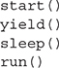

The action happens in the run() method. Think of the code you want to execute in a separate thread as *the job to do.* In other words, you have some work that needs to be done—say, downloading stock prices in the background while other things are happening in the program—so what you really want is that *job* to be executed in its own thread. So, if the *work* you want done is the *job,* the one *doing* the work (actually executing the job code) is the *thread*. And the*job always starts from a*run() *method,* as follows:

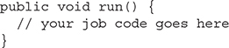

You always write the code that needs to be run in a separate thread in a run() method. The run() method will call other methods, of course, but the thread of execution—the new call stack—always begins by invoking run(). So where does the run() method go? In one of the two classes you can use to define your thread job.

You can define and instantiate a thread in one of two ways:

   Extend the java.lang.Thread class.

   Implement the Runnable interface.

You need to know about both for the exam, although in the real world, you’re much more likely to implement Runnable than extend Thread. Extending the Thread class is the easiest, but it’s usually not good OO practice. Why? Because subclassing should be reserved for specialized versions of more general superclasses. So the only time it really makes sense (from an OO perspective) to extend Thread is when you have a more specialized version of a Thread class. In other words, because *you have more specialized thread-specific behavior.* Chances are, though, that the thread work you want is really just a job to be done *by* a thread. In that case, you should design a class that implements the Runnable interface, which also leaves your class free to extend some *other* class.

Defining a Thread

To define a thread, you need a place to put your run() method, and as we just discussed, you can do that by extending the Thread class or by implementing the Runnable interface. We’ll look at both in this section.

Extending java.lang.Thread

The simplest way to define code to run in a separate thread is to

   Extend the java.lang.Thread class.

   Override the run() method.

It looks like this:

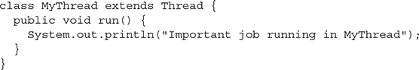

The limitation with this approach (besides being a poor design choice in most cases) is that if you extend Thread, *you can’t extend anything else.* And it’s not as if you really need that inherited Thread class behavior; because in order to use a thread, you’ll need to instantiate one anyway.

Keep in mind that you’re free to overload the run() method in your Thread subclass:

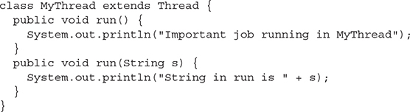

But know this: The overloaded run(String s) method will be ignored by the Thread class unless you call it yourself. The Thread class expects a run() method with no arguments, and it will execute this method for you in a separate call stack after the thread has been started. With a run(String s) method, the Thread class won’t call the method for you, and even if you call the method directly yourself, execution won’t happen in a new thread of execution with a separate call stack. It will just happen in the same call stack as the code that you made the call from, just like any other normal method call.

Implementing java.lang.Runnable

Implementing the Runnable interface gives you a way to extend any class you like but still define behavior that will be run by a separate thread. It looks like this:

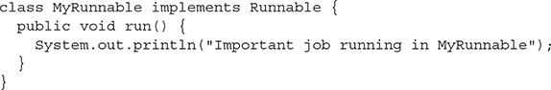

Notice that the Runnable interface is a functional interface, that is, an interface with one abstract method, run(). That means we can also write a Runnable like this:



Regardless of which mechanism you choose, you’ve now got yourself some code that can be run by a thread of execution. Let’s take a look at *instantiating* your thread-capable class, and then we’ll figure out how to actually get the thing *running*.

Instantiating a Thread

Remember, every thread of execution begins as an instance of class Thread. Regardless of whether your run() method is in a Thread subclass or a Runnable implementation class, you still need a Thread object to do the work.

If you extended the Thread class, instantiation is dead simple (we’ll look at some additional overloaded constructors in a moment):



If you implement Runnable, instantiation is only slightly less simple. To have code run by a separate thread, *you still need a Thread instance.*But rather than combining both the *thread* and the *job* (the code in the run()method) into one class, you’ve split it into two classes—the Thread class for the *thread-specific*code and your Runnable implementation class for your*job-that-should-be-run-by-a-thread*code. (Another common way to think about this is that the Thread is the “worker,” and the Runnable is the “job” to be done.)

First, you instantiate your Runnable class:



Next, you get yourself an instance of java.lang.Thread (*somebody*has to run your job…), and you *give it your job!*



Or, if you want to use a lambda expression, you can eliminate MyRunnable and write:



If you create a thread using the no-arg constructor, the thread will call its own run() method when it’s time to start working. That’s exactly what you want when you extend Thread, but when you use Runnable, you need to tell the new thread to use *your* run() method rather than its own. The Runnable you pass to the Thread constructor is called the *target*or the *target*Runnable.

You can pass a single Runnable instance to multiple Thread objects so that the same Runnable becomes the target of multiple threads, as follows:

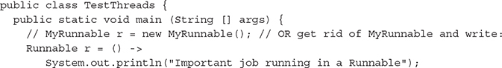

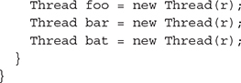

Giving the same target to multiple threads means that several threads of execution will be running the very same job (and that the same job will be done multiple times).



***The Thread class itself implements*Runnable*. (After all, it has a*run()*method that we were overriding.) This means that you could pass a*Thread*to another Thread’s constructor:***



***This is a bit silly, but it’s legal. In this case, you really just need a*Runnnable*, and creating a whole other*Thread*is overkill.***

Besides the no-arg constructor and the constructor that takes a Runnable (the target, i.e., the instance with the job to do), there are other overloaded constructors in class Thread. The constructors we care about are

   Thread()

   Thread(Runnable target)

   Thread(Runnable target, String name)

   Thread(String name)

You need to recognize all of them for the exam! A little later, we’ll discuss some of the other constructors in the preceding list.

So now you’ve made yourself a Thread instance, and it knows which run() method to call. *But nothing is happening yet.* At this point, all we’ve got is a plain-old Java object of type Thread. *It is not yet a thread of execution*. To get an actual thread—a new call stack—we still have to *start* the thread.

When a thread has been instantiated but not started (in other words, the start() method has not been invoked on the Thread instance), the thread is said to be in the *new* state. At this stage, the thread is not yet considered *alive.* Once the start() method is called, the thread is considered *alive* (even though the run() method may not have actually started executing yet). A thread is considered *dead* (no longer *alive*) after the run() method completes. The isAlive() method is the best way to determine if a thread has been started but has not yet completed its run() method. (Note: The getState() method is very useful for debugging, but you don’t have to know it for the exam.)

Starting a Thread

You’ve created a Thread object and it knows its target (either the passed-in Runnable or itself, if you extended class Thread). Now it’s time to get the whole thread thing happening—to launch a new call stack. It’s so simple; it hardly deserves its own subheading:



Prior to calling start() on a Thread instance, the thread (when we use lowercase t, we’re referring to the *thread of execution*rather than the Thread class) is said to be in the *new*state, as we said. The new state means you have a Thread *object* but you don’t yet have a *true thread*. So what happens after you call start()? The good stuff:

   A new thread of execution starts (with a new call stack).

   The thread moves from the *new*state to the *runnable*state.

   When the thread gets a chance to execute, its target run() method will run.

Be *sure*you remember the following: You start a *Thread,* not a *Runnable.* You call start() on a Thread instance, not on a Runnable instance. The following example demonstrates what we’ve covered so far—defining, instantiating, and starting a thread:

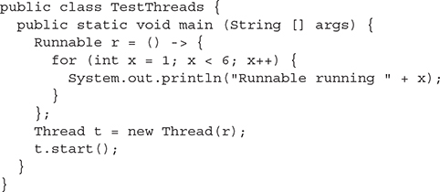

Running the preceding code prints out exactly what you’d expect:

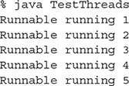

(If this isn’t what you expected, go back and reread everything in this objective.)



***There’s nothing special about the*run()*method as far as Java is concerned. Like*main()*, it just happens to be the name (and signature) of the method that the new thread knows to invoke. So if you see code that calls the*run()*method on a Runnable (or even on a*Thread*instance), that’s perfectly legal. But it doesn’t mean the*run()*method will run in a separate thread! Calling a*run()*method directly just means you’re invoking a method from whatever thread is currently executing, and the*run()*method goes onto the current call stack rather than at the beginning of a new call stack. The following code does not start a new thread of execution:***



So what happens if we start multiple threads? We’ll run a simple example in a moment, but first we need to know how to print out which thread is executing. We can use the getName() method of class Thread and have each Runnable print out the name of the thread executing that Runnable object’s run() method. The following example instantiates a thread and gives it a name, and then the name is printed out from the run() method:

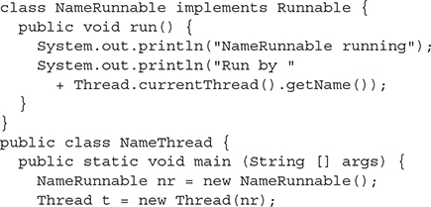

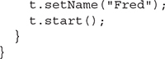

Running this code produces the following extra-special output:

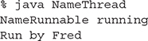

To get the name of a thread, you call—who would have guessed—getName() on the Thread instance. But the target Runnable instance doesn’t even*have* a reference to the Thread instance, so we first invoked the static Thread.currentThread() method, which returns a reference to the currently executing thread, and then we invoked getName() on that returned reference.

Even if you don’t explicitly name a thread, it still has a name. Let’s look at the previous code, commenting out the statement that sets the thread’s name:

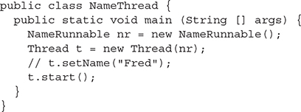

Running the preceding code now gives us

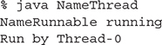

And since we’re getting the current thread by using the static Thread.*currentThread*() method, we can even get the name of the thread running our main code:

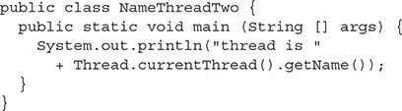

which prints out



That’s right, the main thread already has a name—*main*. (Once again, what are the odds?) [Figure 10-1](https://learning.oreilly.com/library/view/ocp-java-se/9781260117370/ch10.xhtml#ch10fig1) shows the process of starting a thread.

**FIGURE 10-1**

Starting a thread

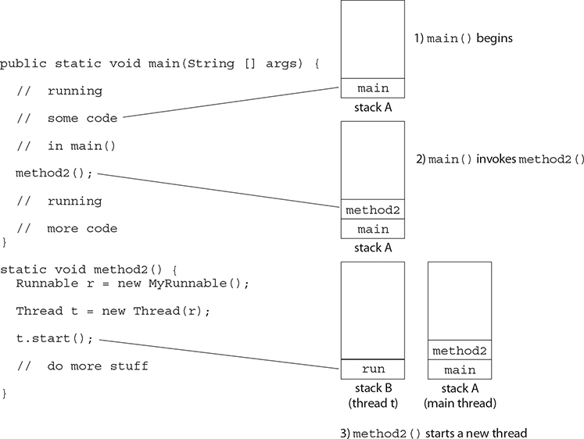

Starting and Running Multiple Threads

Enough playing around here; let’s actually get multiple threads going (more than two, that is). We already had two threads, because the main() method starts in a thread of its own, and then t.start() started a *second* thread. Now we’ll do more. The following code creates a single Runnable instance and three Thread instances. All three Thread instances get the same Runnable instance, and each thread is given a unique name. Finally, all three threads are started by invoking start() on the Thread instances. And just to hammer in one more time how you can use a lambda expression in place of an explicit Runnable class, we’ll eliminate NameRunnable, and replace it with a lambda.

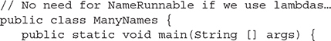

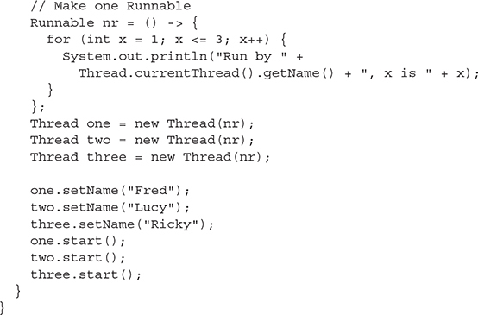

Running this code **might** produce the following:

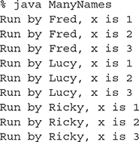

Well, at least that’s what it printed when we ran it—this time, on our machine. But the behavior you see here is not guaranteed. This is so crucial that you need to stop right now, take a deep breath, and repeat after me, “The behavior is not guaranteed.” You need to know, for your future as a Java programmer as well as for the exam, that there is nothing in the Java specification that says threads will start running in the order in which they were started (in other words, the order in which start() was invoked on each thread). And there is no guarantee that once a thread starts executing, it will keep executing until it’s done. Or that a loop will complete before another thread begins. No siree, Bob.

**Nothing is guaranteed in the preceding code except this:**

**Each thread will start, and each thread will run to completion.**

Within each thread, things will happen in a predictable order. But the actions of different threads can mix in unpredictable ways. If you run the program multiple times or on multiple machines, you may see different output. Even if you don’t see different output, you need to realize that the behavior you see is not guaranteed. Sometimes a little change in the way the program is run will cause a difference to emerge. Just for fun we bumped up the loop code so that each run() method ran the for loop 400 times rather than 3, and eventually we did start to see some wobbling:

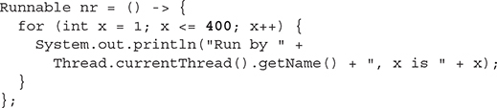

Running the preceding code, with each thread executing its run loop 400 times, started out fine but then became nonlinear. Here’s just a snippet from the command-line output of running that code. To make it easier to distinguish each thread, we put Fred’s output in italics and Lucy’s in bold and left Ricky’s alone:

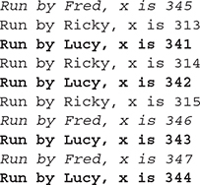

…it continues on…

Notice that there’s not really any clear pattern here. If we look at only the output from Fred, we see the numbers increasing one at a time, as expected:

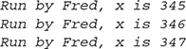

And similarly, if we look only at the output from Lucy or Ricky—each one individually is behaving in a nice, orderly manner. But together—chaos! In the previous fragment we see Fred, then Lucy, then Ricky (in the same order we originally started the threads), but then Lucy butts in when it was Fred’s turn. What nerve! And then Ricky and Lucy trade back and forth for a while until finally Fred gets another chance. They jump around like this for a while after this. Eventually (after the part shown earlier), Fred finishes, then Ricky, and finally Lucy finishes with a long sequence of output. So even though Ricky was started third, he actually completed second. And if we run it again, we’ll get a different result. Why? Because it’s up to the scheduler, and we don’t control the scheduler! Which brings up another key point to remember: Just because a series of threads are started in a particular order doesn’t mean they’ll run in that order. For any group of started threads, order is not guaranteed by the scheduler. And duration is not guaranteed. You don’t know, for example, if one thread will run to completion before the others have a chance to get in, or whether they’ll all take turns nicely, or whether they’ll do a combination of both. There is a way, however, to start a thread but tell it not to run until some other thread has finished. You can do this with the join() method, which we’ll look at a little later.

***A thread is done being a thread when its target*run()*method completes.***

When a thread completes its run() method, the thread ceases to be a thread of execution. The stack for that thread dissolves, and the thread is considered dead. (Technically, the API calls a dead thread “terminated,” but we’ll use “dead” in this chapter.) Not dead and gone, however—just dead. It’s still a Thread *object,* just not a *thread of execution.* So if you’ve got a reference to a Thread instance, then even when that Thread instance is no longer a thread of execution, you can still call methods on the Thread instance, just like any other Java object. What you can’t do, though, is call start() again.

***Once a thread has been started, it can never be started again.***

If you have a reference to a Thread and you call start(), it’s started. If you call start() a second time, it will cause an exception (an IllegalThreadStateException, which is a kind of RuntimeException, but you don’t need to worry about the exact type). This happens whether or not the run() method has completed from the first start() call. Only a new thread can be started, and then only once. A runnable thread or a dead thread cannot be restarted.

So far, we’ve seen three thread states: *new,* *runnable,*and *dead*. We’ll look at more thread states before we’re done with this chapter.



***In addition to using*setName()*and*getName*to identify threads, you might see*getId()*. The*getId()*method returns a positive, unique*long*number, and that number will be that thread’s only ID number for the thread’s entire life.***

The Thread Scheduler

The thread scheduler is the part of the JVM (although most JVMs map Java threads directly to native threads on the underlying OS) that decides which thread should run at any given moment and also takes threads *out* of the run state. Assuming a single processor machine, only one thread can actually *run* at a time. Only one stack can ever be executing at one time. And it’s the thread scheduler that decides *which* thread—of all that are eligible—will actually *run*. When we say *eligible,* we really mean *in the runnable state*.

Any thread in the *runnable* state can be chosen by the scheduler to be the one and only running thread. If a thread is not in a runnable state, then it cannot be chosen to be the *currently running*thread. And just so we’re clear about how little is guaranteed here:

***The order in which runnable threads are chosen to run is not guaranteed.***

Although *queue* behavior is typical, it isn’t guaranteed. Queue behavior means that when a thread has finished with its “turn,” it moves to the end of the line of the runnable pool and waits until it eventually gets to the front of the line, where it can be chosen again. In fact, we call it a runnable *pool,* rather than a runnable *queue,* to help reinforce the fact that threads aren’t all lined up in some guaranteed order.

Although we don’t *control* the thread scheduler (we can’t, for example, tell a specific thread to run), we can sometimes influence it. The following methods give us some tools for *influencing* the scheduler. Just don’t ever mistake influence for control.



***Expect to see exam questions that look for your understanding of what is and is not guaranteed! You must be able to look at thread code and determine whether the output is guaranteed to run in a particular way or is unpredictable.***

**Methods from the java.lang.Thread Class**  Some of the methods that can help us influence thread scheduling are as follows:

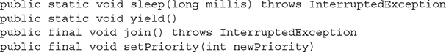

Note that both sleep() and join() have overloaded versions not shown here.

**Methods from the java.lang.Object Class**  Every class in Java inherits the following three thread-related methods:

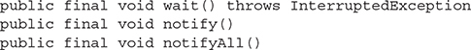

The wait() method has three overloaded versions (including the one listed here).

We’ll look at the behavior of each of these methods in this chapter. First, though, we’re going to look at the different states a thread can be in.

**THREAD STATES AND TRANSITIONS**

We’ve already seen three thread states—*new, runnable,* and*dead*—but wait! There’s more! The thread scheduler’s job is to move threads in and out of the *running* state. While the thread scheduler can move a thread from the running state back to runnable, other factors can cause a thread to move out of running, but *not* back to runnable. One of these is when the thread’s run()method completes, in which case, the thread moves from the running state directly to the dead state. Next, we’ll look at some of the other ways in which a thread can leave the running state and where the thread goes.

Thread States

A thread can be only in one of five states (see [Figure 10-2](https://learning.oreilly.com/library/view/ocp-java-se/9781260117370/ch10.xhtml#ch10fig2)):

**FIGURE 10-2**

Transitioning between thread states

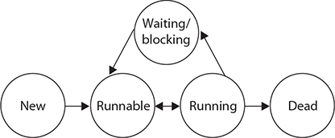

   **New**   This is the state the thread is in after the Thread instance has been created but the start() method has not been invoked on the thread. It is a live Thread object, but not yet a thread of execution. At this point, the thread is considered *not alive*.

   **Runnable**   This is the state a thread is in when it’s eligible to run but the scheduler has not selected it to be the running thread. A thread first enters the runnable state when the start() method is invoked, but a thread can also return to the runnable state after either running or coming back from a blocked, waiting, or sleeping state. When the thread is in the runnable state, it is considered *alive*.

   **Running**   This is it. The “big time.” Where the action is. This is the state a thread is in when the thread scheduler selects it from the runnable pool to be the currently executing process. A thread can transition out of a running state for several reasons, including because “the thread scheduler felt like it.” We’ll look at those other reasons shortly. Note that in [Figure 10-2](https://learning.oreilly.com/library/view/ocp-java-se/9781260117370/ch10.xhtml#ch10fig2), there are several ways to get to the runnable state, but only *one* way to get to the running state: the scheduler chooses a thread from the runnable pool.

   **Waiting/blocked/sleeping**   This is the state a thread is in when it’s not eligible to run. Okay, so this is really three states combined into one, but they all have one thing in common: the thread is still alive but is currently not eligible to run. In other words, it is not *runnable,* but it might *return* to a runnable state later if a particular event occurs. A thread may be *blocked* because it’s waiting for a resource (like I/O or an object’s lock), in which case the event that sends it back to runnable is the availability of the resource—for example, if data comes in through the input stream the thread code is reading from or if the object’s lock suddenly becomes available. A thread may be *sleeping* because the thread’s run code *tells* it to sleep for some period of time, in which case, the event that sends it back to runnable causes it to wake up because its sleep time has expired. Or the thread may be *waiting* because the thread’s run code *causes* it to wait. In that case, an event occurs, causing another thread to be sent a notifcation that it may no longer be necessary to wait. Then the waiting thread will become runnable again. The important point is that one thread does not *tell* another thread to block. Some methods may *look* like they tell another thread to block, but they don’t. If you have a reference t to another thread, you can write something like this:



But those are actually static methods of the Thread class—*they don’t affect the instance* t; instead, they are defined to always affect the thread that’s currently executing. (This is a good example of why it’s a bad idea to use an instance variable to access a static method—it’s misleading. There *is* a method, suspend(), in the Thread class that lets one thread tell another to suspend, but the suspend() method has been deprecated and won’t be on the exam [nor will its counterpart resume()].) There is also a stop() method, but it, too, has been deprecated and we won’t even go there. Both suspend() and stop() turned out to be very dangerous, so you shouldn’t use them, and again, because they’re deprecated, they won’t appear on the exam. Don’t study ‘em; don’t use ‘em. Note also that a thread in a blocked state is still considered *alive*.

   **Dead** A thread is considered dead when its run() method completes. It may still be a viable Thread object, but it is no longer a separate thread of execution. Once a thread is dead, it can never be brought back to life! (The whole “I see dead threads” thing.) If you invoke start() on a dead Thread instance, you’ll get an exception at runtime. And it probably doesn’t take a rocket scientist to tell you that if a thread is dead, it is no longer considered *alive*.

Preventing Thread Execution

A thread that’s been stopped usually means a thread that’s moved to the dead state. But you also need to be able to recognize when a thread will get kicked out of running but *not* be sent back to either runnable or dead.

For the purpose of the exam, we aren’t concerned with a thread blocking on I/O (say, waiting for something to arrive from an input stream from the server). We *are* concerned with the following:

   Sleeping

   Waiting

   Blocked because it needs an object’s lock

Sleeping

The sleep() method is a static method of class Thread. You use it in your code to “slow a thread down” by forcing it to go into a sleep mode before coming back to runnable (where it still has to beg to be the currently running thread). When a thread sleeps, it drifts off somewhere and doesn’t return to runnable until it wakes up.

So why would you want a thread to sleep? Well, you might think the thread is moving too quickly through its code. Or you might need to force your threads to take turns, since reasonable turn-taking isn’t guaranteed in the Java specification. Or imagine a thread that runs in a loop, downloading the latest stock prices and analyzing them. Downloading prices one after another would be a waste of time, as most would be quite similar—and even more important, it would be an incredible waste of precious bandwidth. The simplest way to solve this is to cause a thread to pause (sleep) for five minutes after each download.

You do this by invoking the static Thread.sleep() method, giving it a time in milliseconds as follows:

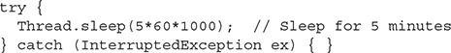

Notice that the sleep() method can throw a checked InterruptedException (you’ll usually know if that is a possibility because another thread has to explicitly do the interrupting), so you must acknowledge the exception with a handle or declare. Typically, you wrap calls to sleep() in a try/catch, as in the preceding code.

Let’s modify our Fred, Lucy, Ricky code by using sleep() to *try* to force the threads to alternate rather than letting one thread dominate for any period of time. Where do you think the call to the sleep() method should go?

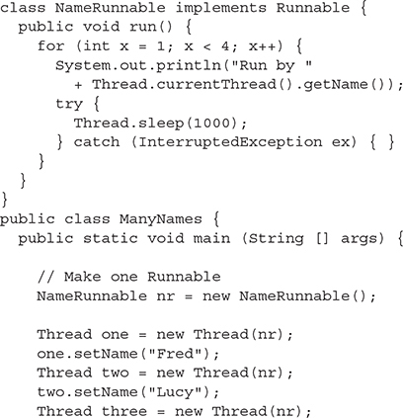

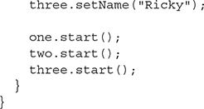

Running this code shows Fred, Lucy, and Ricky alternating nicely:

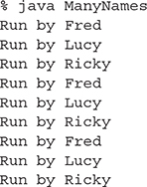

Just keep in mind that the behavior in the preceding output is still not guaranteed. You can’t be certain how long a thread will actually run *before* it gets put to sleep, so you can’t know with certainty that only one of the three threads will be in the runnable state when the running thread goes to sleep. In other words, if two threads are awake and in the runnable pool, you can’t know with certainty that the least recently used thread will be the one selected to run. *Still, using* *sleep()* *is the best way to help all threads get a chance to run!*Or at least to guarantee that one thread doesn’t get in and stay until it’s done. When a thread encounters a sleep call, it *must* go to sleep for *at least* the specified number of milliseconds (unless it is interrupted before its wake-up time, in which case, it immediately throws the InterruptedException).



***Just because a thread’s*sleep()*expires and it wakes up does not mean it will return to running! Remember, when a thread wakes up, it simply goes back to the runnable state. So the time specified in*sleep()*is the minimum duration in which the thread won’t run, but it is not the exact duration in which the thread won’t run. So you can’t, for example, rely on the*sleep()*method to give you a perfectly accurate timer. Although in many applications using*sleep()*as a timer is certainly good enough, you must know that a*sleep()*time is not a guarantee that the thread will start running again as soon as the time expires and the thread wakes.***

Remember that sleep() is a static method, so don’t be fooled into thinking that one thread can put another thread to sleep. You can put sleep() code anywhere since *all* code is being run by *some* thread. When the executing code (meaning the currently running thread’s code) hits a sleep() call, it puts the currently running thread to sleep.

**EXERCISE 10-1**

**Creating a Thread and Putting It to Sleep**

In this exercise, we will create a simple counting thread. It will count to 100, pausing one second between each number. Also, in keeping with the counting theme, it will output a string every ten numbers.

1.   Create a class and extend the Thread class. As an option, you can implement the Runnable interface.

2.   Override the run() method of Thread. This is where the code will go that will output the numbers.

3.   Create a for loop that will loop 100 times. Use the modulus operation to check whether there are any remainder numbers when divided by 10.

4.   Use the static method Thread.sleep() to pause. (Remember, the one-arg version of sleep() specifies the amount of time of sleep in milliseconds.)

Thread Priorities and yield( )

To understand yield(), you must understand the concept of thread *priorities.* Threads always run with some priority, usually represented as a number between 1 and 10 (although in some cases, the range is less than 10). The scheduler in most JVMs uses preemptive, priority-based scheduling (which implies some sort of time slicing). *This does not mean that all JVMs use time slicing.* The JVM specification does not require a VM to implement a time-slicing scheduler, where each thread is allocated a fair amount of time and then sent back to runnable to give another thread a chance. Although many JVMs do use time slicing, some may use a scheduler that lets one thread stay running until the thread completes its run() method.

In most JVMs, however, the scheduler does use thread priorities in one important way: If a thread enters the runnable state and it has a higher priority than any of the threads in the pool and a higher priority than the currently running thread, *the lower-priority running thread usually will be bumped back to runnable and the highest-priority thread will be chosen to run.* In other words, at any given time, the currently running thread usually will not have a priority that is lower than any of the threads in the pool. *In most cases, the running thread will be of equal or greater priority than the highest-priority threads in the pool.* This is as close to a guarantee about scheduling as you’ll get from the JVM specification, so you must never rely on thread priorities to guarantee the correct behavior of your program.



***Don’t rely on thread priorities when designing your multithreaded application. Because thread-scheduling priority behavior is not guaranteed, it’s better to avoid modifying thread priorities. Usually, default priority will be fine.***

What is also *not* guaranteed is the behavior when threads in the pool are of equal priority or when the currently running thread has the same priority as threads in the pool. All priorities being equal, a JVM implementation of the scheduler is free to do just about anything it likes. That means a scheduler might do one of the following (among other things):

   Pick a thread to run, and run it there until it blocks or completes.

   Time-slice the threads in the pool to give everyone an equal opportunity to run.

Setting a Thread’s Priority

A thread gets a default priority that is *the priority of the thread of execution that creates it.*For example, in the code

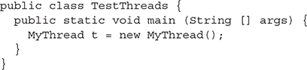

the thread referenced by t will have the same priority as the *main* thread because the main thread is executing the code that creates the MyThread instance.

You can also set a thread’s priority directly by calling the setPriority() method on a Thread instance, as follows:

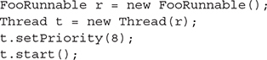

Priorities are set using a positive integer, usually between 1 and 10, and the JVM will never change a thread’s priority. However, values 1 through 10 are not guaranteed. Some JVMs might not recognize 10 distinct values. Such a JVM might merge values from 1 to 10 down to maybe values from 1 to 5, so if you have, say, 10 threads, each with a different priority, and the current application is running in a JVM that allocates a range of only 5 priorities, then 2 or more threads might be mapped to one priority.

Although *the default priority is 5*, the Thread class has the three following constants (static final variables) that define the range of thread priorities:

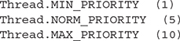

The yield( ) Method

So what does the static Thread.yield() have to do with all this? Not that much, in practice. What yield() is *supposed* to do is make the currently running thread head back to runnable to allow other threads of the same priority to get their turn. So the intention is to use yield() to promote graceful turn-taking among equal-priority threads. In reality, though, the yield() method isn’t guaranteed to do what it claims, and even if yield() does cause a thread to step out of running and back to runnable, *there’s no guarantee the yielding thread won’t just be chosen again over all the others!* So while yield() might—and often does—make a running thread give up its slot to another runnable thread of the same priority, there’s no guarantee.

A yield() won’t ever cause a thread to go to the waiting/sleeping/blocking state. At most, a yield() will cause a thread to go from running to runnable, but again, it might have no effect at all.

The join( ) Method

The non-static join() method of class Thread lets one thread “join onto the end” of another thread. If you have a thread B that can’t do its work until another thread A has completed *its* work, then you want thread B to “join” thread A. This means that thread B will not become runnable until A has finished (and entered the dead state).

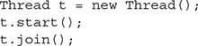

The preceding code takes the currently running thread (if this were in the main() method, then that would be the main thread) and *joins* it to the end of the thread referenced by t. This blocks the current thread from becoming runnable until after the thread referenced by t is no longer alive. In other words, the code t.join() means “Join me (the current thread) to the end of t, so that t must finish before I (the current thread) can run again.” You can also call one of the overloaded versions of join() that takes a timeout duration so that you’re saying, “Wait until thread t is done, but if it takes longer than 5,000 milliseconds, then stop waiting and become runnable anyway.” [Figure 10-3](https://learning.oreilly.com/library/view/ocp-java-se/9781260117370/ch10.xhtml#ch10fig3) shows the effect of the join() method.

**FIGURE 10-3**

The join() method

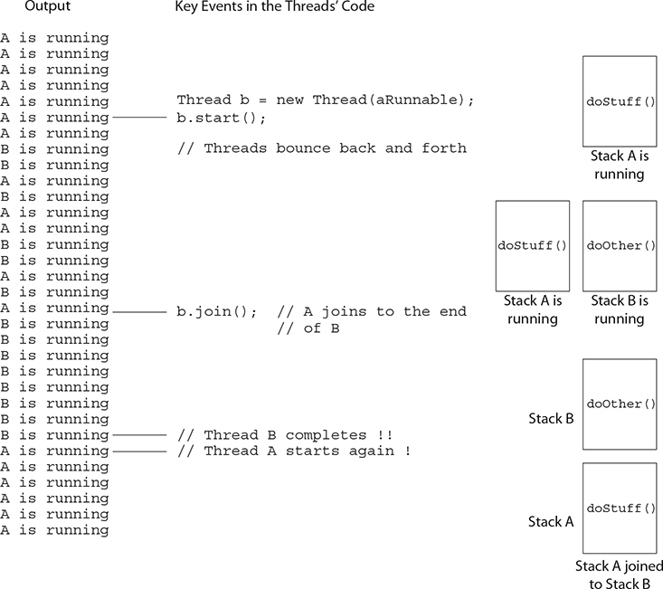

So far, we’ve looked at three ways a running thread could leave the running state:

   **A call to sleep()**   Guaranteed to cause the current thread to stop executing for at least the specified sleep duration (although it might be *interrupted* before its specified time).

   **A call to yield()**   Not guaranteed to do much of anything, although typically, it will cause the currently running thread to move back to runnable so that a thread of the same priority can have a chance.

   **A call to join()**   Guaranteed to cause the current thread to stop executing until the thread it joins with (in other words, the thread it calls join() on) completes, or if the thread it’s trying to join with is not alive, the current thread won’t need to back out.

Besides those three, we also have the following scenarios in which a thread might leave the running state:

   The thread’s run() method completes. Duh.

   A call to wait() on an object (we don’t call wait() on a *thread,* as we’ll see in a moment).

   A thread can’t acquire the *lock* on the object whose method code it’s attempting to run.

   The thread scheduler can decide to move the current thread from running to runnable in order to give another thread a chance to run. No reason is needed—the thread scheduler can trade threads in and out whenever it likes.

**CERTIFICATION OBJECTIVE**

**SYNCHRONIZING CODE, THREAD PROBLEMS (OCP OBJECTIVES 10.2 AND 10.3)**

*10.2   Identify potential threading problems among deadlock, starvation, livelock, and race conditions.*

*10.3   Use synchronized keyword and java.util.concurrent.atomic package to control the order of thread execution.*

Can you imagine the havoc that can occur when two different threads have access to a single instance of a class, and both threads invoke methods on that object…and those methods modify the state of the object? In other words, what might happen if *two* different threads call, say, a setter method on a *single* object? A scenario like that might corrupt an object’s state by changing its instance variable values in an inconsistent way, and if that object’s state is data shared by other parts of the program, well, it’s too scary to even visualize.

But just because we enjoy horror, let’s look at an example of what might happen. The following code demonstrates what happens when two different threads are accessing the same account data. Imagine that two people each have a checkbook for a single checking account (or two people each have ATM cards, but both cards are linked to only one account).

In this example, we have a class called Account that represents a bank account. To keep the code short, this account starts with a balance of 50 and can be used only for withdrawals. The withdrawal will be accepted even if there isn’t enough money in the account to cover it. The account simply reduces the balance by the amount you want to withdraw:

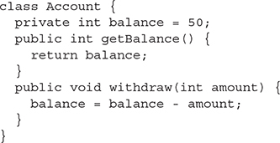

Now here’s where it starts to get fun. Imagine a couple, Fred and Lucy, who both have access to the account and want to make withdrawals. But they don’t want the account to ever be overdrawn, so just before one of them makes a withdrawal, he or she will first check the balance to be certain there’s enough to 670cover the withdrawal. Also, withdrawals are always limited to an amount of 10, so there must be at least 10 in the account balance in order to make a withdrawal. Sounds reasonable. But that’s a two-step process:

1.   Check the balance.

2.   If there’s enough in the account (in this example, at least 10), make the withdrawal.

What happens if something separates step 1 from step 2? For example, imagine what would happen if Lucy checks the balance and sees there’s just exactly enough in the account, 10. *But before she makes the withdrawal, Fred checks the balance and also sees that there’s enough for his withdrawal.* Since Lucy has verified the balance but not yet made her withdrawal, Fred is seeing “bad data.” He is seeing the account balance *before* Lucy actually debits the account, but at this point, that debit is certain to occur. Now both Lucy and Fred believe there’s enough to make their withdrawals. Now imagine that Lucy makes *her* withdrawal, so there isn’t enough in the account for Fred’s withdrawal, but he thinks there is because when he checked, there was enough! Yikes. In a minute, we’ll see the actual banking code, with Fred and Lucy, represented by two threads, each acting on the same Runnable, and that Runnable holds a reference to the one and only account instance—so, two threads, one account.

The logic in our code example is as follows:

1.   The Runnable object holds a reference to a single account.

2.   Two threads are started, representing Lucy and Fred, and each thread is given a reference to the same Runnable (which holds a reference to the actual account).

3.   The initial balance on the account is 50, and each withdrawal is exactly 10.

4.   In the run() method, we loop five times, and in each loop we

   Make a withdrawal (if there’s enough in the account).

   Print a statement *if the account is overdrawn* (which it should never be since we check the balance *before* making a withdrawal).

5.   The makeWithdrawal() method in the test class (representing the behavior of Fred or Lucy) will do the following:

   Check the balance to see if there’s enough for the withdrawal.

   If there is enough, print out the name of the one making the withdrawal.

   Go to sleep for 500 milliseconds—just long enough to give the other partner a chance to get in before you actually *make* the withdrawal.

   Upon waking up, complete the withdrawal and print that fact.

   If there wasn’t enough in the first place, print a statement showing who you are and the fact that there wasn’t enough.

So what we’re really trying to discover is if the following is possible: for one partner to check the account and see that there’s enough, but before making the actual withdrawal, the other partner checks the account and *also* sees that there’s enough. When the account balance gets to 10, if both partners check it before making the withdrawal, both will think it’s okay to withdraw, and the account will be overdrawn by 10!

Here’s the code:

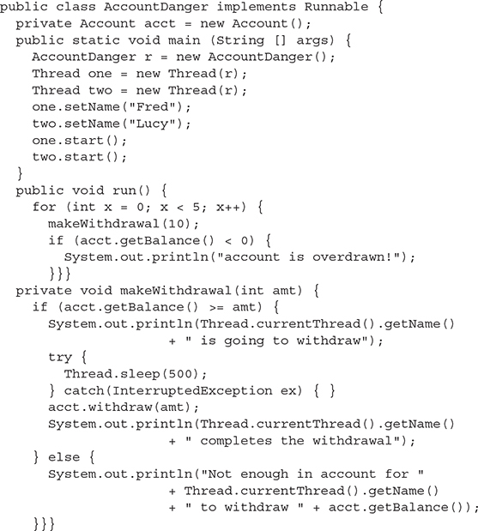

(Note: You might have to tweak this code a bit on your machine to the “account overdrawn” behavior. You might try much shorter sleep times; you might try adding a sleep to the run() method... In any case, experimenting will help you lock in the concepts.) So what happened? Is it possible that, say, Lucy checked the balance, fell asleep, Fred checked the balance, Lucy woke up and completed *her* withdrawal, then Fred completes *his* withdrawal, and in the end, they overdraw the account? Look at the (numbered) output:

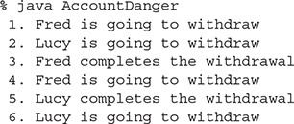

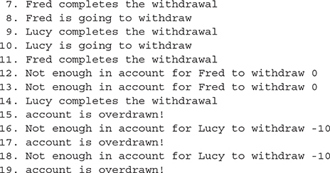

Although each time you run this code the output might be a little different, let’s walk through this particular example using the numbered lines of output. For the first four attempts, everything is fine. Fred checks the balance on line 1 and finds it’s okay. At line 2, Lucy checks the balance and finds it okay. At line 3, Fred makes his withdrawal. At this point, the balance Lucy checked for (and believes is still accurate) has actually changed since she last checked. And now Fred checks the balance *again,* before Lucy even completes her first withdrawal. By this point, even Fred is seeing a potentially inaccurate balance because we know Lucy is going to complete her withdrawal. It is possible, of course, that Fred will complete his before Lucy does, but that’s not what happens here.

On line 5, Lucy completes her withdrawal and then, before Fred completes his, Lucy does another check on the account on line 6. And so it continues until we get to line 8, where Fred checks the balance and sees that it’s 20. On line 9, Lucy completes a withdrawal that she had checked for earlier, and this takes the balance to 10. On line 10, Lucy checks again, sees that the balance is 10, so she knows she can do a withdrawal. *But she didn’t know that Fred, too, has already checked the balance on line 8 so he thinks it’s safe to do the withdrawal!*On line 11, Fred completes the withdrawal he approved on line 8. This takes the balance to 0. But Lucy still has a pending withdrawal that she got approval for on line 10! You know what’s coming.

On lines 12 and 13, Fred checks the balance and finds that there’s not enough in the account. But on line 14, Lucy completes her withdrawal and BOOM! The account is now overdrawn by 10—*something we thought we were preventing by doing a balance check prior to a withdrawal.*

[Figure 10-4](https://learning.oreilly.com/library/view/ocp-java-se/9781260117370/ch10.xhtml#ch10fig4) shows the timeline of what can happen when two threads concurrently access the same object.

**FIGURE 10-4**

Problems with concurrent access

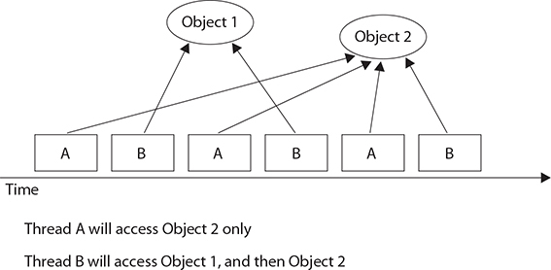

This problem is known as a “race condition,” where multiple threads can access the same resource (typically an object’s instance variables) and can produce corrupted data if one thread “races in” too quickly before an operation that should be “atomic” has completed.

Preventing the Account Overdraw

So what can be done? The solution is actually quite simple. We must guarantee that the two steps of the withdrawal—*checking* the balance and *making* the withdrawal—are never split apart. We need them to always be performed as one operation, even when the thread falls asleep in between step 1 and step 2! We call this an “atomic operation” (although the physics is a little outdated—in this case, “atomic” means “indivisible“) because the operation, regardless of the number of actual statements (or underlying bytecode instructions), is completed *before* any other thread code that acts on the same data.

You can’t guarantee that a single thread will stay running throughout the entire atomic operation. But you can guarantee that even if the thread running the atomic operation moves in and out of the running state, no other running thread will be able to act on the same data. In other words, if Lucy falls asleep after checking the balance, we can stop Fred from checking the balance until after Lucy wakes up and completes her withdrawal.

So how do you protect the data? You must do two things:

   Mark the variables private.

   Synchronize the code that modifies the variables.

Remember, you protect the variables in the normal way—using an access control modifier. It’s the method code that you must protect so only one thread at a time can be executing that code. You do this with the synchronized keyword.

We can solve all of Fred and Lucy’s problems by adding one word to the code. We mark the makeWithdrawal() method synchronized as follows:

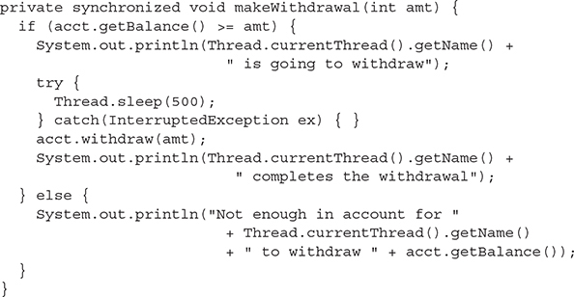

Now we’ve guaranteed that once a thread (Lucy or Fred) starts the withdrawal process by invoking makeWithdrawal(), the other thread cannot enter that method until the first one completes the process by exiting the method. The new output shows the benefit of synchronizing the makeWithdrawal() method:

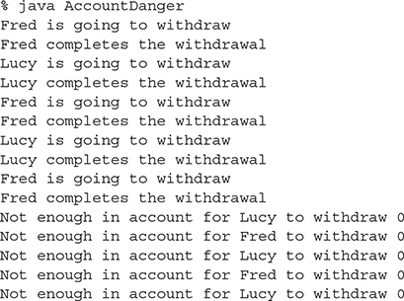

Notice that now both threads, Lucy and Fred, always check the account balance *and* complete the withdrawal before the other thread can check the balance.

Synchronization and Locks

How does synchronization work? With locks. Every object in Java has a built-in lock that only comes into play when the object has synchronized method code. When we enter a synchronized non-static method, we automatically acquire the lock associated with the current instance of the class whose code we’re executing (the this instance). Acquiring a lock for an object is also known as getting the lock, or locking the object, locking *on* the object, or synchronizing on the object. We may also use the term *monitor* to refer to the object whose lock we’re acquiring. Technically, the lock and the monitor are two different things, but most people talk about the two interchangeably, and we will too.

Since there is only one lock per object, if one thread has picked up the lock, no other thread can pick up the lock until the first thread releases (or returns) the lock. This means no other thread can enter the synchronized code (which means it can’t enter any synchronized method of that object) until the lock has been released. Typically, releasing a lock means the thread holding the lock (in other words, the thread currently in the synchronized method) exits the synchronized method. At that point, the lock is free until some other thread enters a synchronized method on that object. Remember the following key points about locking and synchronization:

   Only methods (or blocks) can be synchronized, not variables or classes.

   Each object has just one lock.

   Not all methods in a class need to be synchronized. A class can have both synchronized and non-synchronized methods.

   If two threads are about to execute a synchronized method in a class and both threads are using the same instance of the class to invoke the method, only one thread at a time will be able to execute the method. The other thread will need to wait until the first one finishes its method call. In other words, once a thread acquires the lock on an object, no other thread can enter any of the synchronized methods in that class (for that object).

   If a class has both synchronized and non-synchronized methods, multiple threads can still access the class’s non-synchronized methods! If you have methods that don’t access the data you’re trying to protect, then you don’t need to synchronize them. Synchronization can cause a hit in some cases (or even deadlock if used incorrectly), so you should be careful not to overuse it.

   If a thread goes to sleep, it holds any locks it has—it doesn’t release them.

   A thread can acquire more than one lock. For example, a thread can enter a synchronized method, thus acquiring a lock, and then immediately invoke a synchronized method on a different object, thus acquiring that lock as well. As the stack unwinds, locks are released again. Also, if a thread acquires a lock and then attempts to call a synchronized method on that same object, no problem. The JVM knows that this thread already has the lock for this object, so the thread is free to call other synchronized methods on the same object, using the lock the thread already has.

   You can synchronize a block of code rather than a method.

Because synchronization does hurt concurrency, you don’t want to synchronize any more code than is necessary to protect your data. So if the scope of a method is more than needed, you can reduce the scope of the synchronized part to something less than a full method—to just a block. We call this, strangely, a *synchronized block,* and it looks like this:

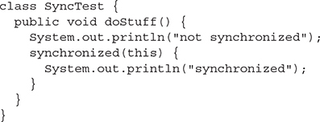

When a thread is executing code from within a synchronized block, including any method code invoked from that synchronized block, the code is said to be executing in a synchronized context. The real question is, synchronized on what? Or, synchronized on which object’s lock?

When you synchronize a method, the object used to invoke the method is the object whose lock must be acquired. But when you synchronize a block of code, you specify which object’s lock you want to use as the lock, so you could, for 677example, use some third-party object as the lock for this piece of code. That gives you the ability to have more than one lock for code synchronization within a single object.

Or you can synchronize on the current instance (this) as in the previous code. Since that’s the same instance that synchronized methods lock on, it means you could always replace a synchronized method with a non-synchronized method containing a synchronized block. In other words, this:

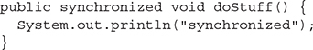

is equivalent to this:

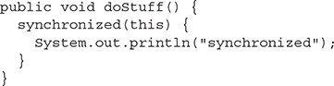

These methods both have the exact same effect—in practical terms. The compiled bytecodes may not be exactly the same for the two methods, but they *could* be—and any differences are not really important. The first form is shorter and more familiar to most people, but the second can be more flexible.

Can Static Methods Be Synchronized?

static methods can be synchronized. There is only one copy of the static data you’re trying to protect, so you only need one lock per class to synchronize static methods—a lock for the whole class. There is such a lock; every class loaded in Java has a corresponding instance of java.lang.Class representing that class. It’s that java.lang.Class instance whose lock is used to protect any synchronized static methods of the class. There’s nothing special you have to do to synchronize a static method:

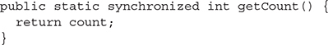

Again, this could be replaced with code that uses a synchronized block. If the method is defined in a class called MyClass, the equivalent code is as follows:

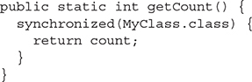

Wait—what’s that MyClass.class thing? That’s called a *class literal.* It’s a special feature in the Java language that tells the compiler (who tells the JVM): Go and find me the instance of Class that represents the class called MyClass. You can also do this with the following code:

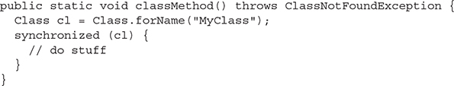

However, that’s longer, ickier, and most importantly, *not on the OCP exam*. But it’s quick and easy to use a class literal—just write the name of the class and add .class at the end. No quotation marks needed. Now you’ve got an expression for the Class object you need to synchronize on.

**EXERCISE 10-2**

**Synchronizing a Block of Code**

In this exercise, we will attempt to synchronize a block of code. Within that block of code, we will get the lock on an object so that other threads cannot modify it while the block of code is executing. We will be creating three threads that will all attempt to manipulate the same object. Each thread will output a single letter 100 times and then increment that letter by one. The object we will be using is StringBuffer.

We could synchronize on a String object, but strings cannot be modified once they are created, so we would not be able to increment the letter without generating a new String object. The final output should have 100 *A*s, 100 *B*s, and 100 *C*s, all in unbroken lines.

1.   Create a class and extend the Thread class.

2.   Override the run() method of Thread. This is where the synchronized block of code will go.

3.   For our three thread objects to share the same object, we will need to create a constructor that accepts a StringBuffer object in the argument.

4.   The synchronized block of code will obtain a lock on the StringBuffer object from step 3.

5.   Within the block, output the StringBuffer 100 times and then increment the letter in the StringBuffer.

6.   Finally, in the main() method, create a single StringBuffer object using the letter *A,* then create three instances of our class and start all three of them.

What Happens If a Thread Can’t Get the Lock?

If a thread tries to enter a synchronized method and the lock is already taken, the thread is said to be blocked on the object’s lock. Essentially, the thread goes into a kind of pool for that particular object and has to sit there until the lock is released and the thread can again become runnable/running. Just because a lock is released doesn’t mean any particular thread will get it. There might be three threads waiting for a single lock, for example, and there’s no guarantee that the thread that has waited the longest will get the lock first.

When thinking about blocking, it’s important to pay attention to which objects are being used for locking:

   Threads calling non-static synchronized methods in the same class will only block each other if they’re invoked using the same instance. That’s because they each lock on this instance, and if they’re called using two different instances, they get two locks, which do not interfere with each other.

   Threads calling static synchronized methods in the same class will always block each other—they all lock on the same Class instance.

   A static synchronized method and a non-static synchronized method will not block each other, ever. The static method locks on a Class instance, while the non-static method locks on the this instance—these actions do not interfere with each other at all.

   For synchronized blocks, you have to look at exactly what object has been used for locking. (What’s inside the parentheses after the word synchronized?) Threads that synchronize on the same object will block each other. Threads that synchronize on different objects will not.

[Table 10-1](https://learning.oreilly.com/library/view/ocp-java-se/9781260117370/ch10.xhtml#ch10tab1) lists the thread-related methods and whether the thread gives up its lock as a result of the call.

So When Do I Need to Synchronize?

**TABLE 10-1**

Methods and Lock Status

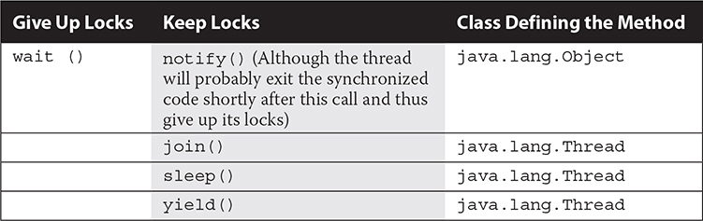

Synchronization can get pretty complicated, and you may be wondering why you would want to do this at all if you can help it. But remember the earlier “race conditions” example with Lucy and Fred making withdrawals from their account. When we use threads, we usually need to use some synchronization somewhere to make sure our methods don’t interrupt each other at the wrong time and mess up our data. Generally, any time more than one thread is accessing mutable (changeable) data, you synchronize to protect that data to make sure two threads aren’t changing it at the same time (or that one isn’t changing it at the same time the other is reading it, which is also confusing). You don’t need to worry about local variables—each thread gets its own copy of a local variable. Two threads executing the same method at the same time will use different copies of the local variables, and they won’t bother each other. However, you do need to worry about static and non-static fields if they contain data that can be changed.

For changeable data in a non-static field, you usually use a non-static method to access it. By synchronizing that method, you will ensure that any threads trying to run that method *using the same instance* will be prevented from simultaneous access. But a thread working with a *different* instance will not be affected because it’s acquiring a lock on the other instance. That’s what we want—threads working with the same data need to go one at a time, but threads working with different data can just ignore each other and run whenever they want to; it doesn’t matter.

For changeable data in a static field, you usually use a static method to access it. And again, by synchronizing the method, you ensure that any two threads trying to access the data will be prevented from simultaneous access, because both threads will have to acquire locks on the Class object for the class the static method’s defined in. Again, that’s what we want.

However—what if you have a non-static method that accesses a static field? Or a static method that accesses a non-static field (using an instance)? In these cases, things start to get messy quickly, and there’s a very good chance that things will not work the way you want. If you’ve got a static method accessing a non-static field and you synchronize the method, you acquire a lock on the Class object. But what if there’s another method that also accesses the non-static field, this time using a non-static method? It probably synchronizes on the current instance (this) instead. Remember that a static synchronized method and a non-static synchronized method will not block each other—they can run at the same time. Similarly, if you access a static field using a non-static method, two threads might invoke that method using two different this instances. Which means they won’t block each other because they use different locks. Which means two threads are simultaneously accessing the same static field—exactly the sort of thing we’re trying to prevent.

It gets very confusing trying to imagine all the weird things that can happen here. To keep things simple, in order to make a class thread-safe, methods that access changeable fields need to be synchronized.

Access to static fields should be done using static synchronized methods. Access to non-static fields should be done using non-static synchronized methods, for example:

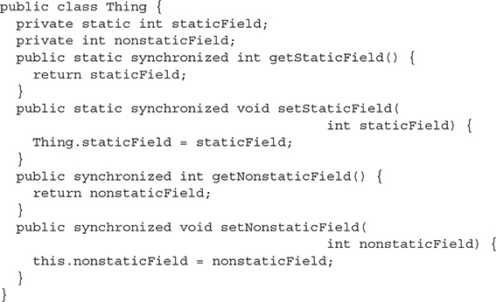

What if you need to access both static and non-static fields in a method? Well, there are ways to do that, but it’s beyond what you need for the exam. You will live a longer, happier life if you JUST DON’T DO IT. Really. Would we lie?

Thread-Safe Classes

When a class has been carefully synchronized to protect its data (using the rules just given or using more complicated alternatives), we say the class is “thread-safe.” Many classes in the Java APIs already use synchronization internally in order to make the class “thread-safe.” For example, StringBuffer and StringBuilder are nearly identical classes, except that all the methods in StringBuffer are synchronized when necessary, whereas those in StringBuilder are not. Generally, this makes StringBuffer safe to use in a multithreaded environment, whereas StringBuilder is not. (In return, StringBuilder is a little bit faster because it doesn’t bother synchronizing.) However, even when a class is “thread-safe,” it is often dangerous to rely on these classes to provide the thread protection you need. (C’mon, the repeated quotes used around “thread-safe” had to be a clue, right?) You still need to think carefully about how you use these classes. As an example, consider the following class:

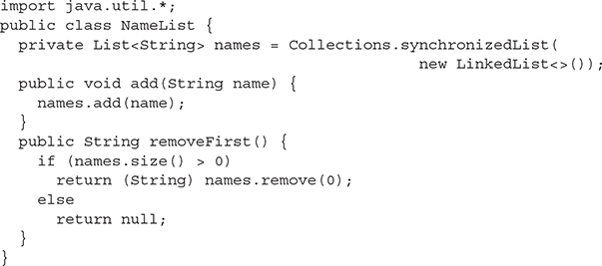

The method Collections.synchronizedList() returns a List whose methods are all synchronized and “thread-safe” according to the documentation (like a Vector—but since this is the 21st century, we’re not going to use a Vector here). The question is, can the NameList class be used safely from multiple threads? It’s tempting to think that yes, because the data in names is in a synchronized collection, the NameList class is “safe” too. However, that’s not the case—the removeFirst() may sometimes throw an IndexOutOfBoundsException. What’s the problem? Doesn’t it correctly check the size() of names before removing anything to make sure there’s something there? How could this code fail? Let’s try to use NameList like this:

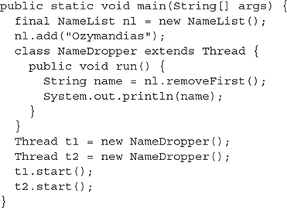

What might happen here is that one of the threads will remove the one name and print it, and then the other will try to remove a name and get null. If we think just about the calls to names.size() and names.remove(0), they occur in this order:

Thread t1 executes names.size(), which returns 1.  
Thread t1 executes names.remove(0), which returns Ozymandias.  
Thread t2 executes names.size(), which returns 0.  
Thread t2 does not call remove(0).

The output here is



However, if we run the program again, something different might happen:

Thread t1 executes names.size(), which returns 1.  
Thread t2 executes names.size(), which returns 1.  
Thread t1 executes names.remove(0), which returns Ozymandias.  
Thread t2 executes names.remove(0), which throws an exception because the list is now empty.

The thing to realize here is that in a “thread-safe” class like the one returned by synchronizedList(), each *individual* method is synchronized. So names.size() is synchronized, and names.remove(0) is synchronized. But nothing prevents another thread from doing something else to the list *in between* those two calls. And that’s where problems can happen.

There’s a solution here: Don’t rely on Collections.synchronizedList(). Instead, synchronize the code yourself:

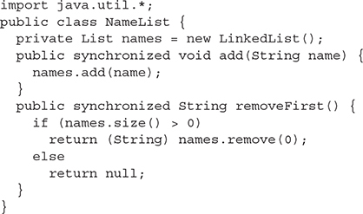

Now the entire removeFirst() method is synchronized, and once one thread starts it and calls names.size(), there’s no way the other thread can cut in and steal the last name. The other thread will just have to wait until the first thread completes the removeFirst() method.

The moral here is that just because a class is described as “thread-safe” doesn’t mean it is *always* thread-safe. If individual methods are synchronized, that may not be enough—you may be better off putting in synchronization at a higher level (i.e., put it in the block or method that *calls* the other methods). Once you do that, the original synchronization (in this case, the synchronization inside the object returned by Collections.synchronizedList()) may well become redundant.

Thread Deadlock

Perhaps the scariest thing that can happen to a Java program is deadlock. Deadlock occurs when two threads are blocked, with each waiting for the other’s lock. Neither can run until the other gives up its lock, so they’ll sit there forever.

This can happen, for example, when thread A hits synchronized code, acquires a lock B, and then enters another method (still within the synchronized code it has the lock on) that’s also synchronized. But thread A can’t get the lock to enter this synchronized code—block C—because another thread D has the lock already. So thread A goes off to the waiting-for-the-C-lock pool, hoping that thread D will hurry up and release the lock (by completing the synchronized method). But thread A will wait a very long time indeed, because while thread D picked up lock C, it then entered a method synchronized on lock B. Obviously, thread D can’t get the lock B because thread A has it. And thread A won’t release it until thread D releases lock C. But thread D won’t release lock C until after it can get lock B and continue. And there they sit. The following example demonstrates deadlock:

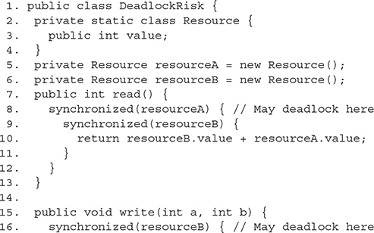

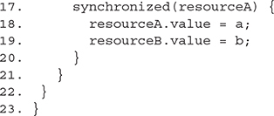

Assume that read() is started by one thread and write() is started by another. If there are two different threads that may read and write independently, there is a risk of deadlock at line 8 or 16. The reader thread will have resourceA, the writer thread will have resourceB, and both will get stuck waiting for the other.

Code like this almost never results in deadlock because the CPU has to switch from the reader thread to the writer thread at a particular point in the code, and the chances of deadlock occurring are quite small. The application may work fine 99.9 percent of the time.

The preceding simple example is easy to fix; just swap the order of locking for either the reader or the writer at lines 16 and 17 (or lines 8 and 9). More complex deadlock situations can take a long time to figure out.

Regardless of how little chance there is for your code to deadlock, the bottom line is that if you deadlock, you’re dead. There are design approaches that can help avoid deadlock, including strategies for always acquiring locks in a predetermined order.

But that’s for you to study and is beyond the scope of this book. We’re just trying to get you through the exam. If you learn everything in this chapter, though, you’ll still know more about threads than most experienced Java programmers.

Thread Livelock

Livelock is almost as scary to a Java program as deadlock. Livelock is similar to deadlock, except that the threads aren’t officially dead; they’re just too busy to make progress.

Imagine you’ve got a program with two threads and two locks. Each thread must get both locks in order to proceed with the work it needs to do. Thread one successfully acquires lock 1 and then tries to get lock 1 and fails, because thread 2 has already gotten lock 2. Thread 1 then unlocks lock 1, giving thread 2 a chance to get it, waits a little while and then tries to get lock 1 and lock 2 again.

At the same time, thread 2 gets lock 2 and then attempts to get lock 1. Well, thread 1 already has lock 1, so lock 2 does a similar thing: it unlocks lock 2, giving thread 1 a chance to get it, waits a little while, and then tries to get lock 2 and lock 1 again.

Livelock occurs if thread 1 tries to get lock 2 when thread 2 has lock 2, and thread 2 tries to get lock 1 when thread 1 has lock 1; they both free up the locks they have, so then thread 1 and thread 2 are both waiting on the other thread to get the lock each wants and then both get their locks again and go back to trying to get the lock the other thread has…over and over and over again.

In this situation, the threads are not completely deadlocked, but they are making no progress. This is an extremely tricky problem to detect! The timing has to be just right, so you might find your code runs perfectly fine 99 percent of the time and livelocks 1 percent of the time. Fortunately, Java makes livelock hard to do; with ReentrantLock (more on this in [Chapter 11](https://learning.oreilly.com/library/view/ocp-java-se/9781260117370/ch11.xhtml#ch11) where we talk about concurrency) and careful ordering of how your threads attempt to access locks, you will be unlikely to encounter this problem.

Thread Starvation

Starvation is related to livelock. Starvation is when a thread is unable to make progress because it cannot get access to a shared resource that other threads are hogging. This could happen when another thread gets access to a synchronized resource and then goes into an infinite loop or takes a really long time to use the resource. It could also happen if one thread has higher priority than another thread so the first thread always gets a resource when both threads attempt to access that resource at the same time.

If you are not fiddling with thread priorities—and you are careful about how long a thread can keep access to a resource before yielding or timing out—then you should be able to avoid starvation. Good thread schedulers will help prevent starvation by allocating time fairly between threads behind the scenes.

Race Conditions

A race condition is another scenario that can crop up when working with multiple threads. To understand what a race condition is and how it can occur, let’s revisit the singleton pattern from [Chapter 2](https://learning.oreilly.com/library/view/ocp-java-se/9781260117370/ch2.xhtml#ch2).

In that chapter, we mentioned that our singleton implementation is not thread-safe without some precautions. Let’s take a look at how we might use the Show singleton from that chapter in a multithreaded program to see where things can go wrong. In the process, we’ll create a race condition.

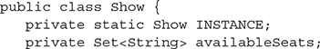

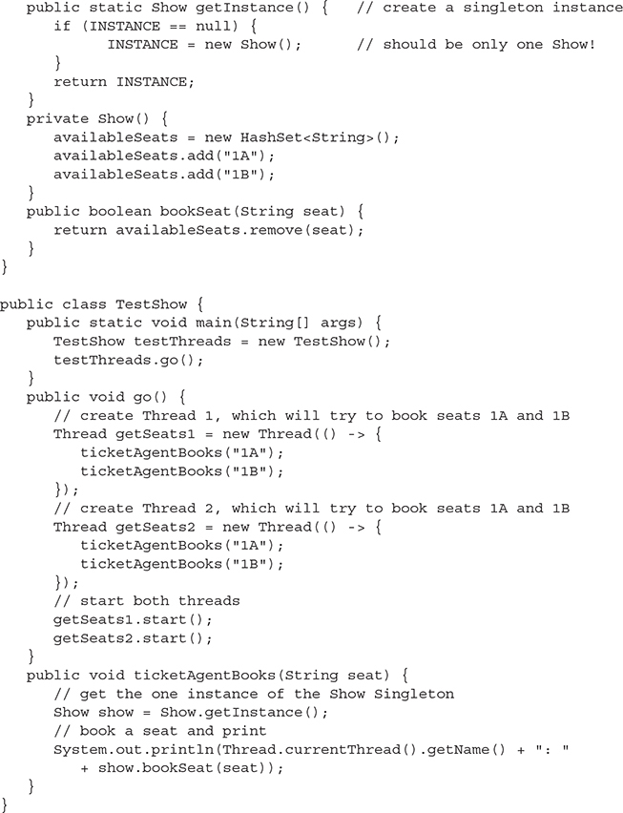

When we run the code, here’s what we get:

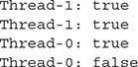

Uh oh. It looks like we’ve sold seat 1A twice! That means two people will show up for the concert and expect to get the same seat.

This issue is caused by a *race condition*. A race condition is when two or more threads try to access and change a shared resource at the same time, and the result is dependent on the order in which the code is executed by the threads.

Let’s step through the code and see how this happens. In TestShow, in go() (which we call from main()), we create two threads. Each thread tries to book seats 1A and 1B by calling ticketAgentBooks(). We start both threads.

Imagine a scenario where thread one calls ticketAgentBooks() with the argument “1A”. Thread one calls Show.getInstance(). It executes the code:



and determines the value in INSTANCE is, indeed, null, and so is just about to execute the next line of code when BOOM! The thread is descheduled, and thread two begins executing.

Now, thread two calls ticketAgentBooks() with the argument “1A”. Thread two calls Show.getInstance(). It executes the code:



and determines the value of INSTANCE is, indeed, null, and so executes the next line of code:



Thread two then gets descheduled and thread one begins executing again. It then executes the line:



Now we have two instances of Show. So when thread one then uses its instance of Show to book a seat by calling show.bookSeat() on “1A”, it succeeds. Similarly, when thread two uses its instance of Show to book a seat, it too succeeds. We had two threads racing to get what should have been one shared resource, and because of timing, we end up with two instances of a resource and a failure in our program logic.

We can fix this race condition by making the getInstance() method synchronized and the INSTANCE variable volatile:

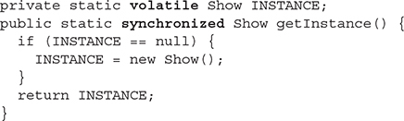

The volatile keyword makes sure that the variable INSTANCE is atomic; that is, a write to the variable happens all at once. Nothing can interrupt this process: it either happens completely, or it doesn’t happen at all. So in getInstance(), where we create a new instance of Show() and assign it to INSTANCE, that entire operation must complete before the thread can be interrupted.

The *synchronized* keyword makes sure only one thread at a time can access the getInstance() method. That ensures we won’t get a race condition: in other words, we can’t check the value of INSTANCE in one thread, then stop, and do the same in another thread.

You can run this code, but you might find it still doesn’t work! Why?

Take a look at the method bookSeat() in Show. When we book a seat by calling this method from the ticketAgentBooks() method, we are changing another shared resource, the availableSeats Set. However, the Set is not thread-safe! That means a thread could be interrupted in the middle of removing seat “1A” from the Set, and another thread could come along and access the Set. If the operations to remove the seat from the availableSeats Set get interleaved, we can still end up in a situation where two threads can book the same seat.

To solve this problem, we must synchronize the bookSeat() method, too:

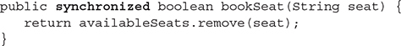

Now when we run the code, we should find that each seat can be booked by only one thread:

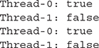

Notice that this does not mean that a thread will get both seats. Right? A thread can still be interrupted in between the two seat bookings:

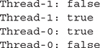

If you want to make sure you sell both seats to the same thread, you have to do even more work. But that’s enough for now (and enough about race conditions for the exam).

In a multithreaded environment, we need to make sure our code is designed so it’s not dependent on the ordering of the threads. In situations where our code is dependent on ordering or dependent on certain operations not being interrupted, we can get race conditions. As you’ve seen, there are ways to fix race conditions, but like deadlock, livelock, and starvation, they can be tricky to detect.

You’ve seen an example where a race condition led to two threads both getting seat “1A”. There are also race conditions in which neither thread gets seat “1A”. It’s far better for neither thread to end up with a seat than for two threads to end up with the same seat (while the venue operator might be unhappy having an empty, unsold seat, it’s worse to have customers fighting over seats!). However, by fixing the race conditions in this code, we’ve enabled the seats to be sold to the threads properly, so only one thread gets any given seat.

**CERTIFICATION OBJECTIVE**

**THREAD INTERACTION (OCP OBJECTIVES 10.2 AND 10.3)**

*10.2   Identify potential threading problems among deadlock, starvation, livelock, and race conditions.*

*10.3   Use synchronized keyword and java.util.concurrent.atomic package to control the order of thread execution.*

The last thing we need to look at is how threads can interact with one another to communicate about—among other things—their locking status. The Object class has three methods, wait(), notify(), and notifyAll(), that help threads communicate the status of an event that the threads care about. For example, if one thread is a mail-delivery thread and one thread is a mail-processor thread, the mail-processor thread has to keep checking to see if there’s any mail to process. Using the wait and notify mechanism, the mail-processor thread could check for mail, and if it doesn’t find any, it can say, “Hey, I’m not going to waste my time checking for mail every two seconds. I’m going to go hang out, and when the mail deliverer puts something in the mailbox, have him notify me so I can go back to runnable and do some work.” In other words, using wait() and notify() lets one thread put itself into a “waiting room” until some *other* thread notifies it that there’s a reason to come back out.

One key point to remember (and keep in mind for the exam) about wait()/notify() is this:

*wait(), notify(), and notifyAll() must be called from within a synchronized context! A thread can’t invoke a wait() or notify() method on an object unless it owns that object’s lock.*

Here we’ll present an example of two threads that depend on each other to proceed with their execution, and we’ll show how to use wait() and notify() to make them interact safely at the proper moment.

Think of a computer-controlled machine that cuts pieces of fabric into different shapes and an application that allows users to specify the shape to cut. The current version of the application has one thread, which loops, first asking the user for instructions, and then directs the hardware to cut the requested shape:

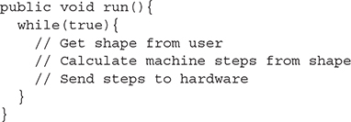

This design is not optimal because the user can’t do anything while the machine is busy and while there are other shapes to define. We need to improve the situation.

A simple solution is to separate the processes into two different threads, one of them interacting with the user and another managing the hardware. The user thread sends the instructions to the hardware thread and then goes back to interacting with the user immediately. The hardware thread receives the instructions from the user thread and starts directing the machine immediately. Both threads use a common object to communicate, which holds the current design being processed.

The following pseudocode shows this design:

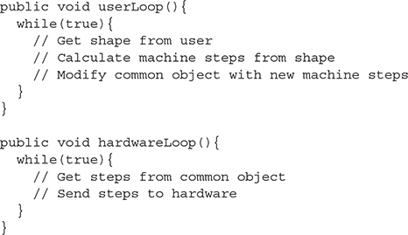

The problem now is to get the hardware thread to process the machine steps as soon as they are available. Also, the user thread should not modify them until they have all been sent to the hardware. The solution is to use wait() and notify() and also to synchronize some of the code.

The methods wait() and notify(), remember, are instance methods of Object. In the same way that every object has a lock, every object can have a list of threads that are waiting for a signal (a notification) from the object. A thread gets on this waiting list by executing the wait() method of the target object. From that moment, it doesn’t execute any further instructions until the notify() method of the target object is called. If many threads are waiting on the same object, only one will be chosen (in no guaranteed order) to proceed with its execution. If there are no threads waiting, then no particular action is taken. Let’s take a look at some real code that shows one object waiting for another object to notify it (take note, it is somewhat complex):

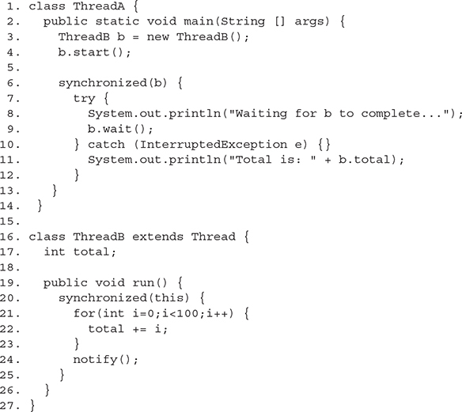

This program contains two objects with threads: ThreadA contains the main thread, and ThreadB has a thread that calculates the sum of all numbers from 0 through 99. As soon as line 4 calls the start() method, ThreadA will continue with the next line of code in its own class, which means it could get to line 11 before ThreadB has finished the calculation. To prevent this, we use the wait() method in line 9.

Notice in line 6 the code synchronizes itself with the object b—this is because in order to call wait() on the object, ThreadA must own a lock on b. For a thread to call wait() or notify(), the thread has to be the owner of the lock for that object. When the thread waits, it temporarily releases the lock for other threads to use, but it will need it again to continue execution. It’s common to find code like this:

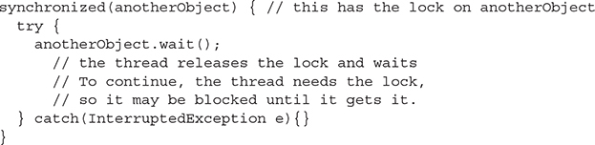

The preceding code waits until notify() is called on anotherObject.



This code notifies a single thread currently waiting on the this object. The lock can be acquired much earlier in the code, such as in the calling method. Note that if the thread calling wait() does not own the lock, it will throw an IllegalMonitorStateException. This exception is not a checked exception, so you don’t have to *catch* it explicitly. You should always be clear whether a thread has the lock of an object in any given block of code.

Notice in lines 7–10 there is a try/catch block around the wait() method. A waiting thread can be interrupted in the same way as a sleeping thread, so you have to take care of the exception:

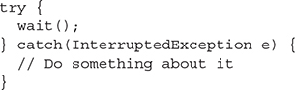

In the next example, the way to use these methods is to have the hardware thread wait on the shape to be available and the user thread to notify after it has written the steps. The machine steps may comprise global steps, such as moving the required fabric to the cutting area, and a number of substeps, such as the direction and length of a cut. As an example, they could be

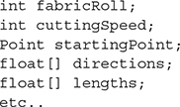

It is important that the user thread does not modify the machine steps while the hardware thread is using them, so this reading and writing should be synchronized.

The resulting code would look like this:

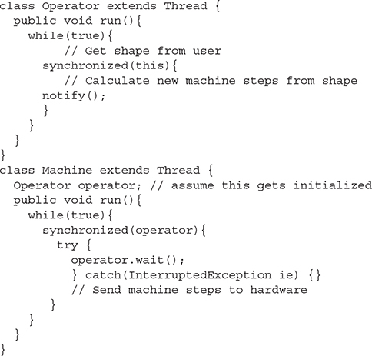

The machine thread, once started, will immediately go into the waiting state and will wait patiently until the operator sends the first notification. At that point, it is the operator thread that owns the lock for the object, so the hardware thread gets stuck for a while. It’s only after the operator thread abandons the synchronized block that the hardware thread can really start processing the machine steps.

While one shape is being processed by the hardware, the user may interact with the system and specify another shape to be cut. When the user is finished with the shape and it is time to cut it, the operator thread attempts to enter the synchronized block, maybe blocking until the machine thread has finished with the previous machine steps. When the machine thread has finished, it repeats the loop, going again to the waiting state (and therefore releasing the lock). Only then can the operator thread enter the synchronized block and overwrite the machine steps with the new ones.

Having two threads is definitely an improvement over having one, although in this implementation, there is still a possibility of making the user wait. A further improvement would be to have many shapes in a queue, thereby reducing the possibility of requiring the user to wait for the hardware.

There is also a second form of wait() that accepts a number of milliseconds as a maximum time to wait. If the thread is not interrupted, it will continue normally whenever it is notified or the specified timeout has elapsed. This normal continuation consists of getting out of the waiting state, but to continue execution, it will have to get the lock for the object:

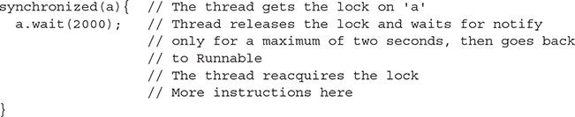



***When the*wait()*method is invoked on an object, the thread executing that code gives up its lock on the object immediately. However, when*notify()*is called, that doesn’t mean the thread gives up its lock at that moment. If the thread is still completing synchronized code, the lock is not released until the thread moves out of synchronized code. So just because*notify()*is called, this doesn’t mean the lock becomes available at that moment.***

Using notifyAll( ) When Many Threads May Be Waiting

In most scenarios, it’s preferable to notify *all* of the threads that are waiting on a particular object. If so, you can use notifyAll() on the object to let all the threads rush out of the waiting area and back to runnable. This is especially important if you have several threads waiting on one object, but for different reasons, and you want to be sure that the *right* thread (along with all of the others) is notified.



All of the threads will be notified and start competing to get the lock. As the lock is used and released by each thread, all of them will get into action without a need for further notification.

As we said earlier, an object can have many threads waiting on it, and using notify() will affect only one of them. Which one, exactly, is not specified and depends on the JVM implementation, so you should never rely on a particular thread being notified in preference to another.

In cases in which there might be a lot more waiting, the best way to do this is by using notifyAll(). Let’s take a look at this in some code. In this example, there is one class that performs a calculation and many readers that are waiting to receive the completed calculation. At any given moment, many readers may be waiting.

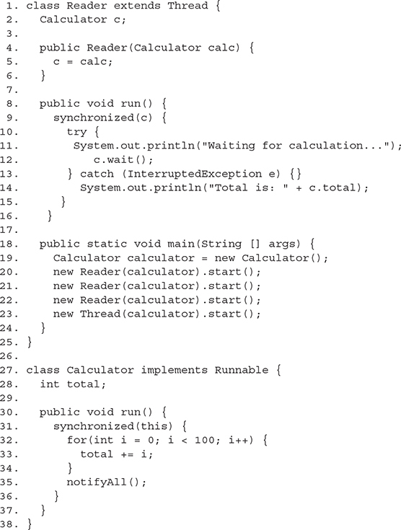

The program starts three threads that are all waiting to receive the finished calculation (lines 18–24) and then starts the calculator with its calculation. Note that if the run() method at line 30 used notify() instead of notifyAll(), only one reader would be notified instead of all the readers.

Using wait( ) in a Loop

Actually, both of the previous examples (Machine/Operator and Reader/Calculator) had a common problem. In each one, there was at least one thread calling wait() and another thread calling notify() or notifyAll(). This works well enough as long as the waiting threads have actually started waiting before the other thread executes the notify() or notifyAll(). But what happens if, for example, the Calculator runs first and calls notify() before the Readers have started waiting? This could happen since we can’t guarantee the order in which the different parts of the thread will execute. Unfortunately, when the Readers run, they just start waiting right away. They don’t do anything to see if the event they’re waiting for has already happened. So if the Calculator has already called notifyAll(), it’s not going to call notifyAll() again—and the waiting Readers will keep waiting forever. This is probably *not* what the programmer wanted to happen. Almost always, when you want to wait for something, you also need to be able to check if it has already happened. Generally, the best way to solve this is to put in some sort of loop that checks on some sort of conditional expressions and only waits if the thing you’re waiting for has not yet happened. Here’s a modified, safer version of the earlier fabric-cutting machine example:

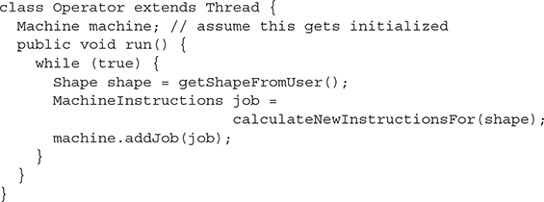

The operaator will still keep on looping forever, getting more shapes from users, calculating new instructions for those shapes, and sending them to the machine. But now the logic for notify() has been moved into the addJob() method in the Machine class:

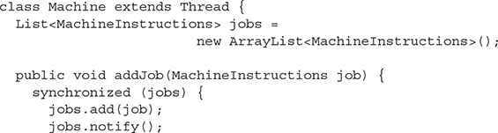

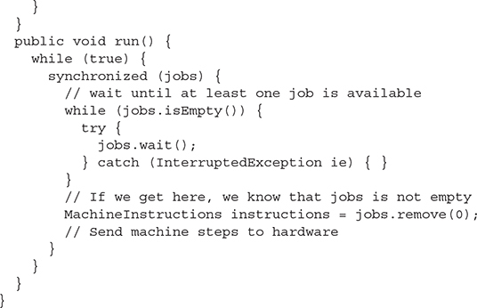

A machine keeps a list of the jobs it’s scheduled to do. Whenever an operator adds a new job to the list, it calls the addJob() method and adds the new job to the list. Meanwhile, the run() method just keeps looping, looking for any jobs on the list. If there are no jobs, it will start waiting. If it’s notified, it will stop waiting and then recheck the loop condition: Is the list still empty? In practice, this double-check is probably not necessary, as the only time a notify() is ever sent is when a new job has been added to the list. However, it’s a good idea to require the thread to recheck the isEmpty() condition whenever it’s been woken up because it’s possible that a thread has accidentally sent an extra notify() that was not intended. There’s also a possible situation called *spontaneous wakeup* that may exist in some situations—a thread may wake up even though no code has called notify() or notifyAll(). (At least, no code you know about has called these methods. Sometimes, the JVM may call notify() for reasons of its own, or code in some other class calls it for reasons you just don’t know.) What this means is that when your thread wakes up from a wait(), you don’t know for sure why it was awakened. By putting the wait() method in a while loop and rechecking the condition that represents what we were waiting for, we ensure that *whatever* the reason we woke up, we will re-enter the wait() if (and only if) the thing we were waiting for has not happened yet. In the Machine class, the thing we were waiting for is for the jobs list to not be empty. If it’s empty, we wait, and if it’s not, we don’t.

Note also that both the run() method and the addJob() method synchronize on the same object—the jobs list. This is for two reasons. One is because we’re calling wait() and notify() on this instance, so we need to synchronize in order to avoid an IllegalMonitorStateException. The other reason is that 700the data in the jobs list is changeable data stored in a field that is accessed by two different threads. We need to synchronize in order to access that changeable data safely. Fortunately, the same synchronized blocks that allow us to wait() and notify() also provide the required thread safety for our other access to changeable data. In fact, this is a main reason why synchronization is required to use wait() and notify() in the first place—you almost always need to share some mutable data between threads at the same time, and that means you need synchronization. Notice that the synchronized block in addJob() is big enough to also include the call to jobs.add(job)—which modifies shared data. And the synchronized block in run() is large enough to include the whole while loop—which includes the call to jobs.isEmpty(), which accesses shared data.

The moral here is that when you use wait() and notify() or notifyAll(), you should almost always also have a while loop around the wait() that checks a condition and forces continued waiting until the condition is met. And you should also make use of the required synchronization for the wait() and notify() calls to also protect whatever other data you’re sharing between threads. If you see code that fails to do this, there’s usually something wrong with the code—even if you have a hard time seeing what exactly the problem is.



***The methods*wait(), notify(),*and*notifyAll()*are methods of only*java.lang.Object*, not of*java.lang.Thread*or*java.lang.Runnable.*Be sure you know which methods are defined in*Thread*, which in*Object*, and which in*Runnable*(just*run()*, so that’s an easy one). Of the key methods in*Thread*, be sure you know which are*static*—*sleep()*and*yield()*—and which are*not static—join()*and*start()*.***[***Table 10-2***](https://learning.oreilly.com/library/view/ocp-java-se/9781260117370/ch10.xhtml#ch10tab2)***lists the key methods you’ll need to know for the exam, with the*static*methods shown in italics.***

**TABLE 10-2**

Key Thread Methods

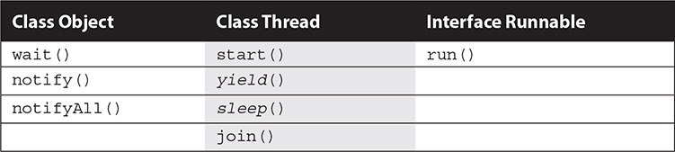

CERTIFICATION SUMMARY

This chapter covered the required thread knowledge you’ll need to apply on the certification exam. Threads can be created by either extending the Thread class or implementing the Runnable interface. The only method that must be implemented in the Runnable interface is the run() method, but the thread doesn’t become a *thread of execution* until somebody calls the Thread object’s start() method. We also looked at how the sleep() method can be used to pause a thread, and we saw that when an object goes to sleep, it holds onto any locks it acquired prior to sleeping.

We looked at five thread states: new, runnable, running, blocked/waiting/sleeping, and dead. You learned that when a thread is dead, it can never be restarted even if it’s still a valid object on the heap. We saw that there is only one way a thread can transition to running, and that’s from runnable. However, once running, a thread can become dead, go to sleep, wait for another thread to finish, block on an object’s lock, wait for a notification, or return to runnable.

You saw how two threads acting on the same data can cause serious problems (remember Lucy and Fred’s bank account?). We saw that to let one thread execute a method but prevent other threads from running the same object’s method, we use the synchronized keyword. And we saw how the wait(), notify(), and notifyAll() methods can be used to coordinate activity between different threads.

 TWO-MINUTE DRILL

Here are some of the key points from each certification objective in this chapter. Photocopy it and sleep with it under your pillow for complete absorption.

Defining, Instantiating, and Starting Threads (OCP Objective 10.1)

  Threads can be created by extending Thread and overriding the public void run() method.

  Thread objects can also be created by calling the Thread constructor that takes a Runnable argument. The Runnable object is said to be the *target* of the thread.

  A Runnable can be defined as an instance of a class that implements the Runnable interface. You can create a Runnable with a lambda expression, because Runnable is a functional interface.

  You can call start() on a Thread object only once. If start() is called more than once on a Thread object, it will throw a IllegalThreadStateException.

  It is legal to create many Thread objects using the same Runnable object as the target.

  When a Thread object is created, it does not become a *thread of execution* until its start() method is invoked. When a Thread object exists but hasn’t been started, it is in the *new* state and is not considered *alive*.

Transitioning Between Thread States (OCP Objective 10.1)

  Once a new thread is started, it will always enter the runnable state.

  The thread scheduler can move a thread back and forth between the runnable state and the running state.

  For a single-processor machine, only one thread can be running at a time, although many threads may be in the runnable state.

  There is no guarantee that the order in which threads were started determines the order in which they’ll run.

  There’s no guarantee that threads will take turns in any fair way. It’s up to the thread scheduler, as determined by the particular virtual machine implementation. If you want a guarantee that your threads will take turns, regardless of the underlying JVM, you can use the sleep() method. This prevents one thread from hogging the running process while another thread starves. (In most cases, though, yield() works well enough to encourage your threads to play together nicely.)

  A running thread may enter a blocked/waiting state by a wait(), sleep(), or join() call.

  A running thread may enter a blocked/waiting state because it can’t acquire the lock for a synchronized block of code.

  When the sleep or wait is over, or an object’s lock becomes available, the thread can only reenter the runnable state. It will *go* directly from waiting to runnable (well, for all practical purposes anyway).

  A dead thread cannot be started again.

Sleep, Yield, and Join (OCP Objective 10.1)

  Sleeping is used to delay execution for a period of time, and no locks are released when a thread goes to sleep.

  A sleeping thread is guaranteed to sleep for at least the time specified in the argument to the sleep() method (unless it’s interrupted), but there is no guarantee as to when the newly awakened thread will actually return to running.

  The sleep() method is a static method that sleeps the currently executing thread’s state. One thread *cannot* tell another thread to sleep.

  The setPriority() method gives Thread objects a priority of between 1 (low) and 10 (high). Priorities are not guaranteed, and not all JVMs recognize ten distinct priority levels—some levels may be treated as effectively equal.

  If not explicitly set, a thread’s priority will have the same priority as the thread that created it.

  The yield() method *may* cause a running thread to back out if there are runnable threads of the same priority. There is no guarantee that this will happen, and there is no guarantee that when the thread backs out there will be a *different* thread selected to run. A thread might yield and then immediately reenter the running state.

  The closest thing to a guarantee is that at any given time, when a thread is running, it will usually not have a lower priority than any thread in the runnable state. If a low-priority thread is running when a high-priority thread enters runnable, the JVM will usually preempt the running low-priority thread and put the high-priority thread in.

  When one thread calls the join() method of another thread, the currently running thread will wait until the thread it joins with has completed. Think of the join() method as saying, “Hey, thread, I want to join on to the end of you. Let me know when you’re done, so I can enter the runnable state.”

Concurrent Access Problems and Synchronized Threads (OCP Objectives 10.2 and 10.3)

  synchronized methods prevent more than one thread from accessing an object’s critical method code simultaneously.

  You can use the synchronized keyword as a method modifier or to start a synchronized block of code.

  To synchronize a block of code (in other words, a scope smaller than the whole method), you must specify an argument that is the object whose lock you want to synchronize on.

  While only one thread can be accessing synchronized code of a particular instance, multiple threads can still access the same object’s unsynchronized code.

  When a thread goes to sleep, its locks will be unavailable to other threads.

  static methods can be synchronized using the lock from the java.lang.Class instance representing that class.

Communicating with Objects by Waiting and Notifying (OCP Objective 10.1)

  The wait() method lets a thread say, “There’s nothing for me to do now, so put me in your waiting pool and notify me when something happens that I care about.” Basically, a wait() call means “let me wait in your pool” or “add me to your waiting list.”

  The notify() method is used to send a signal to one and only one of the threads that are waiting in that same object’s waiting pool.

  The notify() method CANNOT specify which waiting thread to notify.

  The method notifyAll() works in the same way as notify(), only it sends the signal to *all* of the threads waiting on the object.

  All three methods—wait(), notify(), and notifyAll()—must be called from within a synchronized context! A thread invokes wait() or notify() on a particular object, and the thread must currently hold the lock on that object.

Deadlocked, Livelocked, and Starved Threads and Race Conditions (OCP Objective 10.2)

  Deadlocking is when thread execution grinds to a halt because the code is waiting for locks to be removed from objects.

  Deadlocking can occur when a locked object attempts to access another locked object that is trying to access the first locked object. In other words, both threads are waiting for each other’s locks to be released; therefore, the locks will *never* be released!

  Deadlocking is bad. Don’t do it.

  Livelocking is when thread execution grinds to a halt because the threads are too busy to make any progress. The threads are still working but can’t get anywhere.

  Thread starvation is when a thread can’t get access to a resource it needs so it starves. It’s still alive, but barely.

  A race condition is when two threads race to get the same shared resource, and the result (often wrong) depends on which thread gets there first.

  Race conditions are bad. Don’t allow them to happen. Use the volatile keyword to protect variables that should be atomic, and the synchronized keyword to make sure only one thread at a time can run code that manages a resource.

 SELF TEST

The following questions will help you measure your understanding of the material presented in this chapter. If you have a rough time with some of these at first, don’t beat yourself up. Some of these questions are long and intricate. Expect long and intricate questions on the real exam, too!

[**1**](https://learning.oreilly.com/library/view/ocp-java-se/9781260117370/ch10.xhtml#r_ch10ans1)**.**   The following block of code creates a Thread using a Runnable target:



Which of the following classes can be used to create the target so that the preceding code compiles correctly?

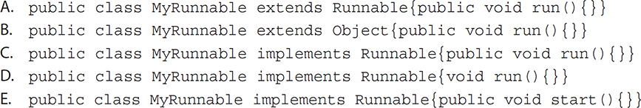

[**2**](https://learning.oreilly.com/library/view/ocp-java-se/9781260117370/ch10.xhtml#r_ch10ans2)**.**   Given:

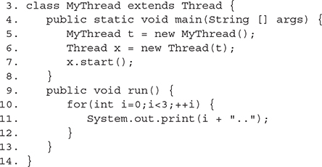

What is the result of this code?

A. Compilation fails

B. 1..2..3..

C. 0..1..2..3..

D. 0..1..2..

E. An exception occurs at runtime

[**3**](https://learning.oreilly.com/library/view/ocp-java-se/9781260117370/ch10.xhtml#r_ch10ans3)**.**   Given:

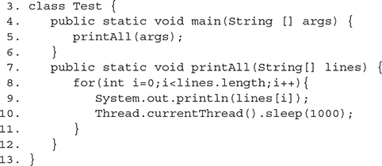

The static method Thread.currentThread() returns a reference to the currently executing Thread object. What is the result of this code?

A. Each String in the array lines will output, with a one-second pause between lines

B. Each String in the array lines will output, with no pause in between because this method is not executed in a Thread

C. Each String in the array lines will output, and there is no guarantee that there will be a pause because currentThread() may not retrieve this thread

D. This code will not compile

E. Each String in the lines array will print, with at least a one-second pause between lines

[**4**](https://learning.oreilly.com/library/view/ocp-java-se/9781260117370/ch10.xhtml#r_ch10ans4)**.**   Assume you have a class that holds two private variables: a and b. Which of the following pairs can prevent concurrent access problems in that class? (Choose all that apply.)

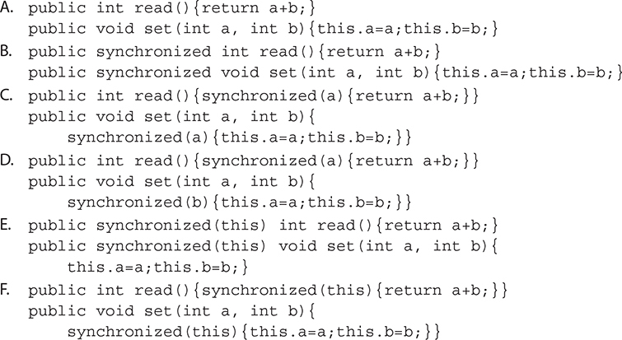

[**5**](https://learning.oreilly.com/library/view/ocp-java-se/9781260117370/ch10.xhtml#r_ch10ans5)**.**   Given:

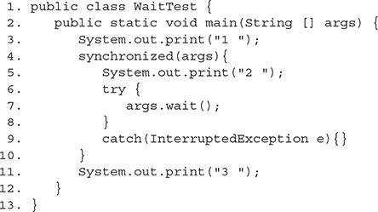

What is the result of trying to compile and run this program?

A. It fails to compile because the IllegalMonitorStateException of wait() is not dealt with in line 7

B. 1 2 3

C. 1 3

D. 1 2

E. At runtime, it throws an IllegalMonitorStateException when trying to wait

F. It will fail to compile because it has to be synchronized on the this object

[**6**](https://learning.oreilly.com/library/view/ocp-java-se/9781260117370/ch10.xhtml#r_ch10ans6)**.**   Assume the following method is properly synchronized and called from a thread A on an object B:



After calling this method, when will thread A become a candidate to get another turn at the CPU?

A. After object B is notified, or after two seconds

B. After the lock on B is released, or after two seconds

C. Two seconds after object B is notified

D. Two seconds after lock B is released

[**7**](https://learning.oreilly.com/library/view/ocp-java-se/9781260117370/ch10.xhtml#r_ch10ans7)**.**   Which are true? (Choose all that apply.)

A. The notifyAll() method must be called from a synchronized context

B. To call wait(), an object must own the lock on the thread

C. The notify() method is defined in class java.lang.Thread

D. When a thread is waiting as a result of wait(), it releases its lock

E. The notify() method causes a thread to immediately release its lock

F. The difference between notify() and notifyAll() is that notifyAll() notifies all waiting threads, regardless of the object they’re waiting on

[**8**](https://learning.oreilly.com/library/view/ocp-java-se/9781260117370/ch10.xhtml#r_ch10ans8)**.**   Given this scenario: This class is intended to allow users to write a series of messages so that each message is identified with a timestamp and the name of the thread that wrote the message:

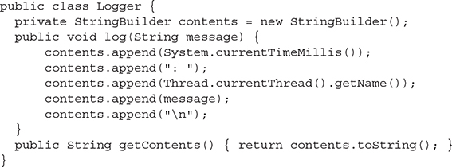

How can we ensure that instances of this class can be safely used by multiple threads?

A. This class is already thread-safe

B. Replacing StringBuilder with StringBuffer will make this class thread-safe

C. Synchronize the log() method only

D. Synchronize the getContents() method only

E. Synchronize both log() and getContents()

F. This class cannot be made thread-safe

[**9**](https://learning.oreilly.com/library/view/ocp-java-se/9781260117370/ch10.xhtml#r_ch10ans9)**.**   Given:

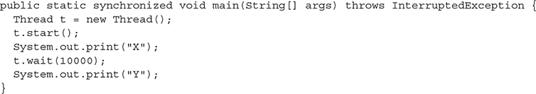

What is the result of this code?

A. It prints X and exits

B. It prints X and never exits

C. It prints XY and exits almost immediately

D. It prints XY with a 10-second delay between X and Y

E. It prints XY with a 10,000-second delay between X and Y

F. The code does not compile

G. An exception is thrown at runtime

[**10**](https://learning.oreilly.com/library/view/ocp-java-se/9781260117370/ch10.xhtml#r_ch10ans10)**.**   Given:

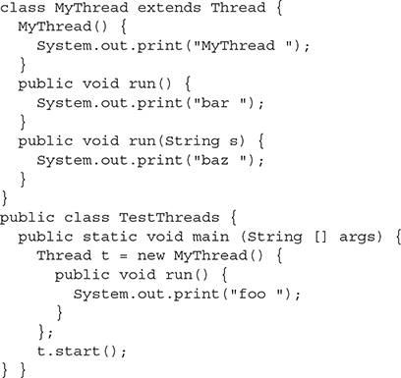

What is the result?

A. foo

B. MyThread foo

C. MyThread bar

D. foo bar

E. foo bar baz

F. bar foo

G. Compilation fails

H. An exception is thrown at runtime

[**11**](https://learning.oreilly.com/library/view/ocp-java-se/9781260117370/ch10.xhtml#r_ch10ans11)**.**   Given:

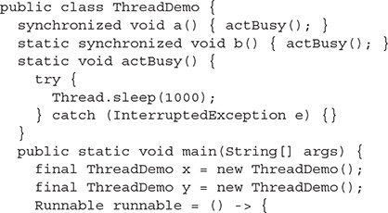

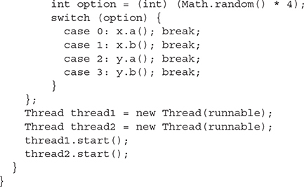

If the code compiles, which of the following pairs of method invocations could NEVER be executing at the same time? (Choose all that apply.)

A. x.a() in thread1, and x.a() in thread2

B. x.a() in thread1, and x.b() in thread2

C. x.a() in thread1, and y.a() in thread2

D. x.a() in thread1, and y.b() in thread2

E. x.b() in thread1, and x.a() in thread2

F. x.b() in thread1, and x.b() in thread2

G. x.b() in thread1, and y.a() in thread2

H. x.b() in thread1, and y.b() in thread2

I. Compilation fails due to an error in declaring the Runnable

[**12**](https://learning.oreilly.com/library/view/ocp-java-se/9781260117370/ch10.xhtml#r_ch10ans12)**.**   Given:

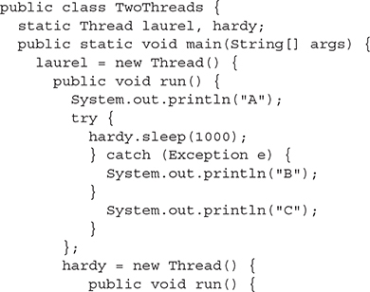

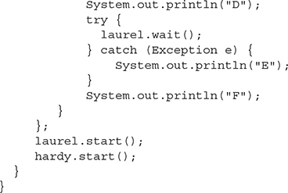

Which letters will eventually appear somewhere in the output? (Choose all that apply.)

A. A

B. B

C. C

D. D

E. E

F. F

G. The answer cannot be reliably determined

H. The code does not compile

[**13**](https://learning.oreilly.com/library/view/ocp-java-se/9781260117370/ch10.xhtml#r_ch10ans13)**.**   Given:

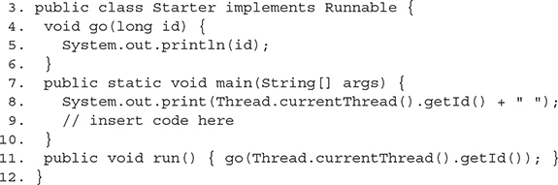

And given the following five fragments:

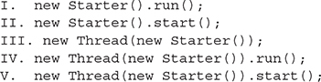

When the five fragments are inserted, one at a time at line 9, which are true? (Choose all that apply.)

A. All five will compile

B. Only one might produce the output 4 4

C. Only one might produce the output 4 2

D. Exactly two might produce the output 4 4

E. Exactly two might produce the output 4 2

F. Exactly three might produce the output 4 4

G. Exactly three might produce the output 4 2

[**14**](https://learning.oreilly.com/library/view/ocp-java-se/9781260117370/ch10.xhtml#r_ch10ans14)**.**   Given:

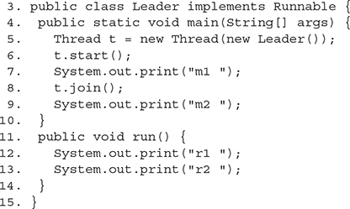

Which are true? (Choose all that apply.)

A. Compilation fails

B. The output could be r1 r2 m1 m2

C. The output could be m1 m2 r1 r2

D. The output could be m1 r1 r2 m2

E. The output could be m1 r1 m2 r2

F. An exception is thrown at runtime

[**15**](https://learning.oreilly.com/library/view/ocp-java-se/9781260117370/ch10.xhtml#r_ch10ans15)**.**   Given:

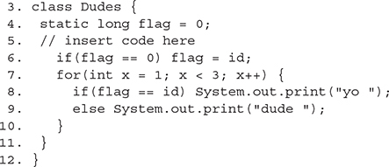

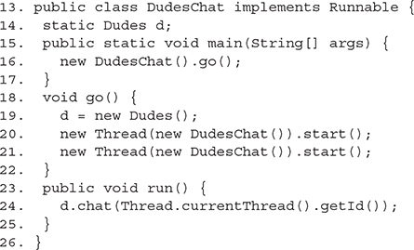

And given these two fragments:

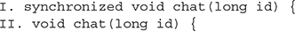

When fragment I or fragment II is inserted at line 5, which are true? (Choose all that apply.)

A. An exception is thrown at runtime

B. With fragment I, compilation fails

C. With fragment II, compilation fails

D. With fragment I, the output could be yo dude dude yo

E. With fragment I, the output could be dude dude yo yo

F. With fragment II, the output could be yo dude dude yo

[**16**](https://learning.oreilly.com/library/view/ocp-java-se/9781260117370/ch10.xhtml#r_ch10ans16)**.**   Given:

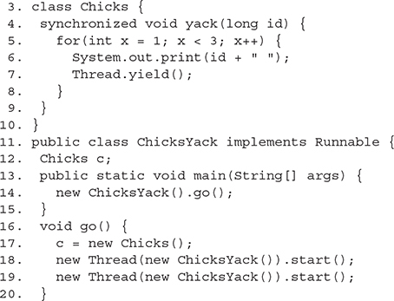

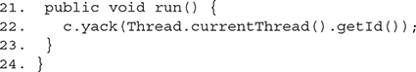

Which are true? (Choose all that apply.)

A. Compilation fails

B. The output could be 4 4 2 3

C. The output could be 4 4 2 2

D. The output could be 4 4 4 2

E. The output could be 2 2 4 4

F. An exception is thrown at runtime

[**17**](https://learning.oreilly.com/library/view/ocp-java-se/9781260117370/ch10.xhtml#r_ch10ans17)**.**   Given:

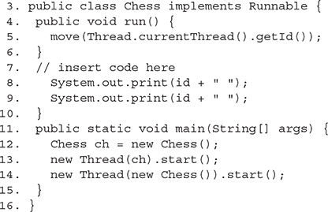

And given these two fragments:

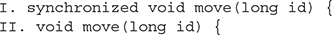

When either fragment I or fragment II is inserted at line 7, which are true? (Choose all that apply.)

A. Compilation fails

B. With fragment I, an exception is thrown

C. With fragment I, the output could be 4 2 4 2

D. With fragment I, the output could be 4 4 2 3

E. With fragment II, the output could be 2 4 2 4

[**18**](https://learning.oreilly.com/library/view/ocp-java-se/9781260117370/ch10.xhtml#r_ch10ans18)**.**   You have two threads, t1 and t2, attemping to access a shared resource, and t2 is always descheduled when it tries to access that resource. What is this kind of problem called?

A. A race condition

B. Deadlock

C. Livelock

D. Starvation

E. Synchronization

F. Multitasking

 SELF TEST ANSWERS

[**1**](https://learning.oreilly.com/library/view/ocp-java-se/9781260117370/ch10.xhtml#ch10ans1)**.**    **C** is correct. The class implements the Runnable interface with a legal run() method.

 **A** is incorrect because interfaces are implemented, not extended. **B** is incorrect because even though the class has a valid public void run() method, it does not implement the Runnable interface. **D** is incorrect because the run() method must be public. **E** is incorrect because the method to implement is run(), not start(). Note that we could replace the first line of code with:



and dispense with MyRunnable completely. (OCP Objective 10.1)

[**2**](https://learning.oreilly.com/library/view/ocp-java-se/9781260117370/ch10.xhtml#ch10ans2)**.**    **D** is correct. The thread MyThread will start and loop three times (from 0 to 2).

 **A** is incorrect because the Thread class implements the Runnable interface; therefore, in line 6, Thread can take an object of type Thread as an argument in the constructor (this is NOT recommended). **B** and **C** are incorrect because the variable i in the for loop starts with a value of 0 and ends with a value of 2. **E** is incorrect based on the above. (OCP Objective 10.1)

[**3**](https://learning.oreilly.com/library/view/ocp-java-se/9781260117370/ch10.xhtml#ch10ans3)**.**    **D** is correct. The sleep() method must be enclosed in a try/catch block, or the method printAll() must declare it throws the InterruptedException.

 **E** is incorrect, but it would be correct if the InterruptedException was dealt with (**A** is too precise). **B** is incorrect (even if the InterruptedException was dealt with) because all Java code, including the main() method, runs in threads. **C** is incorrect. The sleep() method is static; it always affects the currently executing thread. (OCP Objective 10.1)

[**4**](https://learning.oreilly.com/library/view/ocp-java-se/9781260117370/ch10.xhtml#ch10ans4)**.**    **B** and **F** are correct. By marking the methods as synchronized, the threads will get the lock of the this object before proceeding. Only one thread will be setting or reading at any given moment, thereby assuring that read() always returns the addition of a valid pair.

 **A** is incorrect because it is not synchronized; therefore, there is no guarantee that the values added by the read() method belong to the same pair. **C** and**D** are incorrect; only objects can be used to synchronize on. **E** is incorrect because it fails to compile—it is not possible to select other objects (even this) to synchronize on when declaring a method as synchronized. (OCP Objectives 10.2 and 10.3)

[**5**](https://learning.oreilly.com/library/view/ocp-java-se/9781260117370/ch10.xhtml#ch10ans5)**.**    **D** is correct. 1 and 2 will be printed, but there will be no return from the wait call because no other thread will notify the main thread, so 3 will never be printed. It’s frozen at line 7.

 **A** is incorrect; IllegalMonitorStateException is an unchecked exception. **B** and **C** are incorrect; 3 will never be printed, since this program will wait forever.**E** is incorrect because IllegalMonitorStateException will never be thrown because the wait() is done on args within a block of code synchronized on args. **F** is incorrect because any object can be used to synchronize on, and this and static don’t mix. (OCP Objective 10.3)

[**6**](https://learning.oreilly.com/library/view/ocp-java-se/9781260117370/ch10.xhtml#ch10ans6)**.**    **A** is correct. Either of the two events will make the thread a candidate for running again.

 **B** is incorrect because a waiting thread will not return to runnable when the lock is released unless a notification occurs. **C** is incorrect because the thread will become a candidate immediately after notification. **D** is also incorrect because a thread will not come out of a waiting pool just because a lock has been released. (OCP Objective 10.3)

[**7**](https://learning.oreilly.com/library/view/ocp-java-se/9781260117370/ch10.xhtml#ch10ans7)**.**    **A** is correct because notifyAll() (and wait() and notify()) must be called from within a synchronized context. **D** is a correct statement.

 **B** is incorrect because to call wait(), the thread must own the lock on the object that wait() is being invoked on, not the other way around. **C** is incorrect because notify() is defined in java.lang.Object. **E** is incorrect because notify() will not cause a thread to release its locks. The thread can only release its locks by exiting the synchronized code. **F** is incorrect because notifyAll() notifies all the threads waiting on a particular locked object, not all threads waiting on *any* object. (OCP Objectives 10.2 and 10.3)

[**8**](https://learning.oreilly.com/library/view/ocp-java-se/9781260117370/ch10.xhtml#ch10ans8)**.**    **E** is correct because synchronizing the public methods is sufficient to make this safe, which is why**F** is incorrect. This class is not thread-safe unless some sort of synchronization protects the changing data.

 **B** is incorrect because although a StringBuffer is synchronized internally, we call append() multiple times, and nothing would prevent two simultaneous log() calls from mixing up their messages. **C** and **D** are incorrect because if one method remains unsynchronized, it can run while the other is executing, which could result in reading the contents while one of the messages is incomplete, or worse. (You don’t want to call toString() on the StringBuffer as it’s resizing its internal character array.) **F** is incorrect based on the information above.(OCP Objective 10.3)

[**9**](https://learning.oreilly.com/library/view/ocp-java-se/9781260117370/ch10.xhtml#ch10ans9)**.**    **G** is correct. The code does not acquire a lock on t before calling t.wait(), so it throws an IllegalMonitorStateException. The method is synchronized, but it’s not synchronized on t so the exception will be thrown. If the wait were placed inside a synchronized(t) block, then **D** would be correct.

 **A, B, C, D, E,** and **F** are incorrect based on the logic described above. (OCP Objective 10.3)

[**10**](https://learning.oreilly.com/library/view/ocp-java-se/9781260117370/ch10.xhtml#ch10ans10)**.**    **B** is correct. In the first line of main we’re constructing an instance of an anonymous inner class extending from MyThread. So the MyThread constructor runs and prints MyThread. Next, main() invokes start() on the new thread instance, which causes the overridden run() method (the run() method in the anonymous inner class) to be invoked.

 **A, C, D, E, F, G,** and **H** are incorrect based on the logic described above. (OCP Objective 10.1)

[**11**](https://learning.oreilly.com/library/view/ocp-java-se/9781260117370/ch10.xhtml#ch10ans11)**.**    **A, F,** and **H** are correct. **A** is correct because when synchronized instance methods are called on the same *instance,* they block each other. **F** and **H** can’t happen because synchronized static methods in the same class block each other, regardless of which instance was used to call the methods. (An instance is not required to call static methods; only the class.)

 **C,** although incorrect, could happen because synchronized instance methods called on different instances do not block each other. **B, D, E,** and **G** are incorrect but also could all happen because instance methods and static methods lock on different objects and do not block each other. **I** is incorrect because the code compiles. (OCP Objectives 10.2 and 10.3)

[**12**](https://learning.oreilly.com/library/view/ocp-java-se/9781260117370/ch10.xhtml#ch10ans12)**.**    **A, C, D, E,** and**F** are correct. This may look like laurel and hardy are battling to cause the other to sleep() or wait()—but that’s not the case. Since sleep() is a static method, it affects the current thread, which is laurel (even though the method is invoked using a reference to hardy). That’s misleading, but perfectly legal, and the Thread laurel is able to sleep with no exception, printing **A** and **C** (after at least a one-second delay). Meanwhile, hardy tries to call laurel.wait()—but hardy has not synchronized on laurel, so calling laurel.wait() immediately causes an IllegalMonitorStateException, and so hardy prints **D**, **E**, and **F**. Although the *order* of the output is somewhat indeterminate (we have no way of knowing whether **A** is printed before **D**, for example), it is guaranteed that **A, C, D, E,** and **F** will all be printed in some order, eventually—so **G** is incorrect.

 **B, G,** and **H** are incorrect based on the above. (OCP Objective 10.2)

[**13**](https://learning.oreilly.com/library/view/ocp-java-se/9781260117370/ch10.xhtml#ch10ans13)**.**    **C** and **D** are correct. Fragment I doesn’t start a new thread. Fragment II doesn’t compile. Fragment III creates a new thread but doesn’t start it. Fragment IV creates a new thread and invokes run() directly, but it doesn’t start the new thread. Fragment V creates and starts a new thread.

 **A, B, E, F,** and **G** are incorrect based on the above. (OCP Objective 10.1)

[**14**](https://learning.oreilly.com/library/view/ocp-java-se/9781260117370/ch10.xhtml#ch10ans14)**.**    **A** is correct. The join() must be placed in a try/catch block. If it were, answers **B** and **D** would be correct. The join() causes the main thread to pause and join the end of the other thread, meaning "m2" must come last.

 **B, C, D, E,** and **F** are incorrect based on the above. (OCP Objective 10.1)

[**15**](https://learning.oreilly.com/library/view/ocp-java-se/9781260117370/ch10.xhtml#ch10ans15)**.**    **F** is correct. With Fragment I, the chat method is synchronized, so the two threads can’t swap back and forth. With either fragment, the first output must be yo.

 **A, B, C, D,** and **E** are incorrect based on the above. (OCP Objective 10.3)

[**16**](https://learning.oreilly.com/library/view/ocp-java-se/9781260117370/ch10.xhtml#ch10ans16)**.**    **F** is correct. When run() is invoked, it is with a new instance of ChicksYack and c has not been assigned to an object. If c were static, then because yack is synchronized, answers **C** and **E** would have been correct.

 **A, B, C, D,** and **E** are incorrect based on the above. (OCP Objectives 10.1 and 10.3)

[**17**](https://learning.oreilly.com/library/view/ocp-java-se/9781260117370/ch10.xhtml#ch10ans17)**.**    **C** and **E** are correct. **E** should be obvious. **C** is correct because, even though move() is synchronized, it’s being invoked on two different objects.

 **A, B,** and **D** are incorrect based on the above. (OCP Objective 10.3)

[**18**](https://learning.oreilly.com/library/view/ocp-java-se/9781260117370/ch10.xhtml#ch10ans18)**.**    **D** is correct. Starvation occurs when one or more threads cannot get access to a resource.

 **A, B, C, E** and **F** are incorrect based on the above. (OCP Objective 10.2)

EXERCISE ANSWERS

Exercise 10-1: Creating a Thread and Putting It to Sleep

The final code should look something like this:

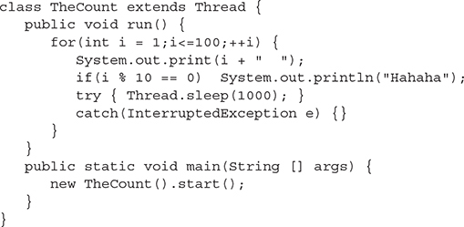

Exercise 10-2: Synchronizing a Block of Code

Your code might look something like this when completed:

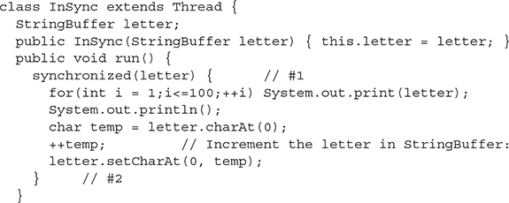

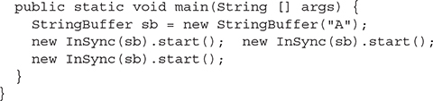

Just for fun, try removing lines 1 and 2 and then run the program again. It will be unsynchronized—watch what happens



11

Concurrency

**CERTIFICATION OBJECTIVES**

•       Create Worker Threads Using Runnable, Callable and Use an ExecutorService to Concurrently Execute Tasks

•       Use Synchronized Keyword and java.util.concurrent.atomic Package to Control the Order of Thread Execution

•       Use java.util.concurrent Collections and Classes Including CyclicBarrier and CopyOnWriteArrayList

•       Use Parallel Fork/Join Framework

•       Use Parallel Streams Including Reduction, Decomposition, Merging Processes, Pipelines and Performance

•       Identify Potential Threading Problems among Deadlock, Starvation, Livelock, and Race Conditions

     Two-Minute Drill

**Q&A**   Self Test

**CONCURRENCY WITH THE JAVA.UTIL.CONCURRENT PACKAGE**

As you learned in the previous chapter on threads, the Java platform supports multithreaded programming. Supporting multithreaded programming is essential for any modern programming language because servers, desktop computers, laptops, and most mobile devices contain multiple CPUs. If you want your applications to take advantage of all of the processing power present in a modern system, you must create multithreaded applications.

Unfortunately, creating efficient and error-free multithreaded applications can be a challenge. The low-level threading constructs such as Thread, Runnable, wait(), notify(), and synchronized blocks are too primitive for many requirements and force developers to create their own high-level threading libraries. Custom threading libraries can be both error prone and time consuming to create.

The java.util.concurrent package provides high-level APIs that support many common concurrent programming use cases. When possible, you should use these high-level APIs in place of the traditional low-level threading constructs (synchronized, wait, notify). Some features (such as the locking API) provide functionality similar to what existed already, but with more flexibility at the cost of slightly awkward syntax. Using the java.util.concurrent classes requires a solid understanding of the traditional Java threading types (Thread and Runnable) and their use (start, run, synchronized, wait, notify, join, sleep, etc.). If you are not comfortable with Java threads, you should return to the previous chapter before continuing with these high-level concurrency APIs.

**CERTIFICATION OBJECTIVE**

**APPLY ATOMIC VARIABLES AND LOCKS (OCP OBJECTIVE 10.3)**

*10.3   Use synchronized keyword and java.util.concurrent.atomic package to control the order of thread execution.*

The java.util.concurrent.atomic and java.util.concurrent.locks packages solve two different problems. They are grouped into a single exam objective simply because they are the only two packages below java.util.concurrent and both have a small number of classes and interfaces to learn. The java.util.concurrent.atomic package enables multithreaded applications to safely access individual variables without locking, whereas the java.util.concurrent.locks package provides a locking framework that can be used to create locking behaviors that are the same or superior to those of Java’s synchronized keyword.

Atomic Variables

Imagine a multiplayer video game that contains monsters that must be destroyed. The players of the game (threads) are vanquishing monsters, while at the same time a monster-spawning thread is repopulating the world to ensure players always have a new challenge to face. To keep the level of difficulty consistent, you would need to keep track of the monster count and ensure that the monster population stays the same (a hero’s work is never done). Both the player threads and the monster-spawning thread must access and modify the shared monster count variable. If the monster count somehow became incorrect, your players may find themselves with more adversaries than they could handle.

The following example shows how even the seemingly simplest of code can lead to undefined results. Here you have a class that increments and reports the current value of an integer variable:

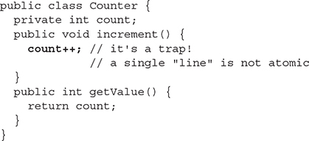

A Thread that will increment the counter 10,000 times:

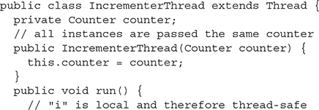

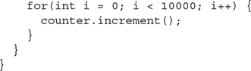

Here is the code from within this application’s main method:

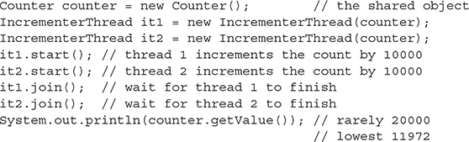

The trap in this example is that count++ looks like a single action when, in fact, it is not. When incrementing a field like this, what *probably* happens is the following sequence:

1.   The value stored in count is copied to a temporary variable.

2.   The temporary variable is incremented.

3.   The value of the temporary variable is copied back to the count field.

We say “probably” in this example because while the Java compiler will translate the count++ statement into multiple Java bytecode instructions, you really have no control over what native instructions are executed. The JIT (Just In Time compiler)–based nature of most Java runtime environments means you don’t know when or if the count++ statement will be translated to native CPU instructions and whether it ends up as a single instruction or several. You should always act as if a single line of Java code takes multiple steps to complete. Getting an incorrect result also depends on many other factors, such as the type of CPU you have. Do both threads in the example run concurrently or in sequence? A large loop count was used in order to make the threads run longer and be more likely to execute concurrently.

While you could make this code thread-safe with synchronized blocks, the act of obtaining and releasing a lock flag would probably be more time consuming than the work being performed. This is where the classes in the java.util.concurrent.atomic package can benefit you. They provide variables whose values can be modified atomically. An atomic operation is one that, for all intents and purposes, appears to happen all at once. The java.util.concurrent.atomic package provides several classes for different data types, such as AtomicInteger, AtomicLong, AtomicBoolean, and AtomicReference, to name a few.

Here is a thread-safe replacement for the Counter class from the previous example:

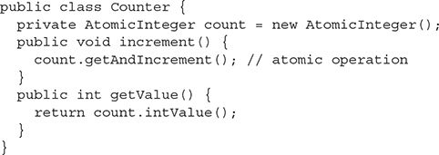

In reality, even a method such as getAndIncrement() still takes several steps to execute. The reason this implementation is now thread-safe is something called CAS. CAS stands for Compare And Swap. Most modern CPUs have a set of CAS instructions. Following is a basic outline of what is happening now:

1.   The value stored in count is copied to a temporary variable.

2.   The temporary variable is incremented.

3.   Compare the value currently in count with the original value. If it is unchanged, then swap the old value for the new value.

Step 3 happens atomically. If step 3 finds that some other thread has already modified the value of count, then repeat steps 1–3 until we increment the field without interference.

The central method in a class like AtomicInteger is the boolean compareAndSet(int expect, int update) method, which provides the CAS behavior. Other atomic methods delegate to the compareAndSet method. The getAndIncrement method implementation is simply:

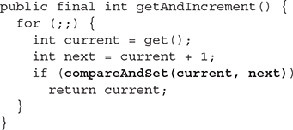

Locks

The java.util.concurrent.locks package is about creating (not surprisingly) locks. Why would you want to use locks when so much of java.util.concurrent seems geared toward avoiding overt locking? You use java.util.concurrent.locks classes and traditional monitor locking (the synchronized keyword) for roughly the same purpose: creating segments of code that require exclusive execution (one thread at a time).

Why would you create code that limits the number of threads that can execute it? While atomic variables work well for making single variables thread-safe, imagine if you have two or more variables that are related. A video game character might have a number of gold pieces that can be carried in his backpack and a number of gold pieces he keeps in an in-game bank vault. Transferring gold into the bank is as simple as subtracting gold from the backpack and adding it to the vault. If we have 10 gold pieces in our backpack and 90 in the vault, we have a total of 100 pieces that belong to our character. If we want to transfer all 10 pieces to the vault, we can first add 10 to the vault count and then subtract 10 from the backpack, or first subtract 10 from the backpack and then add 10 to the vault. If another thread were to try to assess our character’s wealth during the middle of our transfer, it might see 90 pieces or 110 pieces, depending on the order of our operations, neither being the correct count of 100 pieces.

This other thread that is attempting to read the character’s total wealth might do all sorts of things, such as increase the likelihood of your character being robbed or a variety of other actions to control the in-game economics. All game threads must correctly gauge a character’s wealth even if there is a transfer in progress.

The solution to our balance inquiry transfer problem is to use locking. Create a single method to get a character’s wealth and another to perform gold transfers. You should never be able to check a character’s total wealth while a gold transfer is in progress. Having a single method to get a character’s total wealth is also important because you don’t want a thread to read the backpack’s gold count before a transfer and then the vault’s gold count after a transfer. That would lead to the same incorrect total as trying to calculate the total during a transfer.

Much of the functionality provided by the classes and interfaces of the java.util.concurrent.locks package duplicates that of traditional synchronized locking. In fact, the hypothetical gold transfer outlined earlier could be solved with either the synchronized keyword or classes in the java.util.concurrent.locks package. In Java 5, when java.util.concurrent was first introduced, the new locking classes performed better than the synchronized keyword, but there is no longer a vast difference in performance. So why would you use these newer locking classes? The java.util.concurrent.locks package provides

   The ability to duplicate traditional synchronized blocks.

   Nonblock scoped locking—obtain a lock in one method and release it in another (this can be dangerous, though).

   Multiple wait/notify/notifyAll pools per lock—threads can select which pool (Condition) they wait on.

   The ability to attempt to acquire a lock and take an alternative action if locking fails.

   An implementation of a multiple-reader, single-writer lock.

ReentrantLock

The java.util.concurrent.locks.Lock interface provides the outline of locking provided by the java.util.concurrent.locks package. Like any interface, the Lock interface requires an implementation to be of any real use. The java.util.concurrent.locks.ReentrantLock class provides that implementation. To demonstrate the use of Lock, we will first duplicate the functionality of a basic traditional synchronized block.

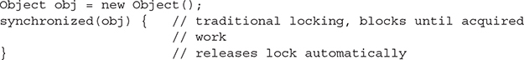

Here is an equivalent piece of code using the java.util.concurrent.locks package. Notice how ReentrantLock can be stored in a Lock reference because it implements the Lock interface. This example blocks on attempting to acquire a lock, just like traditional synchronization.

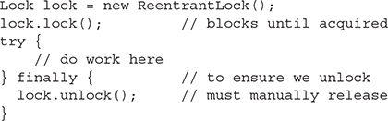

It is recommended that you always follow the lock() method with a try-finally block, which releases the lock. The previous example doesn’t really provide a compelling reason for you to choose to use a Lock instance instead of traditional synchronization. One of the very powerful features is the ability to attempt (and fail) to acquire a lock. With traditional synchronization, once you hit a synchronized block, your thread either immediately acquires the lock or blocks until it can.

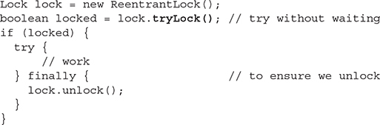

The ability to quickly fail to acquire the lock turns out to be powerful. You can process a different resource (lock) and come back to the failed lock later instead of just waiting for a lock to be released and thereby making more efficient use of system resources. There is also a variation of the tryLock method that allows you to specify an amount of time you are willing to wait to acquire the lock:

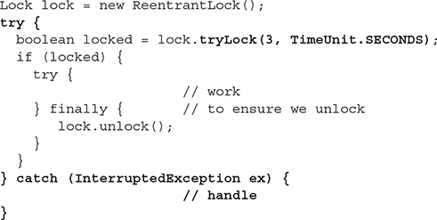

Another benefit of the tryLock method is deadlock avoidance. With traditional synchronization, you must acquire locks in the same order across all threads. For example, if you have two objects to lock against:

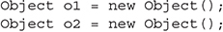

and you synchronize using the internal lock flags of both objects:

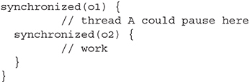

you should never acquire the locks in the opposite order because it could lead to deadlock. Although thread A has only the o1 lock, thread B acquires the o2 lock. You are now at an impasse because neither thread can obtain the second lock it needs to continue.

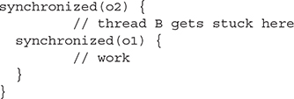

Looking at a similar example using a ReentrantLock, start by creating two locks:

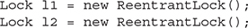

Next, you acquire both locks in thread A:

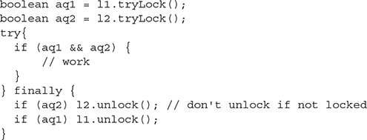

Notice the example is careful to always unlock any acquired lock, but ONLY the lock(s) that were acquired. A ReentrantLock has an internal counter that keeps track of the number of times it has been locked/unlocked, and it is an error to unlock without a corresponding successful lock operation. If a thread attempts to release a lock that it does not own, an IllegalMonitorStateException will be thrown.

Now in thread B, the locks are obtained in the reverse order in which thread A obtained them. With traditional locking, using synchronized code blocks and attempting to obtain locks in the reverse order could lead to deadlock.

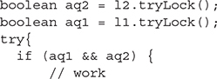

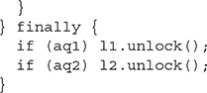

Now, even if thread A was only in possession of the l1 lock, there is no possibility that thread B could block because we use the nonblocking tryLock method. Using this technique, you can avoid deadlocking scenarios, but you must deal with the possibility that both locks could not be acquired. Using a simple loop, you can repeatedly attempt to obtain both locks until successful (Note: This approach is CPU intensive; we’ll look at a better solution later):

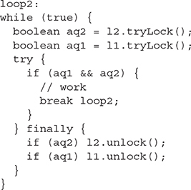



***It is remotely possible that this example could lead to livelock. Imagine if thread A always acquires*lock1*at the same time that thread B acquires*lock2*. Each thread’s attempt to acquire the second lock would always fail, and you’d end up repeating forever, or at least until you were lucky enough to have one thread fall behind the other. You can avoid livelock in this scenario by introducing a short random delay with*Thread.sleep(int)*any time you fail to acquire both locks.***

Condition

A Condition provides the equivalent of the traditional wait, notify, and notifyAll methods. The traditional wait and notify methods allow developers to implement an await/signal pattern. You use an await/signal pattern when you would use locking, but with the added stipulation of trying to avoid spinning (endless checking if it is okay to do something). Imagine a video game character who wants to buy something from a store, but the store is out of stock at the moment. The character’s thread could repeatedly lock the store object and check for the desired item, but that would lead to unneeded system utilization. Instead, the character’s thread can say, “I’m taking a nap, wake me up when new stock arrives.”

The java.util.concurrent.locks.Condition interface is a replacement for the wait and notify methods. A three-part code example shows you how to use a condition. Part one shows that a Condition is created from a Lock object:



When your thread reaches a point where it must delay until another thread performs an activity, you “await” the completion of that other activity. Before calling await, you must have locked the Lock used to produce the Condition. It is possible that the awaiting thread may be interrupted, and you must handle the possible InterruptedException. When you call the await method, the Lock associated with the Condition is released. Before the await method returns, the lock will be reacquired. In order to use a Condition, a thread must first acquire a Lock. Part two of the three-part Condition example shows how a Condition is used to pause or wait for some event:

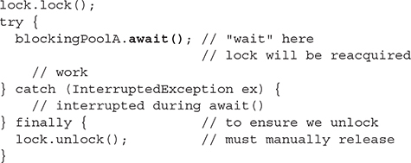

In another thread, you perform the activity that the first thread was waiting on and then signal that first thread to resume (return from the await method). Part three of the Condition example is run in a different thread than part two. This part causes the thread waiting in the second piece to wake up:

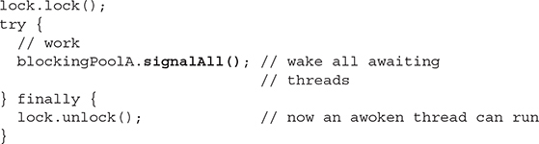

The signalAll() method causes all threads awaiting on the same Condition to wake up. You can also use the signal() method to wake up a single awaiting thread. Remember that “waking up” is not the same thing as proceeding. Each awoken thread will have to reacquire the Lock before continuing.

One advantage of a Condition over the traditional wait/notify operations is that multiple Conditions can exist for each Lock. A Condition is effectively a waiting/blocking pool for threads.

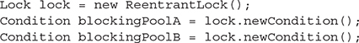

By having multiple conditions, you are effectively categorizing the threads waiting on a lock and can, therefore, wake up a subset of the waiting threads.

Conditions can also be used when you can’t use a BlockingQueue to coordinate the activities of two or more threads.

ReentrantReadWriteLock

Imagine a video game that was storing a collection of high scores using a non-thread-safe collection. With a non-thread-safe collection, it is important that if a thread is attempting to modify the collection, it must have exclusive access to the collection. To allow multiple threads to concurrently read the high score list or allow a single thread to add a new score, you could use a ReadWriteLock.

A ReentrantReadWriteLock is not actually a Lock; it implements the ReadWriteLock interface. What a ReentrantReadWriteLock does is produce two specialized Lock instances, one to a read lock and the other to a write lock.

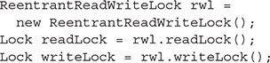

These two locks are a matched set—one cannot be held at the same time as the other (by different threads). What makes these locks unique is that multiple threads can hold the read lock at the same time, but only one thread can hold the write lock at a time.

This example shows how a non-thread-safe collection (an ArrayList) can be made thread-safe, allowing concurrent reads but exclusive access by a writing thread:

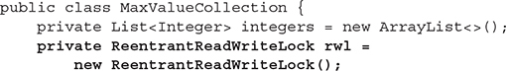

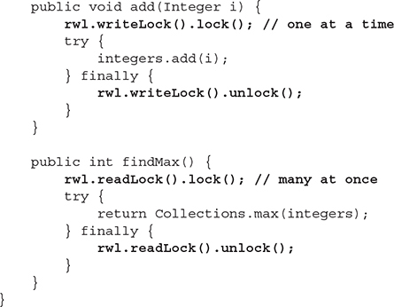

Instead of wrapping a collection with Lock objects to ensure thread safety, you can use one of the thread-safe collections you’ll learn about in the next section.

**CERTIFICATION OBJECTIVE**

**USE JAVA.UTIL.CONCURRENT COLLECTIONS (OCP OBJECTIVE 10.4)**

*10.4   Use java.util.concurrent collections and classes including CyclicBarrier and CopyOnWriteArrayList.*

Imagine an online video game with a list of the top 20 scores in the last 30 days. You could model the high score list using a java.util.ArrayList. As scores expire, they are removed from the list, and as new scores displace existing scores, remove and insert operations are performed. At the end of every game, the list of high scores is displayed. If the game is popular, then a lot of people (threads) will be reading the list at the same time. Occasionally, the list will be modified—734sometimes by multiple threads—probably at the same time that it is being read by a large number of threads.

A traditional java.util.List implementation such as java.util.ArrayList is not thread-safe. Concurrent threads can safely read from an ArrayList and possibly even modify the elements stored in the list, but if any thread modifies the structure of the list (add or remove operation), then unpredictable behavior can occur.

Look at the ArrayListRunnable class in the following example. What would happen if there were a single instance of this class being executed by several threads? You might encounter several problems, including ArrayIndexOutOfBoundsException, duplicate values, skipped values, and null values. Not all threading problems manifest immediately. To observe the bad behavior, you might have to execute the faulty code multiple times or under different system loads. It is important that you are able to recognize the difference between thread-safe and non-thread-safe code yourself, because the compiler will not detect thread-unsafe code.

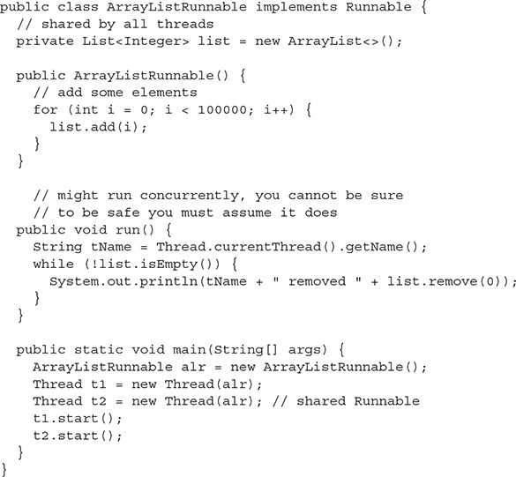

To make a collection thread-safe, you could surround all the code that accessed the collection in synchronized blocks or use a method such as Collections.synchronizedList(new ArrayList()). Using synchronization to safeguard a collection creates a performance bottleneck and reduces the liveness of your application. The java.util.concurrent package provides several types of collections that are thread-safe but do not use coarse-grained synchronization. When a collection will be concurrently accessed in an application you are developing, you should always consider using the collections outlined in the following sections.



***Problems in multithreaded applications may not always manifest—a lot depends on the underlying operating system and how other applications affect the thread scheduling of a problematic application. On the exam, you might be asked about the “probable” or “most likely“ outcome. Unless you are asked to identify every possible outcome of a code sample, don’t get hung up on unlikely results. For example, if a code sample uses*Thread.sleep(1000)*and nothing indicates that the thread would be interrupted while it was sleeping, it would be safe to assume that the thread would resume execution around one second after the call to sleep.***

Copy-on-Write Collections

The copy-on-write collections from the java.util.concurrent package implement one of several mechanisms to make a collection thread-safe. By using the copy-on-write collections, you eliminate the need to implement synchronization or locking when manipulating a collection using multiple threads.

The CopyOnWriteArrayList is a List implementation that can be used concurrently without using traditional synchronization semantics. As its name implies, a CopyOnWriteArrayList will never modify its internal array of data. Any mutating operations on the List (add, set, remove, etc.) will cause a new modified copy of the array to be created, which will replace the original read-only array. The read-only nature of the underlying array in a CopyOnWriteArrayList allows it to be safely shared with multiple threads. **Remember that read-only (immutable) objects are always thread-safe.**

The essential thing to remember with a copy-on-write collection is that a thread that is looping through the elements in a collection must keep a reference to the same unchanging elements throughout the duration of the loop; this is achieved with the use of an Iterator. You want to keep using the old, unchanging collection that you began a loop with. When you use list.iterator(), the returned Iterator will always reference the collection of elements as it was when list.iterator() was called, even if another thread modifies the collection. Any mutating methods called on a copy-on-write–based Iterator or ListIterator (such as add, set, or remove) will throw an UnsupportedOperationException.



***A*for-each*loop uses an*Iterator*when executing, so it is safe to use with a copy-on-write collection, unlike a traditional*for*loop.***



The java.util.concurrent package provides two copy-on-write-based collections: CopyOnWriteArrayList and CopyOnWriteArraySet. Use the copy-on-write collections when your data sets remain relatively small and the number of read operations and traversals greatly outnumber modifications to the collections. Modifications to the collections (not the elements within) are expensive because the entire internal array must be duplicated for each modification.



***A thread-safe collection does not make the elements stored within the collection thread-safe. Just because a collection that contains elements is threadsafe does not mean the elements themselves can be safely modified by multiple threads. You might have to use atomic variables, locks, synchronized code blocks, or immutable (read-only) objects to make the objects referenced by a collection thread-safe.***

Concurrent Collections

The java.util.concurrent package also contains several concurrent collections that can be concurrently read and modified by multiple threads, but without the copy-on-write behavior seen in the copy-on-write collections. The concurrent collections include

   ConcurrentHashMap

   ConcurrentLinkedDeque

   ConcurrentLinkedQueue

   ConcurrentSkipListMap

   ConcurrentSkipListSet

Be aware that an Iterator for a concurrent collection is weakly consistent; it can return elements from the point in time the Iterator was created **or later**. This means that while you are looping through a concurrent collection, you might observe elements that are being inserted by other threads. In addition, you may observe only some of the elements that another thread is inserting with methods such as addAll when concurrently reading from the collection. Similarly, the size method may produce inaccurate results. Imagine attempting to count the number of people in a checkout line at a grocery store. While you are counting the people in line, some people may join the line and others may leave. Your count might end up close but not exact by the time you reach the end. This is the type of behavior you might see with a weakly consistent collection. The benefit to this type of behavior is that it is permissible for multiple threads to concurrently read and write a collection without having to create multiple internal copies of the collection, as is the case in a copy-on-write collection. If your application cannot deal with these inconsistencies, you might have to use a copy-on-write collection.

The ConcurrentHashMap and ConcurrentSkipListMap classes implement the ConcurrentMap interface. A ConcurrentMap enhances a Map by adding the atomic putIfAbsent, remove, and replace methods. For example, the putIfAbsent method is equivalent to performing the following code as an atomic operation:

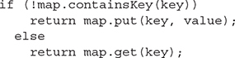

ConcurrentSkipListMap and ConcurrentSkipListSet are sorted. ConcurrentSkipListMap keys and ConcurrentSkipListSet elements require the use of the Comparable or Comparator interfaces to enable ordering.

Blocking Queues

The copy-on-write and the concurrent collections are centered on the idea of multiple threads sharing data. Sometimes, instead of shared data (objects), you need to transfer data between two threads. A BlockingQueue is a type of shared collection that is used to exchange data between two or more threads while causing one or more of the threads to wait until the point in time when the data can be exchanged. One use case of a BlockingQueue is called the producer-consumer problem. In a producer-consumer scenario, one thread produces data, then adds it to a queue, and another thread must consume the data from the queue. A queue provides the means for the producer and the consumer to exchange objects. The java.util.concurrent package provides several BlockingQueue implementations. They include

   ArrayBlockingQueue

   LinkedBlockingDeque

   LinkedBlockingQueue

   PriorityBlockingQueue

   DelayQueue

   LinkedTransferQueue

   SynchronousQueue

General Behavior

A blocking collection, depending on the method being called, may cause a thread to block until another thread calls a corresponding method on the collection. For example, if you attempt to remove an element by calling take() on any BlockingQueue that is empty, the operation will block until another thread inserts an element. Don’t call a blocking operation in a thread unless it is safe for that thread to block. The commonly used methods in a BlockingQueue are described in the following table.

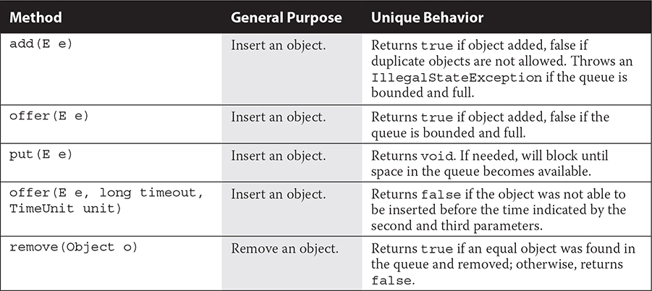

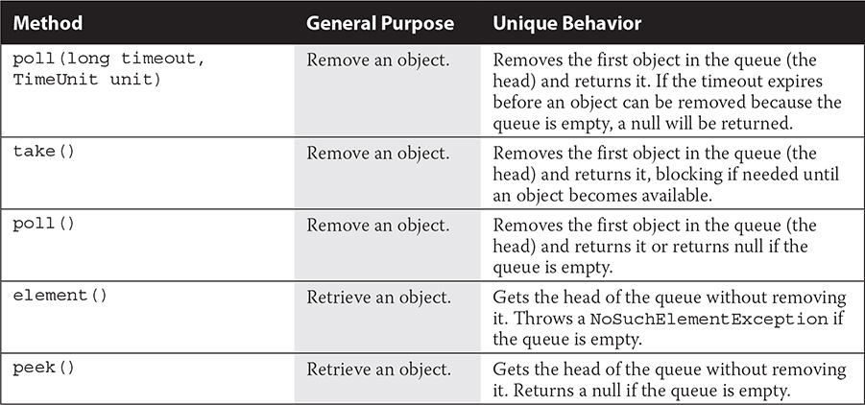

Bounded Queues

ArrayBlockingQueue, LinkedBlockingDeque, and LinkedBlockingQueue support a bounded capacity and will block on put(e) and similar operations if the collection is full. LinkedBlockingQueue is optionally bounded, depending on the constructor you use.

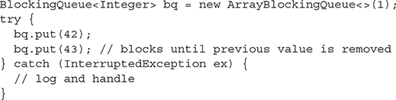

Special-Purpose Queues

A SynchronousQueue is a special type of bounded blocking queue; it has a capacity of zero. Having a zero capacity, the first thread to attempt either an insert or remove operation on a SynchronousQueue will block until another thread performs the opposite operation. You use a SynchronousQueue when you need threads to meet up and exchange an object.

A DelayQueue is useful when you have objects that should not be consumed until a specific time. The elements added to a DelayQueue will implement the java.util.concurrent.Delayed interface, which defines a single method: public long getDelay(TimeUnit unit). The elements of a DelayQueue can only be taken once their delay has expired.

The LinkedTransferQueue

A LinkedTransferQueue (added in Java 7) is a superset of ConcurrentLinkedQueue, SynchronousQueue, and LinkedBlockingQueue. It can function as a concurrent Queue implementation similar to ConcurrentLinkedQueue. It also supports unbounded blocking (consumption blocking) similar to LinkedBlockingQueue via the take() method. Like a SynchronousQueue, a LinkedTransferQueue can be used to make two threads rendezvous to exchange an object. Unlike a SynchronousQueue, a LinkedTransferQueue has internal capacity, so the transfer(E) method is used to block until the inserted object (and any previously inserted objects) is consumed by another thread.

In other words, a LinkedTransferQueue might do almost everything you need from a Queue.

Because a LinkedTransferQueue implements the BlockingQueue, TransferQueue, and Queue interfaces, it can be used to showcase all the different methods that can be used to add and remove elements using the various types of queues. Creating a LinkedTransferQueue is easy. Because LinkedTransferQueue is not bound by size, a limit to the number of elements CANNOT be supplied to its constructor.



There are many methods to add a single element to a LinkedTransferQueue. Note that any method that blocks or waits for any period may throw an InterruptedException.

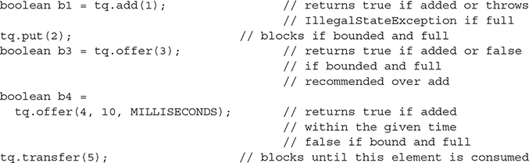

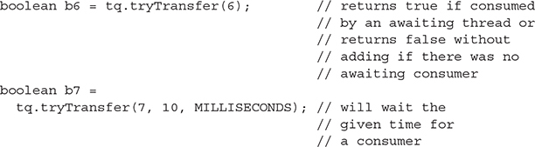

Shown next are the various methods to access a single value in a LinkedTransferQueue. Again, any method that blocks or waits for any period may throw an InterruptedException.

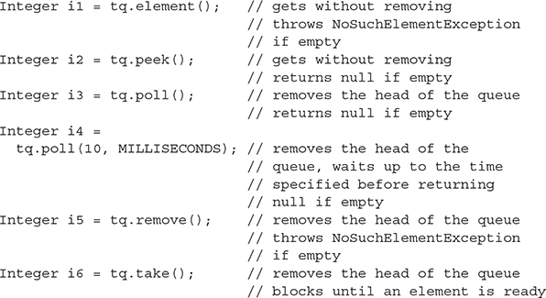



***Use a*LinkedTransferQueue*(added in Java 7) instead of another comparable queue type. The other*java.util.concurrent*queues (introduced in Java 5) are less efficient than*LinkedTransferQueue*.***

Controlling Threads with CyclicBarrier

Whereas blocking queues force threads to wait based on capacity or until a method is called on the queue, a CyclicBarrier can force threads to wait at a specific point in the execution until all threads reach that point before continuing. You can think of that point in the execution as a *barrier:* no thread can proceed beyond that point until all other threads have also reached it.

Imagine you have two threads that are processing data in arrays and you want to copy the processed data from the arrays to a final ArrayList that contains data from both threads. You can’t have both threads accessing the final ArrayList because ArrayList is not thread-safe. It is better to wait until both threads are done processing the arrays and only then copy the data to the final ArrayList using one thread.

This is an example of the type of problem where CyclicBarrier can be useful. When you can break up a problem into smaller pieces that can be processed concurrently and then combine the data into a result at certain key points in the processing, using a CyclicBarrier ensures the threads wait for each other at those key points in the execution.

Let’s take a look at some code to see how to use CyclicBarrier to force two threads to wait for each other. In this example, we’ll use the optional Runnable that CyclicBarrier will take and run, once both threads reach the barrier point. This Runnable is run only one time, by the last thread to reach the barrier and before any of the threads can continue, ensuring the code in the Runnable is thread-safe. Each thread processes a small array and then ends, but imagine how this idea might be applied to threads processing large arrays a chunk at a time and continuing after a barrier is reached. In fact, that’s exactly why CyclicBarrier is named “cyclic”: the CyclicBarrier can be reused after the threads are released to continue running.

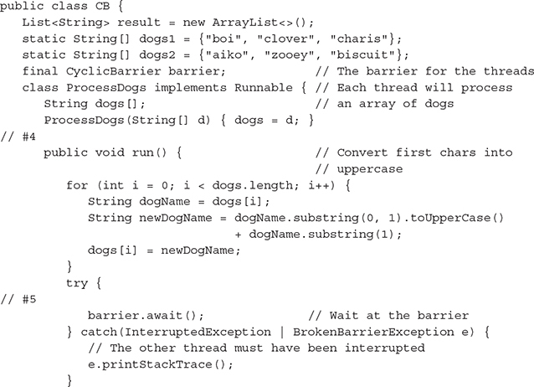

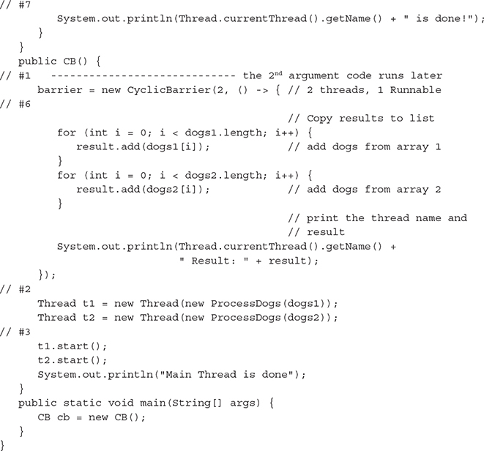

In this example, we have two arrays of dog names and the processing is quite simple; we just convert the first letter of each dog name from lowercase to uppercase. Once both arrays have been processed, we then combine the results into an ArrayList of dog names. In the class CB, we define the result ArrayList, where we’ll write results when both threads have finished processing the two arrays, dogs1 and dogs2. We also declare the CyclicBarrier that both threads will use to wait for each other. Let’s step through how the code executes (follow the numbers in the code):

1.   In the CB constructor, we create a new CyclicBarrier, passing in the number of threads that will wait at the barrier **and a Runnable that will be run by the last thread to reach the barrier.** Here, we’re using a lambda expression for this Runnable.

2.   We then create two threads, t1 and t2, and pass each the ProcessDogs Runnable. When we create the ProcessDogs Runnables for the threads, we pass in the array that the thread will process: we pass dogs1 to thread t1 and dogs2 to thread t2.

3.   We then start both threads and print a message saying the main thread is done.

4.   The two threads begin running and process their respective arrays. The ProcessDogs run() method simply iterates through the array and converts the first letter of the dog name to uppercase, storing the modified string back in the original array.

5.   Once the loop is complete, the thread then waits at the barrier by calling the barrier’s await() method. We’ll come back and talk about the exception handling in a minute.

6.   Once both threads reach the barrier, then the Runnable we passed to the CyclicBarrier constructor is executed by the last thread to reach the barrier. This adds all the items from both arrays to the ArrayList result and prints the result.

7.   When the Runnable completes, then both threads are released and can continue executing where they left off at the barrier. In this example, each thread just prints a message to the console indicating it’s done (with the thread name), but you can imagine that in a more realistic example, they could continue on to do more processing. Notice that neither thread can print out that it’s done until *both* threads have reached the barrier and the barrier Runnable is complete.

If you have a machine with at least two cores and you run this code several times, you may see thread 0 displaying the result or you may see thread 1 displaying the result. It just depends on which thread gets to the barrier last. Also, notice that the main thread often finishes before the other threads, but not always. The most important point to notice is that *every time* you run this code, you will see the resulting ArrayList displayed *before* the messages from the threads that they are done. Why? Because both threads must wait at the barrier for the barrier Runnable to complete before they can continue!

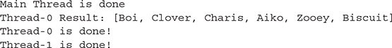

Now let’s get back to the exception handling on the barrier.await() method. What if one of the threads gets stuck? If this happens, then all the other threads waiting at the barrier get an InterruptedException or a BrokenBarrierException and are all released. In that case, the barrier Runnable will not run and the remaining threads will continue.

You can reuse a CyclicBarrier or use multiple CyclicBarriers to coordinate threads at more than one barrier point. For example, you might have the thread Runnable execute some code, wait at barrier 1, then execute some more code, wait at barrier 2, and then finally execute more code and finish. To reset a barrier to its initial state, call the reset() method. If you need the main thread to also wait at the barrier, you can call await() on the barrier in the main thread, but don’t forget to increase the number of threads allowed at the barrier by one when you create the CyclicBarrier.

**CERTIFICATION OBJECTIVE**

**USE EXECUTORS AND THREADPOOLS (OCP OBJECTIVE 10.1)**

*10.1   Create worker threads using Runnable, Callable and use an ExecutorService to concurrently execute tasks.*

Executors (and the ThreadPools used by them) help meet two of the same needs as Threads do:

1.   Creating and scheduling some Java code for execution and

2.   Optimizing the execution of that code for the hardware resources you have available (using all CPUs, for example)

With traditional threading, you handle needs 1 and 2 yourself. With Executors, you handle need 1, but you get to use an off-the-shelf solution for need 2. The java.util.concurrent package provides several different off-the-shelf solutions (Executors and ThreadPools), which you’ll read about in this chapter.



***When you have multiple needs or concerns, it is common to separate the code for each need into different classes. This makes your application more modular and flexible. This is a fundamental programming principle called “separation of concerns.”***

In a way, an Executor is an alternative to starting new threads. Using Threads directly can be considered low-level multithreading, whereas using Executors can be considered high-level multithreading. To understand how an Executor can replace manual thread creation, let us first analyze what happens when starting a new thread.

1.   First, you must identify a task of some sort that forms a self-contained unit of work. You will typically code this task as a class that implements the Runnable interface.

2.   After creating a Runnable, the next step is to execute it. You have two options for executing a Runnable:

   **Option one** Call the run method synchronously (i.e., without starting a thread). This is probably **not** what you would normally do.



   **Option two** Call the method indirectly, most likely with a new thread.

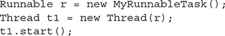

The second approach has the benefit of executing your task asynchronously, meaning the primary flow of execution in your program can continue executing, without waiting for the task to complete. On a multiprocessor system, you must divide a program into a collection of asynchronous tasks that can execute 747concurrently in order to take advantage of all of the computing power a system possesses.

Identifying Parallel Tasks

Some applications are easier to divide into separate tasks than others. A single-user desktop application may only have a handful of tasks that are suitable for concurrent execution. Networked multiuser servers, on the other hand, have a natural division of work. Each user’s actions can be a task. Continuing our computer game scenario, imagine a computer program that can play chess against thousands of people simultaneously. Each player submits his or her move, the computer calculates its move, and finally it informs the player of that move.

Why do we need an alternative to new Thread(r).start()? What are the drawbacks? If we use our online chess game scenario, then having 10,000 concurrent players might mean 10,001 concurrent threads. (One thread awaits network connections from clients and performs a Thread(r).start() for each player.) The player thread would be responsible for reading the player’s move, computing the computer’s move, and making the response.

How Many Threads Can You Run?

Do you own a computer that can concurrently run 10,000 threads or 1,000 or even 100? Probably not—this is a trick question. A quad-core CPU (with four processors per unit) might be able to execute two threads per core for a total of eight concurrently executing threads. You can start 10,000 threads, but not all of them will be running at the same time. The underlying operating system’s task scheduler rotates the threads so that they each get a slice of time on a processor. Ten thousand threads all competing for a turn on a processor wouldn’t make for a very responsive system. Threads would either have to wait so long for a turn or get such small turns (or both) that performance would suffer.

In addition, each thread consumes system resources. It takes processor cycles to perform a context switch (saving the state of a thread and resuming another thread), and each thread consumes system memory for its stack space. Stack space is used for temporary storage and to keep track of where a thread returns to after completing a method call. Depending on a thread’s behavior, it might be possible to lower the cost (in RAM) of creating a thread by reducing a thread’s stack size.



***To reduce a thread’s stack size, the Oracle JVM supports using the nonstandard-*Xss1024k*option to the*java*command. Note that decreasing the value too far can result in some threads throwing exceptions when performing certain tasks, such as making a large number of recursive method calls.***

Another limiting factor in being able to run 10,000 threads in an application has to do with the underlying limits of the OS. Operating systems typically have limits on the number of threads an application can create. These limits can prevent a buggy application from spawning countless threads and making your system unresponsive. If you have a legitimate need to run 10,000 threads, you will probably have to consult your operating system’s documentation to discover possible limits and configuration options.

CPU-Intensive vs. I/O-Intensive Tasks

If you correctly configure your OS and you have enough memory for each thread’s stack space plus your application’s primary memory (heap), will you be able to run an application with 10,000 threads? It depends…. Remember that your processor can only run a small number of concurrent threads (in the neighborhood of 8 to 16 threads). Yet many network server applications, such as our online chess game, would have traditionally started a new thread for each connected client. A system might be able to run an application with such a high number of threads because most of the threads are not doing anything. More precisely, in an application like our online chess server, most threads would be blocked waiting on I/O operations such as InputStream.read or OutputStream.write method calls.

When a thread makes an I/O request using InputStream.read and the data to be read isn’t already in memory, the calling thread will be put to sleep by the system until the requested data can be loaded. This is much more efficient than keeping the thread on the processor while it has nothing to do. I/O operations are extremely slow when compared to compute operations—reading a sector from a hard drive takes much longer than adding hundreds of numbers. A processor might execute hundreds of thousands, or even millions, of instructions while awaiting the completion of an I/O request. The type of work (either CPU intensive or I/O intensive) a thread will be performing is important when considering how many threads an application can safely run. Imagine your world-class-computer 749chess-playing program takes one minute of processor time (no I/O at all) to calculate each move. In this scenario, it would only take about 16 concurrent players to cause your system to have periods of maximum CPU utilization.



***If your tasks will be performing I/O operations, you should be concerned about how increased load (users) might affect scalability. If your tasks perform blocking I/O, then you might need to utilize a thread-per-task model. If you don’t, then all your threads may be tied up in I/O operations with no threads remaining to support additional users. Another option would be to investigate whether you can use nonblocking I/O instead of blocking I/O.***

Fighting for a Turn

If it takes the computer player one minute to calculate a turn and it takes a human player about the same time, then each player only uses one minute of CPU time out of every two minutes of real time. With a system capable of executing 16 concurrent game threads, that means we could handle 32 connected players. But if all 32 players make their turn at once, the computer will be stuck trying to calculate 32 moves at once. If the system uses preemptive multitasking (the most common type), then each thread will get preempted while it is running (paused and kicked off the CPU) so a different thread can take a turn (time slice). In most JVM implementations, this is handled by the underlying operating system’s task scheduler. The task scheduler is itself a software program. The more CPU cycles spent scheduling and preempting threads, the less processor time you have to execute your application threads. Note that it would appear to the untrained observer that all 32 threads were running concurrently because a preemptive multitasking system will switch out the running threads frequently (millisecond time slices).

Decoupling Tasks from Threads

The best design would be one that utilized as many system resources as possible without attempting to overutilize the system. If 16 threads are all you need to fully utilize your CPU, why would you start more than that? In a traditional system, you start more threads than your system can concurrently run and hope that only a small number are in a running state. If we want to adjust the number of threads that are started, we need to decouple the tasks that are to be performed (our Runnable instances) from our thread creation and starting. This is where a java.util.concurrent.Executor can help. The basic usage looks something like this:

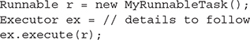

A java.util.concurrent.Executor is used to execute the run method in a Runnable instance much like a thread. Unlike a more traditional new Thread(r).start(), an Executor can be designed to use any number of threading approaches, including

   Not starting any threads at all (task is run in the calling thread)

   Starting a new thread for each task

   Queuing tasks and processing them with only enough threads to keep the CPU utilized

You can easily create your own implementations of an Executor with custom behaviors. As you’ll see soon, several implementations are provided in the standard Java SE libraries. Looking at sample Executor implementations can help you to understand their behavior. This next example doesn’t start any new threads; instead, it executes the Runnable using the thread that invoked the Executor.

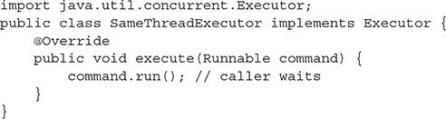

The following Executor implementation would use a new thread for each task:

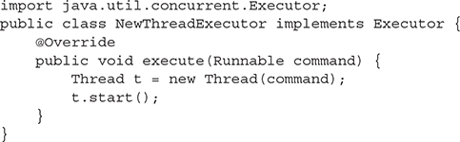

This example shows how an Executor implementation can be put to use:



By coding to the Executor interface, the submission of tasks is decoupled from the execution of tasks. The result is that you can easily modify how threads are used to execute tasks in your applications.



***There is no “right number” of threads for task execution. The type of task (CPU intensive versus I/O intensive), number of tasks, I/O latency, and system resources all factor into determining the ideal number of threads to use. You should test your applications to determine the ideal threading model. This is one reason why the ability to separate task submission from task execution is important.***

Several Executor implementations are supplied as part of the standard Java libraries. The Executors class (notice the “s” at the end) is a factory for Executor implementations.



The Executor instances returned by Executors are actually of type ExecutorService (which extends Executor). An ExecutorService provides management capability and can return Future instances that are used to obtain the result of executing a task asynchronously. We’ll talk more about Future in a few pages!



Three types of ExecutorService instances can be created by the factory methods in the Executors class: cached thread pool executors, fixed thread pool executors, and single thread pool executors.

Cached Thread Pools



A cached thread pool will create new threads as they are needed and reuse threads that have become free. Threads that have been idle for 60 seconds are removed from the pool.

Watch out! Without some type of external limitation, a cached thread pool may be used to create more threads than your system can handle.

Fixed Thread Pools—Most Common



A fixed thread pool is constructed using a numeric argument (4 in the preceding example) that specifies the number of threads used to execute tasks. This type of pool will probably be the one you use the most because it prevents an application from overloading a system with too many threads. Tasks that cannot be executed immediately are placed on an unbounded queue for later execution.



***You might base the number of threads in a fixed thread pool on some attribute of the system your application is executing on. By tying the number of threads to system resources, you can create an application that scales with changes in system hardware. To query the number of available processors, you can use the*java.lang.Runtime*class.***



ThreadPoolExecutor

Both Executors.newCachedThreadPool() and Executors.newFixedThreadPool(4) return objects of type java.util.concurrent.ThreadPoolExecutor (which implements ExecutorService and Executor). You will typically use the Executors factory methods instead of creating ThreadPoolExecutor instances directly, but you can cast the fixed or cached thread pool ExecutorService references if you need access to the additional methods. The following example shows how you could dynamically adjust the thread count of a pool at runtime:



Single Thread Pools



A single thread pool uses a single thread to execute tasks. Tasks that cannot be executed immediately are placed on an unbounded queue for later execution. Unlike a fixed thread pool executor with a size of 1, a single thread executor prevents any adjustments to the number of threads in the pool.

Scheduled Thread Pool

In addition to the three basic ExecutorService behaviors outlined already, the Executors class has factory methods to produce a ScheduledThreadPoolExecutor. A ScheduledThreadPoolExecutor enables tasks to be executed after a delay or at repeating intervals. Here, we see some thread-scheduling code in action:

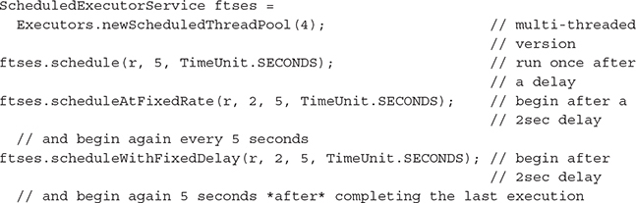

The Callable Interface

So far, the Executors examples have used a Runnable instance to represent the task to be executed. The java.util.concurrent.Callable interface serves the same purpose as the Runnable interface, but provides more flexibility. Unlike the Runnable interface, a Callable may return a result upon completing execution and may throw a checked exception. An ExecutorService can be passed a Callable instead of a Runnable.



***Avoid using methods such as*Object.wait, Object.notify,*and*Object.notifyAll*in tasks (*Runnable*and*Callable*instances) that are submitted to an*Executor*or*ExecutorService*. Because you might not know what the threading behavior of an*Executor*is, it is a good idea to avoid operations that may interfere with thread execution. Avoiding these types of methods is advisable anyway since they are easy to misuse.***

**The primary benefit of using a Callable is the ability to return a result**. Because an ExecutorService may execute the Callable asynchronously (just like a Runnable), you need a way to check the completion status of a Callable and obtain the result later. A java.util.concurrent.Future is used to obtain the status and result of a Callable. Without a Future, you’d have no way to obtain the result of a completed Callable and you might as well use a Runnable (which returns void) instead of a Callable. Here’s a simple Callable example that loops a random number of times and returns the random loop count:

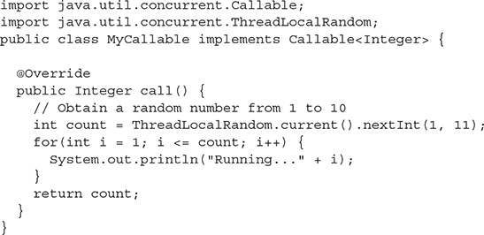

Submitting a Callable to an ExecutorService returns a Future reference. When you use the Future to obtain the Callable’s result, you will have to handle two possible exceptions:

   **InterruptedException** Raised when the thread calling the Future’s get() method is interrupted before a result can be returned

   **ExecutionException** Raised when an exception was thrown during the execution of the Callable’s call() method

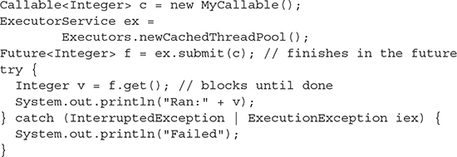



***I/O activities in your*Runnable*and*Callable*instances can be a serious bottleneck. In preceding examples, the use of*System.out.println()*will cause I/O activity. If this wasn’t a trivial example being used to demonstrate*Callable*and*ExecutorService*, you would probably want to avoid repeated calls to*println()*in the*Callable*. One possibility would be to use*StringBuilder*to concatenate all output strings and have a single*println()*call before the*call()*method returns. Another possibility would be to use a logging framework (see*java.util.logging*) in place of any*println()*calls.***

ThreadLocalRandom

The first Callable example used a java.util.concurrent.ThreadLocalRandom. ThreadLocalRandom was introduced in Java 7 as a new way to create random numbers. Math.random() and shared Random instances are thread-safe, but suffer from contention when used by multiple threads. A ThreadLocalRandom is unique to a thread and will perform better because it avoids any contention. ThreadLocalRandom also provides several convenient methods such as nextInt(int,int) that allow you to specify the range of possible values returned.

ExecutorService Shutdown

You’ve seen how to create Executors and how to submit Runnable and Callable tasks to those Executors. The final component to using an Executor is shutting it down once it is done processing tasks. An ExecutorService should be shut down once it is no longer needed to free up system resources and to allow graceful application shutdown. Because the threads in an ExecutorService may be nondaemon threads, they may prevent normal application termination. In other words, your application stays running after completing its main method. You could perform a System.exit(0) call, but it would preferable to allow your threads to complete their current activities (especially if they are writing data).

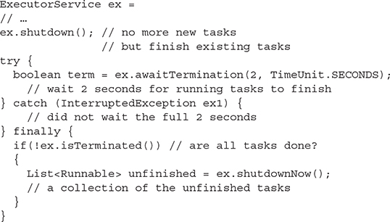

For long-running tasks (especially those with looping constructs), consider using Thread.currentThread().isInterrupted() to determine if a Runnable or Callable should return early. The ExecutorService.shutdownNow() method will typically call Thread.interrupt() in an attempt to terminate any unfinished tasks.

**CERTIFICATION OBJECTIVE**

**USE THE PARALLEL FORK/JOIN FRAMEWORK (OCP OBJECTIVE 10.5)**

*10.5   Use the parallel Fork/Join Framework.*

The Fork-Join Framework provides a highly specialized ExecutorService. The other ExecutorService instances you’ve seen so far are centered on the concept of submitting multiple tasks to an ExecutorService. By doing this, you provide an easy avenue for an ExecutorService to take advantage of all the CPUs in a system by using threads to complete tasks. Sometimes, you don’t have multiple tasks; instead, you have one really big task.

There are many large tasks or problems you might need to solve in your application. For example, you might need to initialize the elements of a large array with values. You might think that initializing an array doesn’t sound like a large complex task in need of a framework. The key is that it needs to be a **large** task. What if you need to fill up a 100,000,000-element array with randomly generated values? The Fork/Join Framework makes it easier to tackle big tasks like this, while leveraging all of the CPUs in a system.

Divide and Conquer

Certain types of large tasks can be split up into smaller subtasks; those subtasks might, in turn, be split up into even smaller tasks. There is no limit to how many times you might subdivide a task. For example, imagine the task of having to repaint a single long fence that borders several houses. The “paint the fence” task could be subdivided so that each household would be responsible for painting a section of the fence. Each household could then subdivide their section into subsections to be painted by individual family members. In this example, there are three levels of recursive calls. The calls are considered recursive because at each step we are trying to accomplish the same thing: paint the fence. In other words, Joe, one of the home owners, was told by his wife, “paint that (huge) fence; it looks old.” Joe decides that painting the whole fence is too much work and talks all the households along the fence into taking a subsection. Now Joe is telling himself “paint that (subsection of) fence; it looks old.” Again, Joe decides that it is still too much work and subdivides his section into smaller sections for each member of his household. Again, Joe tells himself “paint that (subsection of) fence; it looks old,” but this time, he decides that the amount of work is manageable and proceeds to paint his section of fence. Assuming everyone else paints their subsections (hopefully in a timely fashion), the result is the entire fence being painted.



***When using the Fork/Join Framework, your tasks will be coded to decide how many levels of recursion (how many times to subdivide) are appropriate. You’ll want to split things up into enough subtasks that you have adequate tasks to keep all of your CPUs utilized. Sometimes, the best number of tasks can be a little hard to determine because of factors we will discuss later. You might have to benchmark different numbers of task divisions to find the optimal number of subtasks that should be created.***

Just because you can use Fork/Join to solve a problem doesn’t always mean you should. If our initial task is to paint eight fence planks, then Joe might just decide to paint them himself. The effort involved in subdividing the problem and assigning those tasks to workers (threads) can sometimes be more than the actual work you want to perform. The number of elements (or fence planks) is not the only thing to consider—the amount of work performed on each element is also important. Imagine if Joe was asked to paint a mural on each fence plank. Because processing each element (fence plank) is so time consuming, in this case, it might be beneficial to adopt a divide-and-conquer solution even though there is a small number of elements.

ForkJoinPool

The Fork/Join ExecutorService implementation is java.util.concurrent.ForkJoinPool. You will typically submit a single task to a ForkJoinPool and await its completion. The ForkJoinPool and the task itself work together to divide and conquer the problem. Any problem that can be recursively divided can be solved using Fork/Join. Anytime you want to perform the same operation on a collection of elements (painting thousands of fence planks or initializing 100,000,000 array elements), consider using Fork/Join.

To create a ForkJoinPool, simply call its no-arg constructor:



The no-arg ForkJoinPool constructor creates an instance that will use the Runtime.availableProcessors() method to determine the level of parallelism. The level of parallelism determines the number of threads that will be used by the ForkJoinPool.

There is also a ForkJoinPool(int parallelism) constructor that allows you to override the number of threads that will be used.

ForkJoinTask

Just as with Executors, you must capture the task to be performed as Java code. With the Fork/Join Framework, a java.util.concurrent.ForkJoinTask instance (actually a subclass—more on that later) is created to represent the task that should be accomplished. This is different from other executor services that primarily used either Runnable or Callable. A ForkJoinTask concrete subclass has many methods (most of which you will never use), **but the following methods are important: compute(), fork(), and join().**

A ForkJoinTask subclass is where you will perform most of the work involved in completing a Fork/Join task. ForkJoinTask is an abstract base class; we will discuss the two subclasses, RecursiveTask and RecursiveAction, later. The basic structure of any ForkJoinTask is shown in this pseudocode example:

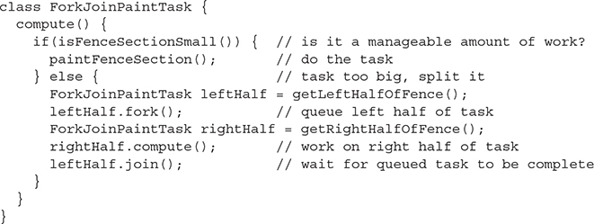

Fork

**With the Fork/Join Framework, each thread in the ForkJoinPool has a queue of the tasks it is working on; this is unlike most ExecutorService implementations that have a single shared task queue.** The fork() method places a ForkJoinTask in the current thread’s task queue. A normal thread does not have a queue of tasks—only the specialized threads in a ForkJoinPool do. This means that you can only call fork() if you are within a ForkJoinTask that is being executed by a ForkJoinPool.

Initially, only a single thread in a ForkJoinPool will be busy when you submit a task. That thread will begin to subdivide the tasks into smaller tasks. Each time a task is subdivided into two subtasks, you fork (or queue) the first task and compute the second task. In the event you need to subdivide a task into more than two subtasks, each time you split a task, you would fork every new subtask except one (which would be computed).

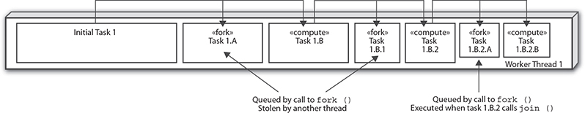

Work Stealing

Notice how the call to fork() is placed before the call to compute() or join(). A key feature of the Fork/Join Framework is work stealing. Work stealing is how the other threads in a ForkJoinPool will obtain tasks. When initially submitting a Fork/Join task for execution, a single thread from a ForkJoinPool begins executing (and subdividing) that task. Each call to fork() placed a new task in the calling thread’s task queue. The order in which the tasks are queued is important. The tasks that have been queued the longest represent larger amounts of work. In the ForkJoinPaintTask example, the task that represents 100 percent of the work would begin executing, and its first queued (forked) task would represent 50 percent of the fence, the next 25 percent, then 12.5 percent, and so on. Of course, this can vary, depending on how many times the task will be subdivided and whether we are 760splitting the task into halves or quarters or some other division, but in this example, we are splitting each task into two parts: queuing one part and executing the second part.

The nonbusy threads in a ForkJoinPool will attempt to steal the oldest (and, therefore, largest) task from any Fork/Join thread with queued tasks. Given a ForkJoinPool with four threads, one possible sequence of events could be that the initial thread queues tasks that represent 50 percent and 25 percent of the work, which are then stolen by two different threads. The thread that stole the 50 percent task then subdivides that task and places a 25 percent task on its queue, which is then stolen by a fourth thread, resulting in four threads that each process 25 percent of the work.

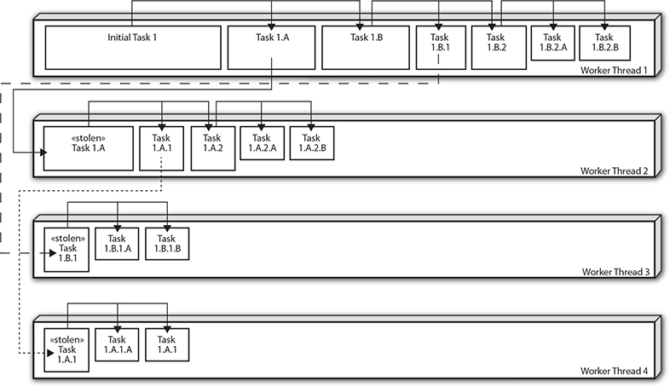

Of course, if everything was always this evenly distributed, you might not have as much of a need for Fork/Join. You could just presplit the work into a number of tasks equal to the number of threads in your system and use a regular ExecutorService. In practice, each of the four threads will not finish their 25 percent of the work at the same time—one thread will be the slow thread that doesn’t get as much work done. There are many reasons for this: The data being processed may affect the amount of computation (25 percent of an array might not mean 25 percent of the workload), or a thread might not get as much time to execute as the other threads. Operating systems and other running applications are also going to consume CPU time. In order to finish executing the Fork/Join task as 761soon as possible, the threads that finish their portions of the work first will start to steal work from the slower threads—this way, you will be able to keep all of the CPU involved. If you only split the tasks into 25 percent of the data (with four threads), then there would be nothing for the faster threads to steal from when they finish early. In the beginning, if the slower thread stole 25 percent of the work and started processing it without further subdividing and queuing, then there would be no work on the slow thread’s queue to steal. You should subdivide the tasks into a few more sections than are needed to evenly distribute the work among the number of threads in your ForkJoinPools because threads will most likely not perform exactly the same. Subdividing the tasks is extra work—if you do it too much, you might hurt performance. Subdivide your tasks enough to keep all CPUs busy, but not more than is needed. Unfortunately, there is no magic number to split your tasks into—it varies based on the complexity of the task, the size of the data, and even the performance characteristics of your CPUs.

Back to fence painting, make the isFenceSectionSmall() logic as simple as possible (low overhead) and easy to change. You should benchmark your Fork/Join code (using the hardware that you expect the code to typically run on) and find an amount of task subdivision that works well. It doesn’t have to be perfect; once you are close to the ideal range, you probably won’t see much variation in performance unless other factors come into play (different CPUs, etc.).

Join

When you call join() on the (left) task, it should be one of the last steps in the compute method, after calling fork() and compute(). Calling join() says, “I can only proceed when this (left) task is done.” Several possible things can happen when you call join():

   The task you call join() on might already be done. Remember you are calling join() on a task that already had fork() called. The task might have been stolen and completed by another thread. In this case, calling join() just verifies the task is complete and you can continue on.

   The task you call join() on might be in the middle of being processed. Another thread could have stolen the task, and you’ll have to wait until the joined task is done before continuing.

   The task you call join() on might still be in the queue (not stolen). In this case, the thread calling join() will execute the joined task.

RecursiveAction

ForkJoinTask is an abstract base class that outlines most of the methods, such as fork() and join(), in a Fork/Join task. If you need to create a ForkJoinTask that does not return a result, then you should subclass RecursiveAction. RecursiveAction extends ForkJoinTask and has a single abstract compute method that you must implement:



An example of a task that does not need to return a result would be any task that initializes an existing data structure. The following example will initialize an array to contain random values. Notice that there is only a single array throughout the entire process. When subdividing an array, you should avoid creating new objects when possible.

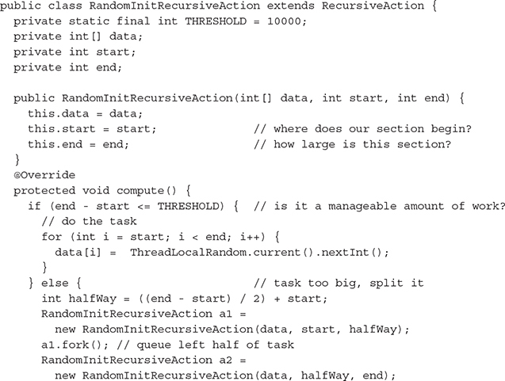

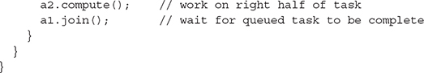

Sometimes, you will see one of the invokeAll methods from the ForkJoinTask class used in place of the fork/compute/join method combination. 763The invokeAll methods are convenience methods that can save some typing. Using them will also help you avoid bugs! The first task passed to invokeAll will be executed (compute is called), and all additional tasks will be forked and joined. In the preceding example, you could eliminate the three fork/compute/join lines and replace them with a single line:



To begin the application, we create a large array and initialize it using Fork/Join:

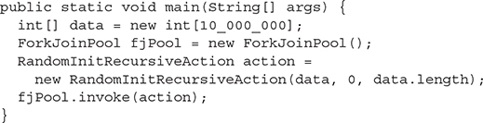

Notice that we do not expect any return values when calling invoke. A RecursiveAction returns nothing.

RecursiveTask

If you need to create a ForkJoinTask that does return a result, then you should subclass RecursiveTask. RecursiveTask extends ForkJoinTask and has a single abstract compute method that you must implement:



The following example will find the position in an array with the greatest value; if duplicate values are found, the first occurrence is returned. Notice that there is only a single array throughout the entire process. (Just like before, when subdividing an array, you should avoid creating new objects when possible.)

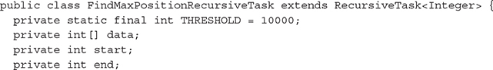

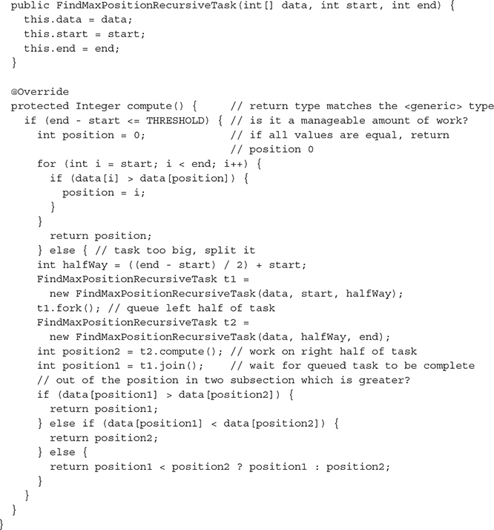

To begin the application, we reuse the RecursiveAction example to create a large array and initialize it using Fork/Join. After initializing the array with random values, we reuse the ForkJoinPool with our RecursiveTask to find the position with the greatest value:

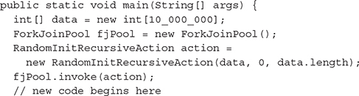

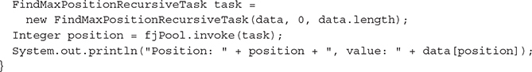

Notice that a value is returned by the call to invoke when using a RecursiveTask.



***If your application will repeatedly submit tasks to a*ForkJoinPool*, then you should reuse a single*ForkJoinPool*instance and avoid the overhead involved in creating a new instance.***

Embarrassingly Parallel

A problem or task is said to be embarrassingly parallel if little or no additional work is required to solve the problem in a parallel fashion. Sometimes, solving a problem in parallel adds so much more overhead that the problem can be solved faster serially. The RandomInitRecursiveAction example, which initializes an array to random values, has no additional overhead because what happens when processing one subsection of an array has no bearing on the processing of another subsection. Technically, there is a small amount of overhead even in the RandomInitRecursiveAction; the Fork/Join Framework and the if statement that determines whether the problem should be subdivided both introduce some overhead. Be aware that it can be difficult to get performance gains that scale with the number of CPUs you have. Typically, four CPUs will result in less than a 4× speedup when moving from a serial to a parallel solution.

The FindMaxPositionRecursiveTask example, which finds the largest value in an array, does introduce a small additional amount of work because you must compare the result from each subsection and determine which is greater. This is only a small amount, however, and adds little overhead. Some tasks may introduce so much additional work that any advantage of using parallel processing is eliminated (the task runs slower than serial execution). If you find yourself performing a lot of processing after calling join(), then you should benchmark your application to determine if there is a performance benefit to using parallel processing. Be aware that performance benefits might only be seen with a certain number of CPUs. A task might run on one CPU in 5 seconds, on two CPUs in 6 seconds, and on four CPUs in 3.5 seconds.

The Fork/Join Framework is designed to have minimal overhead as long as you don’t over-subdivide your tasks and the amount of work required to join results can be kept small. A good example of a task that incurs additional overhead but still benefits from Fork/Join is array sorting. When you split an array into two 766halves and sort each half separately, you then have to combine the two sorted arrays, as shown in the following example:

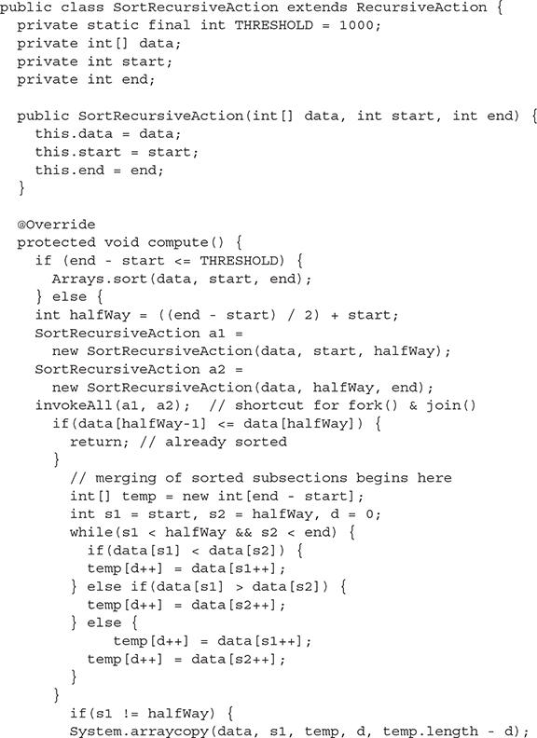

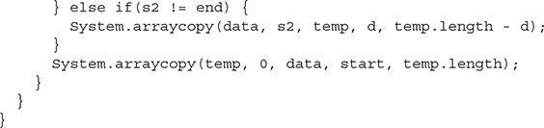

In the previous example, everything after the call to invokeAll is related to merging two sorted subsections of an array into a single larger sorted subsection.



***Because Java applications are portable, the system running your application may not have the hardware resources required to see a performance benefit. Always perform testing to determine which problem and hardware combinations see performance increases when using Fork/Join.***

**CERTIFICATION OBJECTIVE**

**PARALLEL STREAMS (OCP OBJECTIVE 10.6)**

*10.6   Use parallel Streams including reduction, decomposition, merging processes, pipelines and performance.*

Parallel streams are designed for problems you can divide and conquer, just like the problems described in the previous section. In fact, parallel streams are implemented with Fork/Join tasks under the covers, so you’re essentially doing the same thing: that is, splitting up a problem into subtasks that can be executed on separate threads and then joining them back together to produce a result.

Unlike the code you write to take advantage of the Fork/Join Framework, parallel stream code is relatively easy to write. If you think writing RecursiveActions and RecursiveTasks is tricky (we do too!), you’ll be pleased with how much easier parallel streams can be. That said, there are several gotchas to watch out for when using parallel streams, so even though the code is easier to write, you need to pay close attention.

And, like we said about using the Fork/Join Framework, just because you can use parallel streams to solve a problem doesn’t always mean you should. The same concerns apply: the effort to create tasks that can run in threads can add enough overhead that using parallel streams is sometimes slower than using sequential streams. We’ll do testing as we work through some parallel stream code and check our results as we go to make sure we get the performance gains we expect.

How to Make a Parallel Stream Pipeline

In [Chapter 9](https://learning.oreilly.com/library/view/ocp-java-se/9781260117370/ch9.xhtml#ch9), “Streams,” we made a stream parallel by calling the parallel() method on the stream, like this:

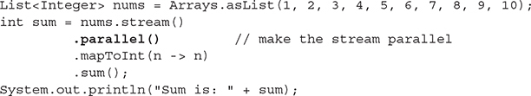

Here, we take a list of numbers, stream them, map each Integer to an int, and sum. To make this very simple stream pipeline parallel, we simply call the parallel() method on the stream.

Let’s take a peek at how the tasks created by this parallel stream get split up and handled by workers in the ForkJoinPool. We can do that by adding a peek() into the pipeline and then printing the name of the thread handling each Integer in the stream:

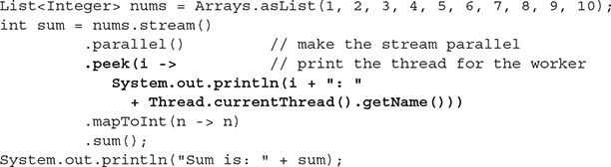

The output (on our computer) is

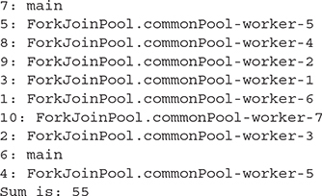

You will likely see different output (although the same final sum) because your computer may have a different number of cores, and the tasks will likely get split up differently. We ran this code on a computer with eight cores, and you can see that the computer used all eight. We might not actually want the computer to use all eight cores (especially for this simple sum), so we can tell the computer 769exactly how many workers to use by creating a custom ForkJoinPool and then submitting a task to the pool for execution:

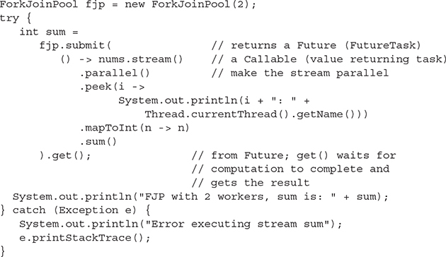

Here is our output now:

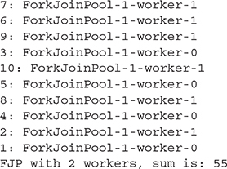

We get the same sum, 55, but now we’re using only two workers to do it. This is friendlier to the computer, which may want some cores to do other things while this task is running.

When we call the submit() method of the ForkJoinPool, we use this method:



and pass a lambda expression for the Callable. Callable is a functional interface, which is why we can express an instance of a class implementing that interface with the lambda expression. The functional method in Callable is call(), which “computes a result” (thus, the lambda we are supplying for the Callable is a Supplier: it takes no arguments and supplies a result).

You’ve seen how to create a parallel stream with parallel(); you can also combine the methods stream() and parallel() into one method, parallelStream(), like this:

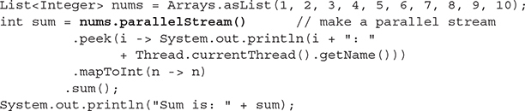

When we run this code (similar to the first version of the code above), we get the following output:

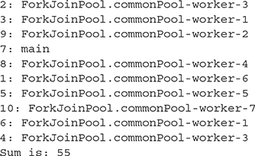

Notice the ordering of the processing: the ordering is totally different from the first example above! When summing numbers, it doesn’t matter in what order they are summed; we’ll get the same result every time. In [Chapter 9](https://learning.oreilly.com/library/view/ocp-java-se/9781260117370/ch9.xhtml#ch9), you saw that if you display the result of a parallel stream pipeline, the ordering is not guaranteed, and you can see that mixed-up ordering in the output here, too.

You can check to see if a stream is parallel with the isParallel() method. This might come in handy if someone hands you a stream and you’re not sure. For instance, the following code checks to see if numsStream is parallel:

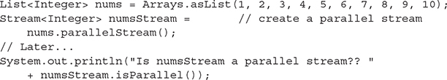

You should see the output:



What if you have a parallel stream and you want to make it not parallel (i.e., sequential)? You can do that with the sequential() method:

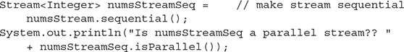

and get the output:



Note here that parallel(), isParallel(), and sequential() are methods of BaseStream (which is the superinterface of Stream), and parallelStream() is a method of the Collection interface. [Table 11-1](https://learning.oreilly.com/library/view/ocp-java-se/9781260117370/ch11.xhtml#ch11tab1) summarizes the methods related to parallel streams that you are expected to know for the exam, which we’ll cover in this chapter.

**TABLE 11-1** Methods Related to Parallel Streams

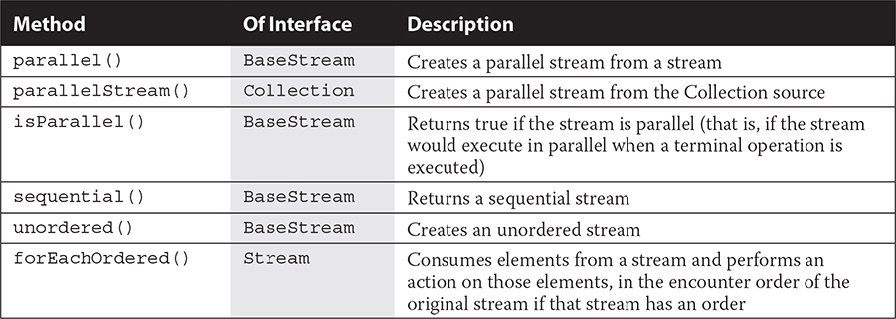

Embarrassingly Parallel, Take Two (with Parallel Streams)

Earlier we talked about how some problems are “embarrassingly parallel”: that is, they’re easily split up into independent pieces that can be computed separately and then combined. These are precisely the kinds of problems that work well with parallel streams. The sum example we’ve been using in this section is a great example of an embarrassingly parallel problem: we can split up the stream into subsections, compute the sum of the subsection, and then combine the sums from each to make one total sum. We visualized this process in [Chapter 9](https://learning.oreilly.com/library/view/ocp-java-se/9781260117370/ch9.xhtml#ch9) with two images. The first illustrates how we compute a sum with a sequential stream:

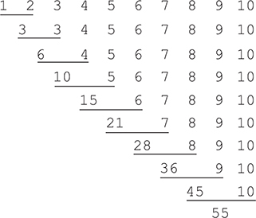

while the second image illustrates how we can compute a sum with a parallel stream that is using two workers:

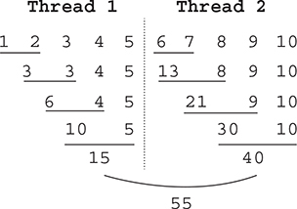

As you can see in the second illustration, the stream can be split in two and each sum computed completely independently from the other and then combined at the end. Again, this is precisely the kind of problem that works well with parallel streams.

We can summarize the conditions that make for successful parallel streams as follows: a problem is most suitable for parallel streams if the pipeline operations are *stateless,* the reduction operation used to compute the result is *associative* and *stateless,* and the stream is *unordered*.

Let’s take a look at each of these.

Associative Operations

We talked about associative operations earlier in [Chapter 9](https://learning.oreilly.com/library/view/ocp-java-se/9781260117370/ch9.xhtml#ch9). Recall from that chapter that sum() is an example of an associative operation. That is, we can compute the sum of a + b, and then add c, or we can compute b + c, and then add a, and get the same result.

Some operations are definitely not associative. We discovered in [Chapter 9](https://learning.oreilly.com/library/view/ocp-java-se/9781260117370/ch9.xhtml#ch9) that computing the average of a stream of numbers is not associative. Recall that when we implemented our own average reduction operation, we got an incorrect result. Using the built-in average() method solved the problem in that chapter.

Because parallel streams are split up for processing in unpredictable ways, operations that aren’t associative will probably fail. Just to reinforce how important associativity is in properly reducing a stream, let’s review how computing the average fails when we don’t use the built-in average() method:

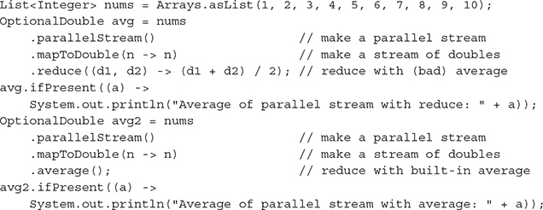

In the first stream pipeline, we make the stream parallel, then we map to a stream of doubles so we can compute the average and return a double value; then we reduce using our own reduction function, which sums two numbers from the stream and divides by 2.

In the second stream pipeline, we do the same except we reduce with the built-in average() stream method, which is implemented in a way to produce the correct result (accounting for the inherent nonassociativity of the average function).

We get the output:



The point is, just as with sequential stream reductions, parallel stream reductions need to be associative. This is even more important for parallel streams given that we don’t know how the system will split up and then recombine the stream results.

Stateless Operations (and Streams)

A stateless operation in a stream pipeline is an operation that does not depend on the context in which it’s operating. Before we talk more about what stateless operations are, let’s talk about what they are not.

There are two main ways you can create a state*ful* stream pipeline. The first is with *side effects*. We talked about this in [Chapter 9](https://learning.oreilly.com/library/view/ocp-java-se/9781260117370/ch9.xhtml#ch9), too; side effects occur when your result creates or depends on changes to state in the pipeline.

**Side Effects and Parallel Streams**   We already said not to ever modify the source of a stream from within the stream pipeline, so you haven’t been—right? Right. That’s one way you can create side effects, but you know not to do that.

Another way you can create side effects is to modify the field of an object. In sequential stream pipelines, you can get away with these kinds of side effects, and you may recall from [Chapter 9](https://learning.oreilly.com/library/view/ocp-java-se/9781260117370/ch9.xhtml#ch9) how we created a list of DVDs from a file input stream. However, in parallel stream pipelines, these kinds of side effects will fail unless the objects you’re modifying from within the pipeline are synchronized (either via a synchronized accessor method or if the objects are a concurrent data type).

Here’s an example: We’re streaming integers between 0 and 50 (noninclusive), filtering to find integers divisible by 10 and then summing those. We’re also attempting to count the integers as we go by updating the field of an object. Although we aren’t allowed to update a plain variable counter from within a lambda (you’ll get a compiler error if you try to do this), we are allowed to update the field of an object, as we’re doing here:

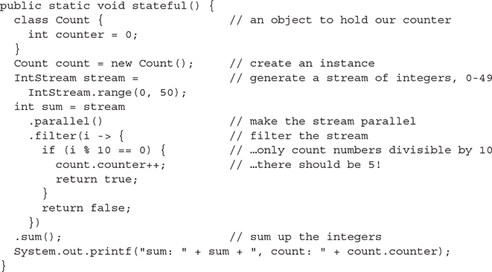

The first time we ran this code, we got:



The next time:



Hmmm. We get the right sum (the sum doesn’t depend on the counter and doesn’t depend on the ordering), but the counter is not always correct (try a bigger number than 50 in the range if this code doesn’t produce different counter values for you). That’s because, when we are using a parallel stream, multiple threads are accessing the Count object to modify the counter field and Count is not thread-safe.

We could use a synchronized object to store our counter and that would solve the problem, but it would also defeat the purpose of using parallel streams in this example.

We can fix the code above by removing the count in the parallel stream pipeline and computing it separately from the sum.

**Stateful Operations in the Stream Pipeline**   Another way we can create stateful stream pipelines is with stateful stream operations. A stateful stream operation is one that requires some knowledge about the stream in order to operate. Take a look at the following stream pipeline:

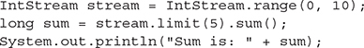

In this code, we are creating a stream of ten ints, limiting the stream to the first five of those ints (0–4) and summing those. The result, as you’d expect, is 10:



Now think about this operation, limit(5). This is a stateful operation. Why? Because it requires context: the stream has to keep some intermediate state to know when it has five items and can stop streaming from the source (that is, short circuit the stream). So adding parallel() to this stream will not improve performance and might even hurt performance because now that state has to be synchronized across threads.

Let’s test this and see what performance we get. We’ll create a stream of 100 million ints, limit the stream to the first 5 ints, and sum, like we just did above. We’ll also time the operation:

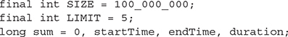

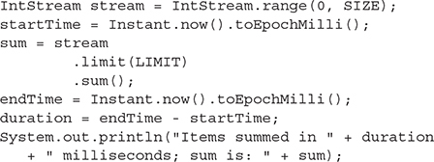

When we run this on our machine (eight cores), we get



Running it several times takes 28 or 29 milliseconds each time.

Now, let’s make this a parallel stream and see what we get:

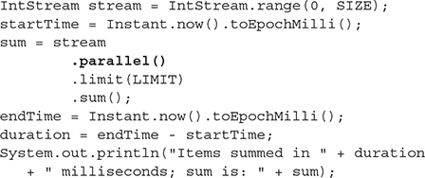

Running this, we get



The performance is worse! Repeated runs yield running times of between 33 and 36 milliseconds each time. Increasing the SIZE to 400 million yields similar results.

One thing we should consider here is that the overhead of creating eight threads might be contributing to the performance problem. To really test that a parallel pipeline can hurt (or, at least, not help) when using limit(), we should try our experiment with a custom ForkJoinPool and set the number of threads ourselves. Let’s do that.

The code is similar to what you’ve seen before: we create a custom ForkJoinPool, submit the task to the ForkJoinPool, get the result from the FutureTask that’s returned, and time the whole thing. We’ve bumped up the 777size of the stream to 400 million ints, but we’re still limiting to 5 ints for the sum. For this initial test, we’ve commented out the call to parallel() in the stream pipeline, so our first test will be on a sequential stream with one thread in the ForkJoinPool:

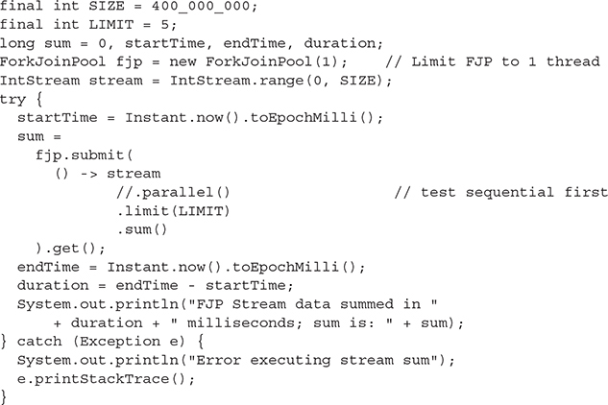

When we ran this code, we got



Now let’s make the stream pipeline parallel and increase the number of threads to two:

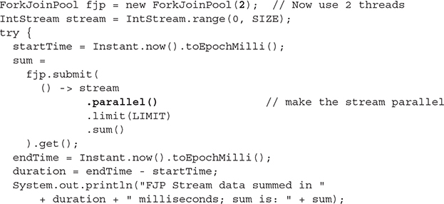

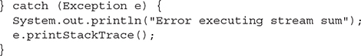

Run it again and we get



Now using parallel streams is not that much slower than running it sequential, but there’s still no benefit to using parallel streams; our results from this test indicate that whether we use two threads or eight, the parallel pipeline runs no faster than the sequential pipeline.

Run some more experiments yourself. Change the number of workers in the ForkJoinPool; see what happens. Change the LIMIT to a much larger number, like 500,000, and see what happens. More than likely, you’ll find that the parallel stream pipeline runs the same as or more slowly than the sequential stream pipeline for this operation, which is what we’d expect.

We’ve talked about a couple of ways that stream pipelines are stateful: that is, stream pipelines are stateful if we create side effects (modifying an object as we process the pipeline) or if we use a stateful stream operation, like limit(). Other stateful stream operations might be fairly obvious to you; they are skip(), distinct(), and sorted(). How do you know which stream operations are stateful? The documentation describing these methods says so. And if you think about it, each of these operations requires some knowledge about the stream in order for the stream to operate.

Stream operations that are not necessarily stateful include map(), filter(), and reduce() (among others), so there’s a lot we can do with streams that is stateless, although, as with all things related to concurrency, we need to be careful. As you saw in the example above, when we tried to count numbers in the stream using a filter(), we can make filter() stateful by creating a side effect.

Just to revisit quickly a simple example of a parallel stream using map(), filter(), and reduce() stateless operations, here’s a slightly modified take on our original example:

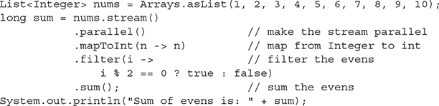

Run this and you should see the following:



None of these stream operations requires any state in order to operate on the values in the stream pipeline. The map simply converts the type of the stream value from Integer to int; the filter simply determines if the value is even or odd, and the reduction (sum()) sums the values, which can happen in any order because sum() is associative, so this operation requires no state either. This is an example of a stateless stream pipeline…well almost.

Hopefully now, you can see the difference between a stateless and a stateful stream pipeline. We’ve mostly talked about what a stateless stream pipeline is by talking about what a stateful stream pipeline is. The short story is that a stateless stream pipeline is one that requires no underlying intermediate state to be stored and accessed by the thread(s) in order to execute properly. And that statelessness is what helps make parallel stream pipelines more efficient.

However, we need to do one more thing to make this stream pipeline completely stateless, as you’ll see next.

Unordered Streams

Earlier we said a problem is suitable for parallel streams if the operations used to compute the result are associative and stateless and the stream is unordered. We’ve talked about the first two; what about unordered?

By default, many (but not all!) streams are ordered. That means there is an inherent ordering to the items in the stream. A stream of ints created by range() and a stream of Integers created from a List of Integers are both ordered streams. Intuitively that makes sense; technically, ordering is determined by whether the stream has an ORDERED *characteristic*. This is just a bit that is set on the underlying implementation of a stream. There are other characteristics of streams, including SORTED and DISTINCT, but you don’t need to worry too much about characteristics of streams except to know that the characteristics of a stream can affect how that stream performs, especially if you make the stream parallel.

Sometimes we want our streams to retain their order; for instance, if we are mapping stream values from ints to Integer, filtering to extract the even numbers, and then displaying the results, we might want the ordering of the stream to be maintained so we see the results in order.

However, an ordered stream pipeline will not execute as efficiently in parallel. Again, it comes down to context: an ordered stream has to maintain some state—in this case, the ordering of the stream values—to keep the stream values in order, which adds overhead to the processing.



***The characteristics of a stream can be inspected by using a*Spliterator*, which is an object for traversing a source, like a collection or a stream, that can also split up that source for potential parallel processing.*Spliterator*and its characteristics are not on the exam, but if you want to explore how streams (and collections) are traversed and partitioned in more detail, you can study*Spliterator*in depth.***

***Here’s how you can use a stream’s*spliterator()*method to determine if that stream is ordered:***

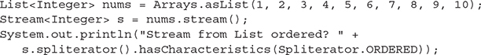

***In this case you’ll see that, indeed, the stream of Integers we make from a*List*is ordered.***

If a stream is ordered and we process it in parallel, the stream will remain ordered, but at the price of some efficiency. If we don’t care about the ordering, as is the case when we are summing numbers, we might as well remove the ordering on the stream in scenarios where we are using a parallel stream pipeline. That way we get the extra performance benefits of working with an unordered stream in a situation where we shouldn’t be concerned about the ordering anyway (because if we are, then the problem we’re trying to solve probably isn’t appropriate for a parallel stream pipeline).

So how do we make sure we’re working with an unordered stream? We can explicitly tell the stream to not worry about remaining ordered by calling the unordered() stream method. Of course, we should do this *before* we call parallel() so we can maximize the efficiency of the parallel processing. Here’s how we can modify the previous example to create an unordered stream pipeline:

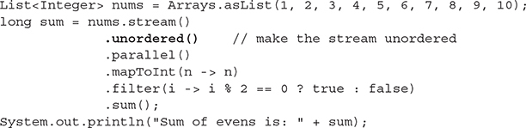

Calling unordered() doesn’t change the ordering of the stream; it just unsets that ORDERED bit so the stream doesn’t have to maintain the ordering state. Depending on how the stream is processed in the parallel pipeline, you may find that the final stream (before the reduction) is in the same order as the source, or not. Note that an ordered stream is not the same thing as a sorted stream. Once you’ve made a stream unordered, there is no way to order it again, except by calling sorted(), which makes it sorted *and* ordered but not necessarily in the same order as it was in the original source.

Don’t worry too much about ordering for the exam; do remember that ordering has an implication for performance and make sure to note which collections create ordered streams (e.g., List) and which create unordered streams (e.g., HashSet) when you call that collection’s stream() method, so you know the performance implications.

To summarize: to make the most efficient parallel stream, you should:

   Make sure your reductions are associative and stateless.

   Avoid side effects.

   Make sure your pipeline is stateless by avoiding contextual operations such as limit(), skip(), distinct(), and sorted().

forEach() and forEachOrdered()

As you know, forEach() is a terminal stream operation that takes a Consumer and consumes each item in the stream. We often use forEach() to show the values in a stream after a map and/or filter operation, for example:



will display any Dog in the stream whose age is > 7 in the order in which the values in the stream are encountered.

Imagine we have a Dog class and a Dog constructor that takes the name and age of a dog. You’ve seen the Dog class often enough that we probably don’t have to repeat it. Given that Dog class, we can make some dogs, like this:

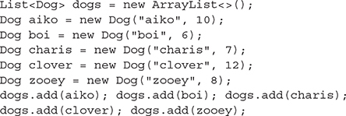

Notice that we’ve added the dogs in alphabetical order on purpose, so we can watch the ordering of our stream when we use a sequential stream and when we use a parallel stream.

Running the code:



gives us the output:



That is, we see all dogs whose age is > 7 in the order in which they are encountered in the stream (which is the order in which they are added to the List). This is because, by default, when we stream the List, we get a sequential, ordered stream.

Now, as you might expect at this point, when we make this a parallel stream, we get different results:

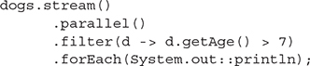

This code produced the output:



The output is unpredictable; if you run it again, you may get different results. Even though the stream is ordered (since we’re streaming a List), we see the output in a random order because the stream is parallel, so the dogs can be processed by different threads that may finish at different times, and the forEach() Consumer is stateful: it is essentially creating a side effect by outputting data to the console, which is not thread-safe.

We can make sure we see the dogs in the order in which they appear in the original source by using the method forEachOrdered() instead:



We can do this because the underlying stream is ordered (it’s made from a List and its ORDERED characteristic is set), and the forEachOrdered() method will make sure the items are seen in the same order as they are encountered in the ordered stream. (Note that if we call unordered() on the stream, then the order will not be guaranteed!)

Of course, this takes a bit of overhead to perform, right? As we discussed earlier, an ordered stream is going to be less efficient when processed in parallel than an unordered stream. However, there may be times when you want to maintain the ordering of the stream when processing in parallel and you’re willing to sacrifice a bit of efficiency.

Typically, you won’t end up using forEachOrdered() much in the real world; you’re sacrificing performance, and usually you don’t want to see the results of a big data operation on a parallel stream; you want to collect the results in a new data structure or compute some final result like a sum. However, you will see forEachOrdered() on the exam, so make sure you understand how it works.

Also, note that forEach() (and forEachOrdered()) as well as peek() are stream operations that are designed for side effects. That is, they consume elements from the stream: peek() typically creates a side effect (say, printing the stream element passing through) and then passes the values on unchanged to the stream; forEach() consumes the stream values and produces a result (it’s a terminal operation), and typically that result is output to the console or saves each item to the field of an object. So take care when using forEach(), forEachOrdered(), and peek() with parallel streams, remembering that stream pipelines with side effects (even just printing to the console) can change how the stream pipeline operates, and reduce the performance of parallel streams.

A Quick Word About findAny()

You might remember from [Chapter 9](https://learning.oreilly.com/library/view/ocp-java-se/9781260117370/ch9.xhtml#ch9) that we used the findAny() stream operation to find any value in the stream pipeline that matched a filter(). For instance, we can use findAny() to find any even int in a stream like this:

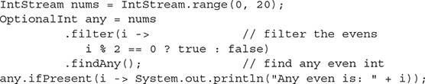

With a sequential stream, findAny() will likely return the first value in the stream, 0, every time, even though it’s not guaranteed.

Now, let’s parallelize this stream and see what happens. We’ll add a peek(), so we can see the thread workers as they work on the problem:

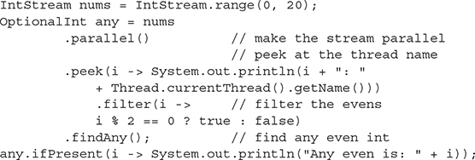

We run this and get

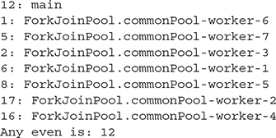

Remember, our computer has eight cores, so this stream pipeline has been split up into eight workers, each tackling part of the stream. The findAny() method is short circuiting, so even though we still have 12 more values in the stream to process (since the stream has 20 values), we stop as soon as we find the first even number. In this run, we had several threads with even numbers: the main worker, worker-1, worker-4, and worker-5. It just so happens that the main thread probably got done first, and so as soon as that even number was found, everything else stopped, and that result, 12, was returned.

Run the code again, and you’ll likely get a different answer.

This example illustrates that findAny() really does find any result, particularly when you’re working with a parallel stream pipeline.

A Parallel Stream Implementation of a RecursiveTask

Let’s write code to sum an array of ints with a ForkJoinPool RecursiveTask, and compare that code with a parallel stream (which, remember, uses ForkJoinPool under the covers). We’ll also implement it with a plain-old for loop, so you can see not only how the code itself compares, but also how the performance compares. Much of this code should look familiar to you by now.

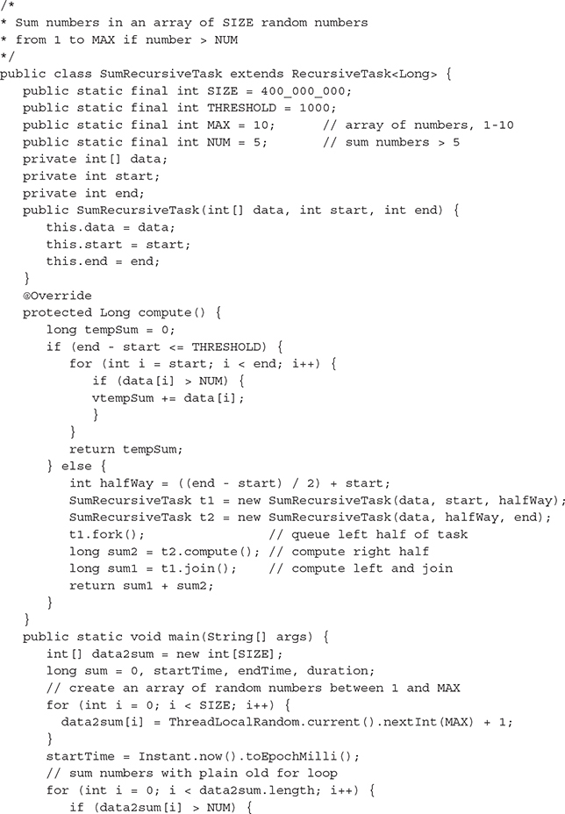

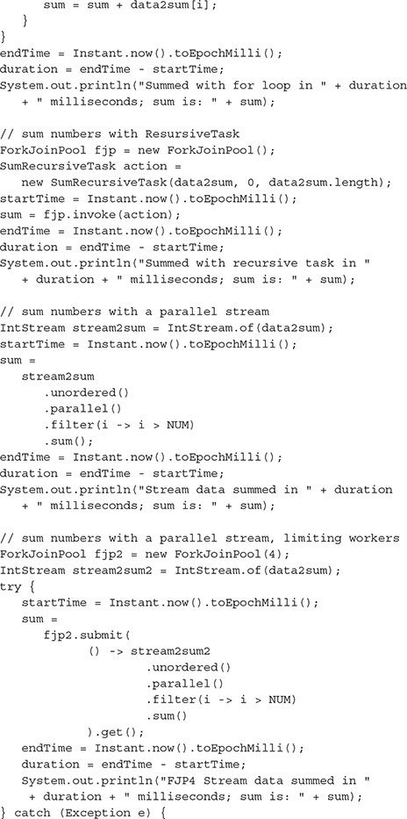

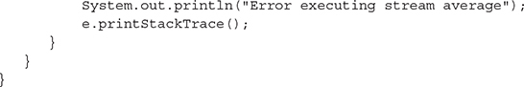

This code first generates a large array of random numbers between 1 and 10 and then computes the sum of all numbers > 5 four different times (from the same data, so we should get the same answer each time): first, using a plain-old for loop; second, using a RecursiveTask, third, using a parallel stream on the default ForkJoinPool (that is, using all eight cores of our machine); and finally, using a parallel stream on a custom ForkJoinPool with four workers (using four cores).

Here are our results:

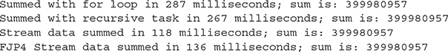

We ran it again and this time we got

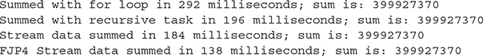

In the first run, the parallel stream running on all eight cores was the winner, slightly faster than the parallel stream running on four cores. Both parallel streams were far superior to the RecursiveTask and the for loop.

In the second run, this time the parallel stream running on four cores was the clear winner, with the RecursiveTask and the parallel stream running on eight cores about the same, both much faster than the for loop.

As you can see, your results will vary depending on the solution you choose as well as your underlying machine architecture. If you get an OutOfMemoryError when you run this, try reducing the SIZE.

Reducing Parallel Streams with reduce()

Let’s say you want to reduce your stream to a value, but none of the built-in stream reduction methods (like sum()) suffice. You can build your own custom reduction with the reduce() function, as you saw in [Chapter 9](https://learning.oreilly.com/library/view/ocp-java-se/9781260117370/ch9.xhtml#ch9).

How about building a custom reduction that multiplies all the elements of a stream? It’s a bit like computing the sum, except we’re multiplying instead. This is known as computing the *product* (as compared to the sum). Before we write this reduction, we should check a few things. First, remember that a reduction produces an Optional value unless we provide an identity.

Recall the type signature of reduce():



Although the identity is optional, providing one is a good idea because it allows us to get a result (rather than an Optional result), and that identity value is also used to make the first result in the stream pipeline, and we want to make sure the correct identity is being used in our custom reduction.

For the sum, the identity value is 0 because any number added to 0 is that number. For the product, the identity is 1 because any number multiplied by 1 is that number. So, we’ll use 1. That’s easy enough.

The accumulator is a BinaryOperator that takes two values and produces one value. Remember that an Operator produces a value of the same type as its arguments. Our BinaryOperator is simple; it just takes two numbers and multiples them together, returning a number:



Another thing we should check is that our accumulator function is associative. Remember the trouble we ran into when we tried to reduce using a custom average function? We didn’t get a correct result because our average function is not associative, so we had to use the built-in average() reduction method instead.

Is our product function associative? It is. That is, we can multiply a * b and then by c and get the same answer as when we multiply b * c and then by a.

Another quick check: Is our accumulator stateless? That is, does it rely on any additional state in the stream to be computed? If it’s not stateless, then we could run into trouble; either we’ll potentially get incorrect results or we’ll drastically reduce the performance of the parallel stream (or both!). In this case, our reduction function is, indeed, stateless. There is no state needed in order to properly multiply two values from the stream and produce a result.

Okay! We’ve got our identity, and we’ve got our associative, stateless reduction function. Now we can write the code to reduce a parallel stream to the product of all values in the stream:

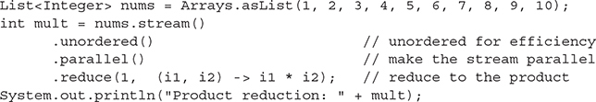

Here, we start with a List of Integer values and create a stream. We call unordered() on that stream so we can get additional efficiency from parallel processing—and this works great, because just like addition, computing the product does not depend on the order of the values. We then make the stream parallel and call the reduce() terminal operation method, passing in our identity, 1, and our product accumulator. Here is the result we get:



That’s the correct answer (phew!). Running the code again several times produces the same result each time. It looks like we got the code correct.

As an exercise, you can try this reduction on a much larger stream of numbers and time the performance, comparing the parallel version with the sequential version. See what results you get!

Collecting Values from a Parallel Stream

As we’ve said before, when processing data with streams, you will most likely want to reduce the stream to a single value, like a sum or a product or a count, or you might want to collect results into a new collection with collect() (which is a reduction, too).

Consider again our ArrayList of dogs we used above, containing aiko, boi, charis, clover, and zooey.

If you forget that you aren’t supposed to create side effects from a parallel stream pipeline, you might do something like this to collect dogs who are older than 7 into a new List collection:

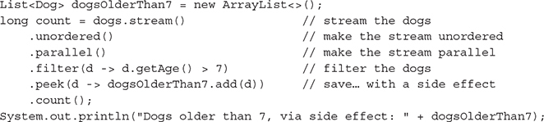

Here, we’re initializing a new List, dogsOlderThan7; we’re streaming our original dogs ArrayList, making it unordered, making it parallel, filtering for dogs older than 7, and then making the mistake of saving those dogs older than 7 to our new List using a side effect from within a peek() lambda expression. We then terminate the pipeline with the count() operation.

The first time we ran this we got the following:



Hmm, definitely a problem there! Running it again, we got this:



Clearly, as you should know well by now, this is not the way to collect results from a stream pipeline. The reason this fails is because we have multiple threads trying to access the List dogsOlderThan7 at the same time and dogsOlderThan7 is not thread-safe.

We could fix this code by using a synchronized list, like this:



Now, the List is thread-safe. The order of the dogs in the resulting List may not be the same as in the source, but at least you’ll get the right set of dogs. However, you’re also sacrificing some performance because you’re forcing a synchronization of all the threads attempting to write to the synchronized List.

A better way to collect values from a parallel stream pipeline is to use Collectors, as we did in [Chapter 9](https://learning.oreilly.com/library/view/ocp-java-se/9781260117370/ch9.xhtml#ch9) with sequential streams. Here’s how:

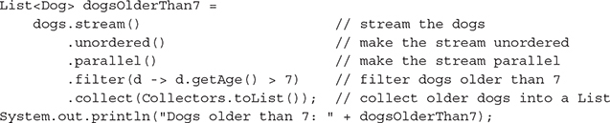

When we run this code, we see the output:



Now you might be thinking, “Didn’t you just say that the List is not thread-safe? We’re still using a List in the collect() method with Collectors.toList(), so how is this working?”

Good question. It turns out that the way collect() works under the covers is that each worker processing a piece of the stream collects its data into its own collection. Worker 1 will create a List of dogs older than 7; worker 2 will create a List of dogs older than 7; and so on. Each of these Lists is separate, built from the pieces of the stream that each worker got when the stream was split up across the parallel workers. At the end, once each thread is complete, the separate Lists are merged together, in a thread-safe manner, to create one final List of dogs.

Lists are inherently ordered, so we will get a reduction in efficiency unless we make sure the stream is unordered, which we’ve done by adding a call to unordered() at the beginning of the pipeline. (Of course, this means the dogs may not be in the same order as they were in the source, but you expected that, right?). You can also collect values from a parallel stream with toSet() and toMap(), and a method toConcurrentMap() is there for additional efficiency since merging maps is expensive.

As we mentioned in [Chapter 9](https://learning.oreilly.com/library/view/ocp-java-se/9781260117370/ch9.xhtml#ch9), you can use the collect() method with your own supplier, accumulator, and combiner functions if you need a way to collect that isn’t provided for by the Collectors class:

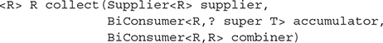

If you use a custom collector, just like with the custom reduction, you’ll need to make sure that your accumulator is associative and stateless. In addition, your combiner should be stateless and thread-safe. Typically, the combiner will be adding values to a new collection, so using a concurrent collection here is a good idea.

CERTIFICATION SUMMARY

This chapter covered the required concurrency knowledge you’ll need to apply on the certification exam. The java.util.concurrent package and its subpackages form a high-level multithreading framework in Java. You should become familiar with threading basics before attempting to apply the Java concurrency libraries, but once you learn java.util.concurrent, you may never extend Thread again.

Callables and Executors (and their underlying thread pools) form the basis of a high-level alternative to creating new Threads directly. As the trend of adding more CPU cores continues, knowing how to get Java to make use of them all concurrently could put you on easy street. The high-level APIs provided by java.util.concurrent help you create efficient multithreaded applications while eliminating the need to use low-level threading APIs such as wait(), notify(), and synchronized, which can be a source of hard-to-detect bugs.

When using an Executor, you will commonly create a Callable implementation to represent the work that needs to be executed concurrently. A Runnable can be used for the same purpose, but a Callable leverages generics to allow a generic return type from its call method. Executor or ExecutorService instances with predefined behavior can be obtained by calling one of the factory methods in the Executors class like so: ExecutorService es = Executors.newFixedThreadPool(100);.

Once you obtain an ExecutorService, you submit a task in the form of a Runnable or Callable, or a collection of Callable instances to the ExecutorService using one of the execute, submit, invokeAny, or invokeAll methods. An ExecutorService can be held onto during the entire life of your application if needed, but once it is no longer needed, it should be terminated using the shutdown and shutdownNow methods.

We looked at the Fork/Join Framework, which supplies a highly specialized type of Executor. Use the Fork/Join Framework when the work you would typically put in a Callable can be split into multiple units of work. The purpose of the Fork/Join Framework is to decrease the amount of time it takes to solve a problem by leveraging the additional CPUs in a system. You should only run a single Fork/Join task at a time in an application, because the goal of the framework is to allow a single task to consume all available CPU resources in order to be solved as quickly as possible. In most cases, the effort of splitting a single task into multiple tasks that can be operated on by the underlying Fork/Join threads will introduce additional overhead. Don’t assume that applying Fork/Join will grant you a performance benefit for all problems. The overhead involved may be large enough that any benefit of applying the framework is offset.

When applying the Fork/Join Framework, first subclass either RecursiveTask (if a return result is desired) or RecursiveAction. Within one of these ForkJoinTask subclasses, you must implement the compute method. The compute() method is where you divide the work of a task into parts and then call the fork and join methods or the invokeAll method. To execute the task, create a ForkJoinPool instance with ForkJoinPool pool = new ForkJoinPool(); and submit the RecursiveTask or RecursiveAction to the pool with the pool.invoke(task) method. Although the Fork/Join API itself is not that large, creating a correct and efficient implementation of a ForkJoinTask can be challenging.

Java 8 added parallel streams to make the Fork/Join Framework easier to use. Parallel streams are built on top of the Fork/Join Framework and allow you to split a task into parts more easily than when using the Fork/Join API directly. Simply create a stream and call parallel(), and your stream pipeline will be split into tasks that execute in separate threads. However, as you saw, you need to be aware of the potential issues with parallel streams and make sure you are using them to solve the appropriate kinds of problems.

We learned about the java.util.concurrent collections. There are three categories of collections: copy-on-write collections, concurrent collections, and blocking queues. The copy-on-write and concurrent collections are similar in use to the traditional java.util collections but are designed to be used efficiently in a thread-safe fashion. The copy-on-write collections (CopyOnWriteArrayList and CopyOnWriteArraySet) should be used for read-heavy scenarios. When attempting to loop through all the elements in one of the copy-on-write collections, always use an Iterator. The concurrent collections included

   ConcurrentHashMap

   ConcurrentLinkedDeque

   ConcurrentLinkedQueue

   ConcurrentSkipListMap

   ConcurrentSkipListSet

These collections are meant to be used concurrently without requiring locking. Remember that iterators of these five concurrent collections are weakly consistent. ConcurrentHashMap and ConcurrentSkipListMap are ConcurrentMap implementations that add atomic putIfAbsent, remove, and replace methods to the Map interface. Seven blocking queue implementations are provided by the java.util.concurrent package:

   ArrayBlockingQueue

   LinkedBlockingDeque

   LinkedBlockingQueue

   PriorityBlockingQueue

   DelayQueue

   LinkedTransferQueue

   SynchronousQueue

These blocking queues are used to exchange objects between threads—one thread will deposit an object and another thread will retrieve that object. Depending on which queue type is used, the parameters used to create the queue, and the method being called, an insert or a removal operation may block until it can be completed successfully. In Java 7, the LinkedTransferQueue class was added and acts as a superset of several blocking queue types; you should prefer it when possible.

Another way to coordinate threads is to use a CyclicBarrier. A CyclicBarrier creates a barrier where all threads must wait until all participating threads reach that barrier; once they do, then the threads can continue. You can have an optional Runnable run before the threads continue; the last thread to reach the barrier is the thread that’s used to run that Runnable.

The java.util.concurrent.atomic and java.util.concurrent.locks packages contain additional utility classes you might consider using in concurrent applications. The java.util.concurrent.atomic package supplies thread-safe classes that are similar to the traditional wrapper classes (such as java.lang.Integer) but with methods that support atomic modifications. The java.util.concurrent.locks.Lock interface and supporting classes enable you to create highly customized locking behaviors that are more flexible than traditional object monitor locking (the synchronized keyword).

 TWO-MINUTE DRILL

Here are some of the key points from the certification objectives in this chapter.

Apply Atomic Variables and Locks (OCP Objective 10.3)

  The java.util.concurrent.atomic package provides classes that are similar to volatile fields (changes to an atomic object’s value will be correctly read by other threads without the need for synchronized code blocks in your code).

  The atomic classes provide a compareAndSet method that is used to validate that an atomic variable’s value will only be changed if it matches an expected value.

  The atomic classes provide several convenience methods such as addAndGet that will loop repeatedly until a compareAndSet succeeds.

  The java.util.concurrent.locks package contains a locking mechanism that is an alternative to synchronized methods and blocks. You get greater flexibility at the cost of a more verbose syntax (such as having to manually call lock.unlock() and having an automatic release of a synchronization monitor at the end of a synchronized code block).

  The ReentrantLock class provides the basic Lock implementation. Commonly used methods are lock(), unlock(), isLocked(), and tryLock(). Calling lock() increments a counter and unlock() decrements the counter. A thread can only obtain the lock when the counter is zero.

  The ReentrantReadWriteLock class provides a ReadWriteLock implementation that supports a read lock (obtained by calling readLock()) and a write lock (obtained by calling writeLock()).

Use java.util.concurrent Collections (OCP Objective 10.4)

  Copy-on-write collections work well when there are more reads than writes because they make a new copy of the collection for each write. When looping through a copy-on-write collection, use an iterator (remember, for-each loops use an iterator).

  None of the concurrent collections make the elements stored in the collection thread-safe—just the collection itself.

  ConcurrentHashMap, ConcurrentSkipListMap, and ConcurrentSkipListSet should be preferred over synchronizing with the more traditional collections.

  ConcurrentHashMap and ConcurrentSkipListMap are ConcurrentMap implementations that enhance a standard Map by adding atomic operations that validate the presence and value of an element before performing an operation: putIfAbsent(K key, V value), remove(Object key, Object value), replace(K key, V value), and replace(K key, V oldValue, V newValue).

  Blocking queues are used to exchange objects between threads. Blocking queues will block (hence the name) when you call certain operations, such as calling take() when there are no elements to take. There are seven different blocking queues that have slightly different behaviors; you should be able to identify the behavior of each type.

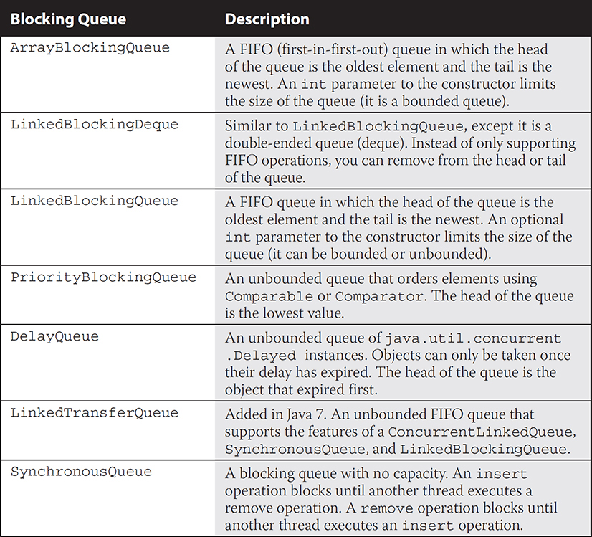

  Some blocking queues are bounded, meaning they have an upper bound on the number of elements that can be added, and a thread calling put(e) may block until space becomes available.

  CyclicBarrier creates a barrier at which threads must wait until all participating threads reach that barrier. Once all of the threads have reached the barrier, they can continue running. You can use CyclicBarrier to coordinate threads so that an action occurs only after another action is complete or to manage data in Collections that are not thread-safe.

  CyclicBarrier takes the number of threads that can wait at the barrier and an optional Runnable that is run after all threads reach the barrier, but before they continue execution. The last thread to reach the barrier is used to run this Runnable.

Use Executors and ThreadPools (OCP Objective 10.1)

  An Executor is used to submit a task for execution without being coupled to how or when the task is executed. Basically, it creates an abstraction that can be used in place of explicit thread creation and execution.

  An ExecutorService is an enhanced Executor that provides additional functionality, such as the ability to execute a Callable instance and to shut down (nondaemon threads in an Executor may keep the JVM running after your main method returns).

  The Callable interface is similar to the Runnable interface, but adds the ability to return a result from its call method and can optionally throw an exception.

  The Executors (plural) class provides factory methods that can be used to construct ExecutorService instances, for example: ExecutorService ex = Executors.newFixedThreadPool(4);.

Use the Parallel Fork/Join Framework (OCP Objective 10.5)

  Fork/Join enables work stealing among worker threads in order to keep all CPUs utilized and to increase the performance of highly parallelizable tasks.

  A pool of worker threads of type ForkJoinWorkerThread is created when you create a new ForkJoinPool(). By default, one thread per CPU is created.

  To minimize the overhead of creating new threads, you should create a single Fork/Join pool in an application and reuse it for all recursive tasks.

  A Fork/Join task represents a large problem to solve (often involving a collection or array).

  When executed by a ForkJoinPool, the Fork/Join task will subdivide itself into Fork/Join tasks that represent smaller segments of the problem to be solved.

  A Fork/Join task is a subclass of the ForkJoinTask class, either RecursiveAction or RecursiveTask.

  Extend RecursiveTask when the compute() method must return a value, and extend RecursiveAction when the return type is void.

  When writing a ForkJoinTask implementation’s compute() method, always call fork() before join() or use one of the invokeAll() methods instead of calling fork() and join().

  You do not need to shut down a Fork/Join pool before exiting your application because the threads in a Fork/Join pool typically operate in daemon mode.

Use Parallel Streams Including Reduction, Decomposition, Merging Processes, Pipelines, and Performance (OCP Objective 10.6)

  Parallel streams are built on top of the Fork/Join pool.

  Parallel streams provide an easier syntax for creating tasks in the Fork/Join pool.

  You can use the default Fork/Join pool, or create a custom pool and submit tasks expressed as parallel streams via a Callable.

  Parallel streams split the stream into subtasks that represent portions of the problem to be solved. Each subtask solution is then combined to produce a final result for the terminal operation of the parallel stream.

  Create a parallel stream by calling parallel() on a stream object or parallelStream() on a Collection object.

  Make a parallel stream sequential again by calling the sequential() method.

  Test to see if a stream is parallel with the isParallel() method.

  Parallel stream pipelines should be stateless, and for optimum performance, parallel streams should be unordered. Reduction operations on parallel streams should be associative and stateless.

  Stateful parallel stream pipelines will either create an error or unexpected results.

  Nonassociative reductions on streams will produce unexpected results.

  Just like sequential streams, parallel streams can have multiple intermediate operations and must have one terminal operation to produce a result.

  Test your parallel streams to verify you are getting the performance benefits you expect. The performance overhead of creating threads can be greater than the performance gain of a parallel stream in some situations.

  Stateful stream operations, such as distinct(), limit(), skip(), and sorted(), will limit the performance of your parallel streams.

  Collect results from a parallel stream pipeline with collect(), just as we did with sequential streams. The collecting happens in a thread-safe way, so you can use collect() with Collectors.toList(), toSet(), and toMap() safely.

 SELF TEST

The following questions might be some of the hardest in the book. It’s just a difficult topic, so don’t panic. (We know some Java book authors who didn’t do well with these topics and still managed to pass the exam.)

[**1**](https://learning.oreilly.com/library/view/ocp-java-se/9781260117370/ch11.xhtml#r_ch11ans1)**.**   The following block of code creates a CopyOnWriteArrayList, adds elements to it, and prints the contents:

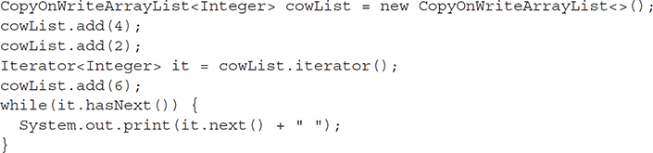

What is the result?

A. 6

B. 12

C. 4 2

D. 4 2 6

E. Compilation fails

F. An exception is thrown at runtime

[**2**](https://learning.oreilly.com/library/view/ocp-java-se/9781260117370/ch11.xhtml#r_ch11ans2)**.**   Given:

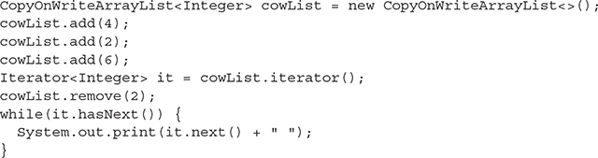

Which shows the output that will be produced?

A. 12

B. 10

C. 4 2 6

D. 4 6

E. Compilation fails

F. An exception is thrown at runtime

[**3**](https://learning.oreilly.com/library/view/ocp-java-se/9781260117370/ch11.xhtml#r_ch11ans3)**.**   Which methods from a CopyOnWriteArrayList will cause a new copy of the internal array to be created? (Choose all that apply.)

A. add

B. get

C. iterator

D. remove

[**4**](https://learning.oreilly.com/library/view/ocp-java-se/9781260117370/ch11.xhtml#r_ch11ans4)**.**   Given:



Which operation(s) can block indefinitely? (Choose all that apply.)

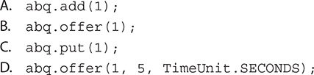

[**5**](https://learning.oreilly.com/library/view/ocp-java-se/9781260117370/ch11.xhtml#r_ch11ans5)**.**   Given the following code fragment:

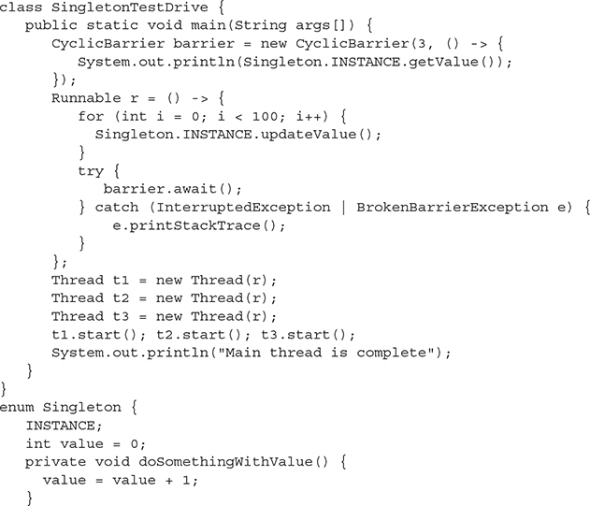

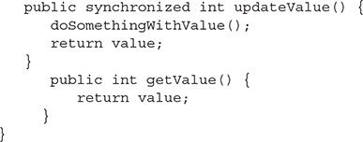

What do you expect the output to be, and which thread(s) will be responsible for the output? (Choose all that apply.)

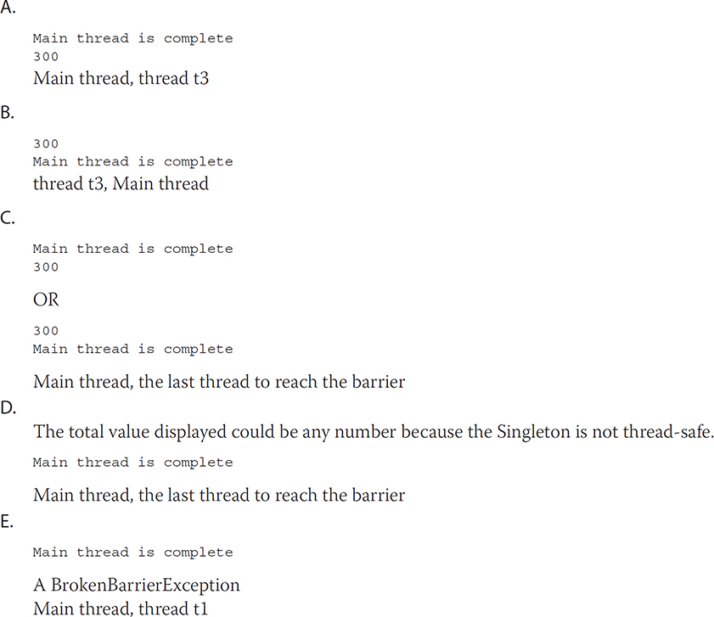

[**6**](https://learning.oreilly.com/library/view/ocp-java-se/9781260117370/ch11.xhtml#r_ch11ans6)**.**   Given:



Which method(s) would delete John from the map only if his value was still equal to 23?

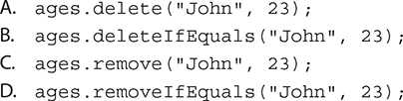

[**7**](https://learning.oreilly.com/library/view/ocp-java-se/9781260117370/ch11.xhtml#r_ch11ans7)**.**   Which method represents the best approach to generating a random number between 1 and 10 if the method will be called concurrently and repeatedly by multiple threads?

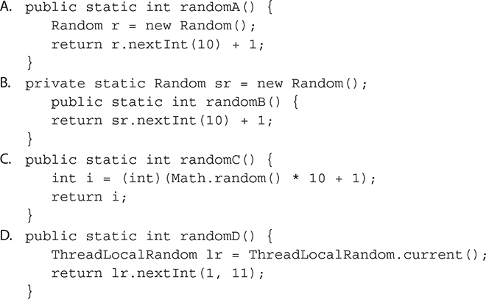

[**8**](https://learning.oreilly.com/library/view/ocp-java-se/9781260117370/ch11.xhtml#r_ch11ans8)**.**   Given:



Which atomically increment i by 9? (Choose all that apply.)

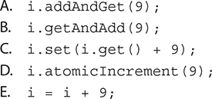

[**9**](https://learning.oreilly.com/library/view/ocp-java-se/9781260117370/ch11.xhtml#r_ch11ans9)**.**   Given:

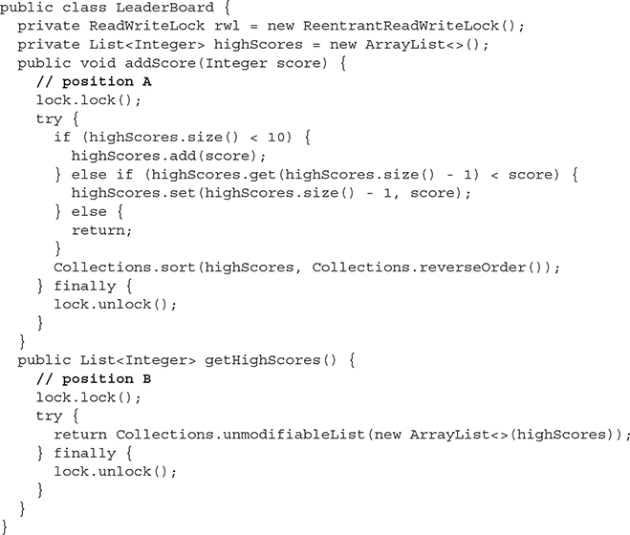

Which block(s) of code best match the behavior of the methods in the LeaderBoard class? (Choose all that apply.)

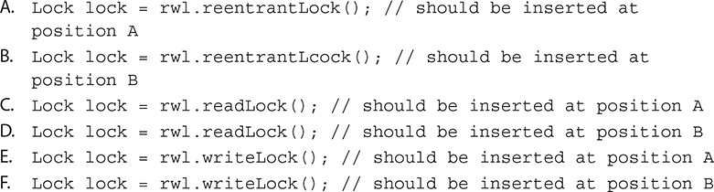

[**10**](https://learning.oreilly.com/library/view/ocp-java-se/9781260117370/ch11.xhtml#r_ch11ans10)**.**   Given:

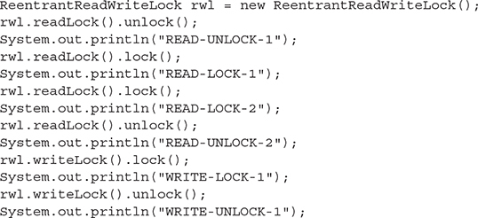

What is the result?

A. The code will not compile

B. The code will compile and output:



C. The code will compile and output:



D. A java.lang.IllegalMonitorStateException will be thrown

[**11**](https://learning.oreilly.com/library/view/ocp-java-se/9781260117370/ch11.xhtml#r_ch11ans11)**.**   Which class contains factory methods to produce preconfigured ExecutorService instances?

A. Executor

B. Executors

C. ExecutorService

D. ExecutorServiceFactory

[**12**](https://learning.oreilly.com/library/view/ocp-java-se/9781260117370/ch11.xhtml#r_ch11ans12)**.**   Given:

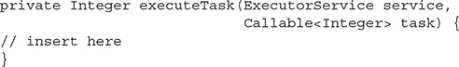

Which set(s) of lines, when inserted, would correctly use the ExecutorService argument to execute the Callable and return the Callable’s result? (Choose all that apply.)

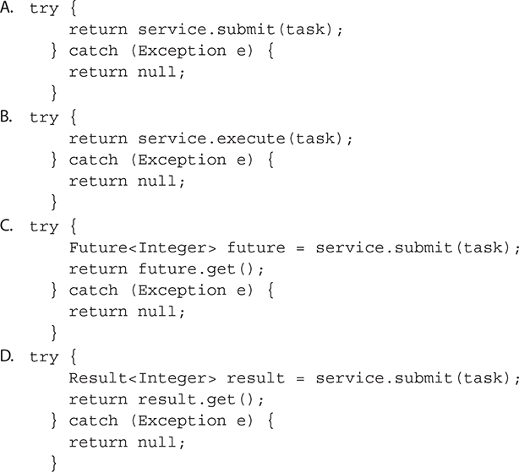

[**13**](https://learning.oreilly.com/library/view/ocp-java-se/9781260117370/ch11.xhtml#r_ch11ans13)**.**   Which are true? (Choose all that apply.)

A. A Runnable may return a result but must not throw an Exception

B. A Runnable must not return a result nor throw an Exception

C. A Runnable must not return a result but may throw an Exception

D. A Runnable may return a result and throw an Exception

E. A Callable may return a result but must not throw an Exception

F. A Callable must not return a result nor throw an Exception

G. A Callable must not return a result but may throw an Exception

H. A Callable may return a result and throw an Exception

[**14**](https://learning.oreilly.com/library/view/ocp-java-se/9781260117370/ch11.xhtml#r_ch11ans14)**.**   Given:

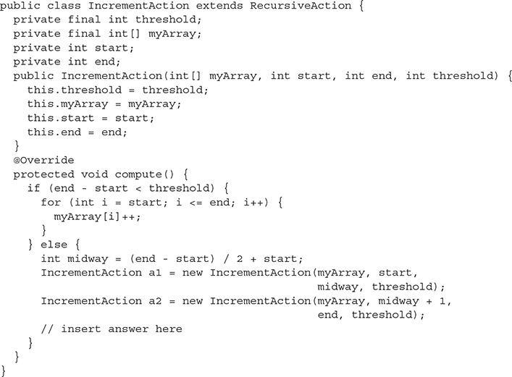

Which line(s), when inserted at the end of the compute method, would correctly take the place of separate calls to fork() and join()? (Choose all that apply.)

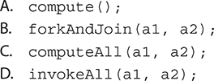

[**15**](https://learning.oreilly.com/library/view/ocp-java-se/9781260117370/ch11.xhtml#r_ch11ans15)**.**   When writing a RecursiveTask subclass, which are true? (Choose all that apply.)

A. fork() and join() should be called on the same task

B. fork() and compute() should be called on the same task

C. compute() and join() should be called on the same task

D. compute() should be called before fork()

E. fork() should be called before compute()

F. join() should be called after fork() but before compute()

[**16**](https://learning.oreilly.com/library/view/ocp-java-se/9781260117370/ch11.xhtml#r_ch11ans16)**.**   Given the following code fragment:

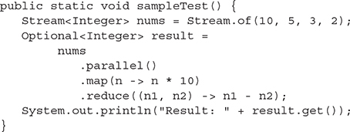

What is the result?

A. 0

B. 40

C. The result is unpredictable

D. Compilation fails

E. An exception is thrown at runtime

[**17**](https://learning.oreilly.com/library/view/ocp-java-se/9781260117370/ch11.xhtml#r_ch11ans17)**.**   Given the following code fragment:

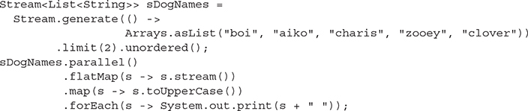

What is the result?

A. BOI AIKO CHARIS ZOOEY CLOVER BOI AIKO CHARIS ZOOEY CLOVER

B. Most likely, although not guaranteed: BOI AIKO CHARIS ZOOEY CLOVER BOI AIKO CHARIS ZOOEY CLOVER

C. A ConcurrentModificationException is thrown

D. Compilation fails

E. An exception other than ConcurrentModificationException is thrown at runtime

[**18**](https://learning.oreilly.com/library/view/ocp-java-se/9781260117370/ch11.xhtml#r_ch11ans18)**.**   Given the following code fragment:

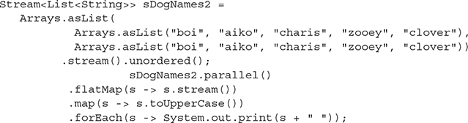

What is the result?

A. BOI AIKO CHARIS ZOOEY CLOVER BOI AIKO CHARIS ZOOEY CLOVER

B. The result is unpredictable

C. A ConcurrentModificationException is thrown

D. Compilation fails

E. An exception is thrown at runtime

[**19**](https://learning.oreilly.com/library/view/ocp-java-se/9781260117370/ch11.xhtml#r_ch11ans19)**.**   Given the code fragment:



What is the result?

A. 1

B. 2

C. The result is unpredictable; it could be any one of the numbers in the stream

D. A ConcurrentModificationException is thrown

E. Compilation fails

F. An exception is thrown at runtime

 SELF TEST ANSWERS

[**1**](https://learning.oreilly.com/library/view/ocp-java-se/9781260117370/ch11.xhtml#ch11ans1)**.**    **C** is correct. The Iterator is obtained before 6 is added. As long as the reference to the Iterator is maintained, it will only provide access to the values 4 and 2.

 **A, B, D, E,** and **F** are incorrect based on the above. (OCP Objective 10.4)

[**2**](https://learning.oreilly.com/library/view/ocp-java-se/9781260117370/ch11.xhtml#ch11ans2)**.**    **C** is correct. Because the Iterator is obtained before remove() is invoked, it will reflect all the elements that have been added to the collection.

 **A, B, D, E,** and **F** are incorrect based on the above. (OCP Objective 10.4)

[**3**](https://learning.oreilly.com/library/view/ocp-java-se/9781260117370/ch11.xhtml#ch11ans3)**.**    **A** and **D** are correct. Of the methods listed, only add and remove will modify the list and cause a new internal array to be created.

 **B** and **C** are incorrect based on the above. (OCP Objective 10.4)

[**4**](https://learning.oreilly.com/library/view/ocp-java-se/9781260117370/ch11.xhtml#ch11ans4)**.**    **C** is correct. The add method will throw an IllegalStateException if the queue is full. The two offer methods will return false if the queue is full. Only the put method will block until space becomes available.

 **A, B,** and **D** are incorrect based on the above. (OCP Objective 10.4)

[**5**](https://learning.oreilly.com/library/view/ocp-java-se/9781260117370/ch11.xhtml#ch11ans5)**.**    **C** is correct; you could see the output in either order because we don’t know in advance if threads t1, t2, and t3 will complete before the main thread or if the main thread will complete first. However, in either case, t1, t2, and t3 will wait at the barrier until t1, t2, and t3 are all at the barrier, and the last thread to reach the barrier will display the output.

 **A, B, D,** and **E** are incorrect; **A** and **B** are incorrect because of the above. **D** is incorrect because the Singleton is thread-safe; enum singletons are guaranteed to be created in a thread-safe manner, and we have synchronized the updateValue() method. **E** is incorrect because it is highly unlikely one of these threads will get stuck or time out and none is accessing any collection that is not thread-safe. (OCP Objective 10.4)

[**6**](https://learning.oreilly.com/library/view/ocp-java-se/9781260117370/ch11.xhtml#ch11ans6)**.**    **C** is correct; it uses the correct syntax.

 The methods for answers **A, B,** and **D** do not exist in a ConcurrentHashMap. A traditional Map contains a single-argument remove method that removes an element based on its key. The ConcurrentMap interface (which ConcurrentHashMap implements) added the two-argument remove method, which takes a key and a value. An element will only be removed from the Map if its value matches the second argument. A boolean is returned to indicate if the element was removed. (OCP Objective 10.4)

[**7**](https://learning.oreilly.com/library/view/ocp-java-se/9781260117370/ch11.xhtml#ch11ans7)**.**    **D** is correct. The ThreadLocalRandom creates and retrieves Random instances that are specific to a thread. You could achieve the same effect prior to Java 7 by using the java.lang.ThreadLocal and java.util.Random classes, but it would require several lines of code. Math.random() is thread-safe, but uses a shared java.util.Random instance and can suffer from contention problems.

 **A, B,** and **C** are incorrect based on the above. (OCP Objective 10.1)

[**8**](https://learning.oreilly.com/library/view/ocp-java-se/9781260117370/ch11.xhtml#ch11ans8)**.**    **A** and **B** are correct. The addAndGet and getAndAdd both increment the value stored in an AtomicInteger.

 Answer **C** is not atomic because in between the call to get and set, the value stored by i may have changed. Answer **D** is invalid because the atomicIncrement method is fictional, and answer **E** is invalid because auto-boxing is not supported for the atomic classes. The difference between the addAndGet and getAndAdd methods is that the first is a prefix method (++x) and the second is a postfix method (x++). (Objective 10.3)

[**9**](https://learning.oreilly.com/library/view/ocp-java-se/9781260117370/ch11.xhtml#ch11ans9)**.**    **D** and **E** are correct. The addScore method modifies the collection and, therefore, should use a write lock, whereas the getHighScores method only reads the collection and should use a read lock.

 **A, B, C,** and**F** are incorrect; they will not behave correctly. (Objective 10.3)

[**10**](https://learning.oreilly.com/library/view/ocp-java-se/9781260117370/ch11.xhtml#ch11ans10)**.**    **D** is correct. A lock counts the number of times it has been locked. Calling lock increments the count, and calling unlock decrements the count. If a call to unlock decreases the count below zero, an exception is thrown.

 **A, B,** and **C** are incorrect based on the above. (OCP Objective 10.3)

[**11**](https://learning.oreilly.com/library/view/ocp-java-se/9781260117370/ch11.xhtml#ch11ans11)**.**    **B** is correct. Executor is the super-interface for ExecutorService. You use Executors to easily obtain ExecutorService instances with predefined threading behavior. If the Executor interface does not produce ExecutorService instances with the behaviors that you desire, you can always look into using java.util.concurrent.AbstractExecutorService or java.util.concurrent.ThreadPoolExecutor directly.

 **A, C,** and **D** are incorrect based on the above. (OCP Objective 10.1)

[**12**](https://learning.oreilly.com/library/view/ocp-java-se/9781260117370/ch11.xhtml#ch11ans12)**.**    **C** is correct. When you submit a Callable to an ExecutorService for execution, you will receive a Future as the result. You can use the Future to check on the status of the Callable’s execution, or just use the get() method to block until the result is available.

 **A, B,** and **D** are incorrect based on the above. (OCP Objective 10.1)

[**13**](https://learning.oreilly.com/library/view/ocp-java-se/9781260117370/ch11.xhtml#ch11ans13)**.**    **B** and **H** are correct. Runnable and Callable serve similar purposes. Runnable has been available in Java since version 1. Callable was introduced in Java 5 and serves as a more flexible alternative to Runnable. A Callable allows a generic return type and permits thrown exceptions, whereas a Runnable does not.

 **A, C, D, E, F,** and **G** are incorrect statements. (Objective 10.1)

[**14**](https://learning.oreilly.com/library/view/ocp-java-se/9781260117370/ch11.xhtml#ch11ans14)**.**    **D** is correct. The invokeAll method is a var-args method that will fork all Fork/Join tasks, except one that will be invoked directly.

 **A, B,** and **C** are incorrect; they would not correctly complete the Fork/Join process. (OCP Objective 10.5)

[**15**](https://learning.oreilly.com/library/view/ocp-java-se/9781260117370/ch11.xhtml#ch11ans15)**.**    **A** and **E** are correct. When creating multiple ForkJoinTask instances, all tasks except one should be forked first, so they can be picked up by other Fork/Join worker threads. The final task should then be executed within the same thread (typically by calling compute()) before calling join() on all the forked tasks to await their results. In many cases, calling the methods in the wrong order will not result in any compiler errors, so care must be taken to call the methods in the correct order.

 **B, C, D,** and **F** are incorrect based on the above. (OCP Objective 10.5)

[**16**](https://learning.oreilly.com/library/view/ocp-java-se/9781260117370/ch11.xhtml#ch11ans16)**.**    **C** is correct. The result is unpredictable because the reduction function is not associative and the stream is parallel.

 **A, B, D,** and **E** are incorrect based on the above (OCP Objective 10.6)

[**17**](https://learning.oreilly.com/library/view/ocp-java-se/9781260117370/ch11.xhtml#ch11ans17)**.**    **B** is correct. Because of the limit(2), we will see the dog names twice, most likely in order. The limit() forces the stream to maintain state about the source data, so it is likely the stream will retain the original source ordering (although that is not guaranteed) even though it’s an unordered parallel stream.

 **A, C, D,** and **E** are incorrect based on the above (OCP Objective 10.6)

[**18**](https://learning.oreilly.com/library/view/ocp-java-se/9781260117370/ch11.xhtml#ch11ans18)**.**    **B** is correct. Unlike the previous sample question, we have no limit() so we have a stateless stream pipeline. The stream is unordered, and the pipeline is executing in parallel, so we cannot predict the ordering of the output. Note that if we were using forEachOrdered() instead of forEach() as the terminal operation, it is likely, but not guaranteed, that we would see the results in the same ordering as the source.

 **A, C, D,** and **E** are incorrect based on the above (OCP Objective 10.6)

[**19**](https://learning.oreilly.com/library/view/ocp-java-se/9781260117370/ch11.xhtml#ch11ans19)**.**    **C** is correct. For a parallel stream, any of the numbers can be multiplied by 2 and returned by findAny().

 **A, B, D, E,** and **F** are incorrect based on the above (OCP Objective 10.6)